Timing Solution
Table of Contents
- Timing Solution - General Idea
- Definitions
- Interface
- Easy Start
- Spectrum Module - Forecast based on fixed cycles
- Composite Module - Forecast based on astronomical cycles
- Object Oriented Neural Network (OONN) - universal Forecasting system
- Object Oriented Neural Network - Inputs (what forecasting is based on...)
- Object Oriented Neural Network - Outputs (what we are forecasting...)
- Timing Solution Worksheet
- Timing Solution Styles
- Back Testing
- Turning Points Analyzer
Work Book
- Composite Module Examples
- Back Testing Examples

Miscellaneous
- Description of the Models in the package
- Detrended Zigzag Index - the best indicator to reveal turning points
- Some hints to create models for intraday trading
Bookmarks
- Training Regime

Timing Solution - General Idea
  - Basic Idea
  - Timing Solution and Technical Analysis

Basic Idea
Timing Solution is the program designed to get a reliable projection line for any consistent set of data.
  - The program creates projection lines for different financial instruments. The projection lines are based on models and built by the specialized Neural Net. The models are based on different ideas - presumably Math methods and some other techniques. We work only with the models that have proved their usefulness.
  - The program uses many parameters. The default settings show the best values for parameters received in the process of extensive Back Testing. This process (i.e. Back Testing of the models) is our work-in-progress. We do constantly the search for best "default" values. Thus, it is quite possible that some discrepancy may occur between the default parameters, written documentation and the program itself. Watch for the upgrades - each upgrade of the program is cumulative and contains the most recent information.
  - Because the main goal of Timing Solution is finding the best projection line, the criteria to evaluate the quality of this projection line will differ from those that are used in Technical Analysis. The most used criteria are: the correlation coefficient between the price data and the projection line and variations of this method (like next day price changes).
  - The best practical results are achieved when several projection lines are considered (such as the projection lines obtained through Spectrum, Astronomical model and the model based on price bar patterns/Japanese Candlesticks method).
  - We constantly do the Back Testing of forecasting models trying to find the best models applicable to different financial instruments.

Timing Solution and Technical Analysis
Timing Solution is not an illustration or application of Technical Analysis ideas.
In brief, the main goal of Technical Analysis (TA) is to build the effective trading strategy that optimizes profit/risk. The final result of this system is the accurately calculated entry/exit signals (Robert Pardo, John Wiley&Sons, Inc. Design, Testing and Optimization of Trading Systems, NY 1992). Mostly, these systems are based on different price indicators (including volume and open interest).
The main idea of Timing Solution is to get the projection line based on different events that actually take place in our world. We can take any event for the analysis, and the price itself might be considered as the event as well (for example, in the auto regression model). The Object Oriented Neural Network models the price movement in respect to the events that we choose. In this case, it is more important to get the fitness between the price and the projection line; thus, we need a correlation coefficient to evaluate the fitness and then Back Testing to get the evidence of the model's effectiveness.
Sometimes users ask me why Timing Solution does not generate buy/sell signals and does not estimate the model's performance this way. To answer this question, let us consider the simplest Technical Analysis trading system: the buy/sell signals generated by intersection of the two moving averages - short and long ones. The profit is the natural measure to estimate the performance of this system. We cannot apply other criteria (like correlation) for this system, because they are simply not applicable here. This approach does not allow to "seeing" the future, all it does is just a statement that the current price configuration indicates the possible turning point.
The question is: what is the real forecasting ability of trading systems based on indicators? I think the best answer can be found in this book: Robert W. Colby "The Encyclopedia of Technical Market Indicators", Mc Grow-Hill, where the trading strategies based on 127 indicators are analyzed. The detailed research conducted by Raden Research Group (P.O. Box 1809, Madison Square Station, New York, NY 10159) shows that the forecast based on these indicators provides usually 0%-10% (if we use 0%-100% scale), and it is mostly closer to zero. Moreover, if we analyze the short term forecast with 0-20 days horizon, the forecast ability is no more than 3% (see Robert W. Colby "The Encyclopedia of Technical Market Indicators" pp 40-43).
Timing Solution allows creating the projection line for many price bars ahead. The method of estimating the accuracy of this line is totally different. First of all, we are interested in fitness between the real price diagram and the projection line; the correlation is the natural measure for this task, it shows the closeness of these curves. To estimate the performance of these models, we use intensively the Back Testing procedure. Here is a piece from a real Back Testing report:
Model | The Best Parameters | Second Best Parameters
FAM_15_Pos_Asp_Geo.hyp | Neural Net (12 hidden)  train last 1000 bars  forecast on 50 bars  Av. Correlation=0.1558 (+32/-19) | Neural Net (12 hidden)  train last 1000 bars  forecast on 100 bars  Av. Correlation=0.1335 (+34/-17)
FAM_10_Pos_Geo.HYP | Linear Model  train last 1000 bars  forecast on 600 bars  Av. Correlation=0.1525 (+46/-5) | Linear Model  train last 1000 bars  forecast on 300 bars  Av. Correlation=0.1437 (+35/-16)
FAM_15_Pos_Geo.hyp | Neural Net (12 hidden)  train last 1000 bars  forecast on 600 bars  Av. Correlation=0.0810 (+30/-21) | Neural Net (12 hidden)  train last 1000 bars  forecast on 600 bars  Av. Correlation=0.0787 (+31/-20)
It shows that one of the models (marked by red color) provides the average correlation 0.1558 for 50 price bars ahead. It means that this model explains 15% (0%-100% scale) of price movements on 50 price bars ahead.
The following diagram is the typical output of Timing Solution program.
Look at it. Here you can see three possible scenarios of future price movements for some security:
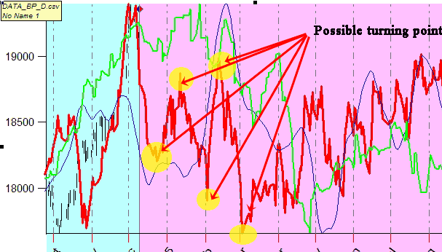
You can locate zones with a strong probability of the trend change for this stock. What is also good, you are able to know them a way ahead. If this information is confirmed by Technical Analysis methods or by some other fundamental factors, this is a serious sign for the trader.
Thus, Timing Solution gives you hints on future price movements. If these hints are confirmed by other methods, you may apply them as a part of your trading strategy.

Timing Solution - Definitions
  - Training and Testing intervals. Learning Border Cursor (LBC) and ABC notation.
  - Back Testing Concept (how to avoid "information leaks")
  - Final Optimization
  - What is the Correlation Coefficient?

Training and Testing intervals. Learning Border Cursor (LBC)
When you download any price data file, you will see that all available data are divided into two intervals:
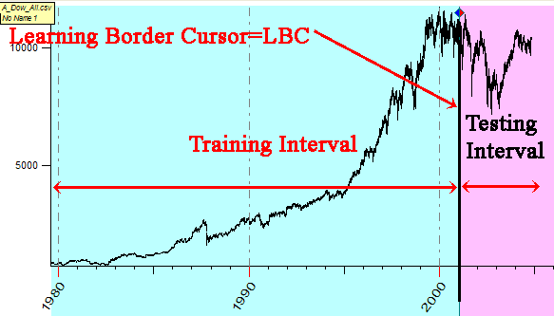
Blue interval is Training Interval, Red interval is Testing Interval. The border between them is Learning Border Cursor - LBC.
You can set the LBC wherever you want. To do this, just click on this icon: and then click the left mouse button at the place where you want to set LBC.
Also you can set LBC clicking on this button: . In this case, you will get the window to set LBC on any price point manually:
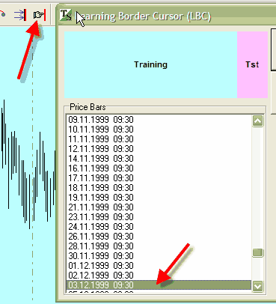

Back Testing Concept (how to avoid "information leaks")
When you create any forecasting model, the program takes the points from TRAINING interval only. It does not use the price points from TESTING interval, these points serve to estimate the model’s performance only.
Look at this example:
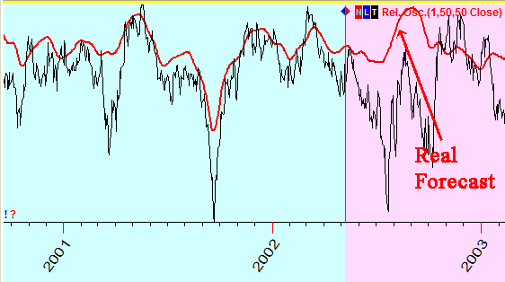
This is one of the models to forecast Dow Jones Industrial (DJI) index. This model is based on fixed cycles plus Neural Net. The Black line is the oscillator for DJI, the red line is the forecasting curve calculated by the Neural Net. It shows good fitness on the blue (training) interval. This is not surprising, because the program uses these points to train our Neural Net.
The fitness on red (testing) interval of the example is not too good. Here the Neural Net works in the forecasting regime. The price points on the testing interval are necessary to evaluate the real forecasting ability of the applied Neural Net model. Here we compare two curves - the data line and the projection line.
So, remember this: the real forecasting ability of any model can be estimated on the TESTING interval only. Thus we can avoid so called "information leaks".
The Neural Net knows and "sees" only the price data before the Learning Border Cursor when it creates the models.
For some tasks, it is necessary to use another interval; it is called VALIDATE INTERVAL, you can define the length of the validate interval here (in “Main Window View”):
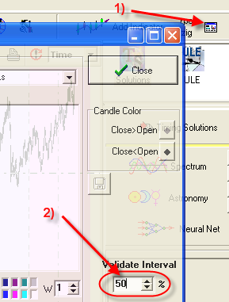

Now the Main window looks:

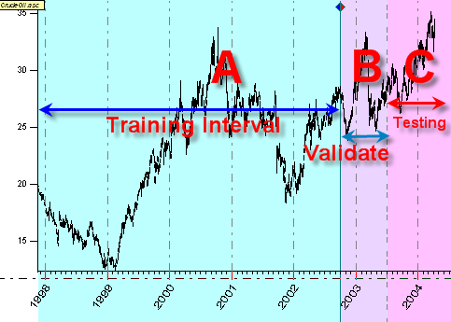

It is divided on three intervals A – training, B- validate and C – testing. The ABC notification is used everywhere in the program.
For example, in Astronomy (Composite) module this means:
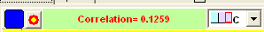
the correlation between projection line and price calculated on TESTING (C) interval is 0.1259.

Final Optimization
Final optimization is when you use ALL available price points to make the forecasting model. When we do this, there is no price points left that can serve as a testing interval to do Back Testing, because now the program uses all of the price points to create the final model. Thus, final optimization is recommended only when you trust your model.
To make the final optimization, move the LBC to the last available price bar (by clicking on this icon ).
Here is how the forecasting model looks like:
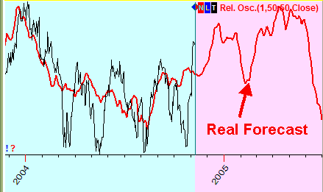
Compare this picture to the diagram above. There is no price data on the red interval, when you do final optimization. You have here only real forecast.

What is the Correlation Coefficient?
This is the definition from Financial Forecast Center (http://www.neatideas.com/cc.htm).

What is the Correlation Coefficient?
The correlation coefficient concept from statistics is a measure of how well trends in the predicted values follow trends in the actual values in the past. It is a measure of how well the predicted values from a forecast model "fit" with the real-life data.
The correlation coefficient is a number between 0 and 1. If there is no relationship between the predicted values and the actual values the correlation coefficient is 0 or very low (the predicted values are no better than random numbers). As the strength of the relationship between the predicted values and actual values increases so does the correlation coefficient. A perfect fit gives a coefficient of 1.0. Thus the higher the correlation coefficient the better.

For practical usage, you should know that:
1 - Means ideal coincidence between some data.
0 - No correlation. Two sets of data are not related.
-1 - This is anti-correlation, which means that the predicted values "mirror" the actual values (or one data set is the "mirror" for another one).
These are examples:
Positive correlation (=0.5); these two curved lines show the same price movement (most of the time). In other words, price goes up or down for both lines:
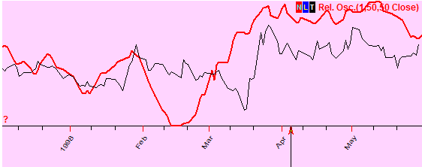

No correlation (0.07); these two curved lines show totally different movements (if one goes up, the other may go up or down and there is no regularity seen):
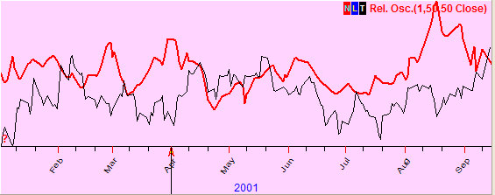

Negative correlation (=-0.4); we observe the "mirror" effect (when one curved line goes up, the other one goes down in most cases, and vice versa):
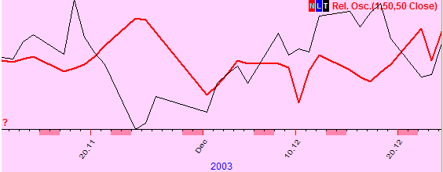
What correlation is good enough? The more the better. Usually, the models that we analyze provide 0.1-0.2 correlation. Sometimes it is more than that, but these results are not stable. To be sure that this result is not accidental, it is necessary to have a sufficient amount of price bars for calculating the correlation.
This table shows the sufficient amount of price bars for different correlation coefficients (Student's t-distribution):
Correlation | Amount of price points to be sure that this result is not accidental
0.1 | 390
0.2 | 100

Timing Solution - Interface
  - Timing Solution Interface at a First Glance
  - Timing Solution Interface at the Second Glance - Downloading the price history data
  - Price Chart Manipulations
  - Creating Indicators

Timing Solution Interface at a First Glance
When you run the Timing Solution program, you will get this window:

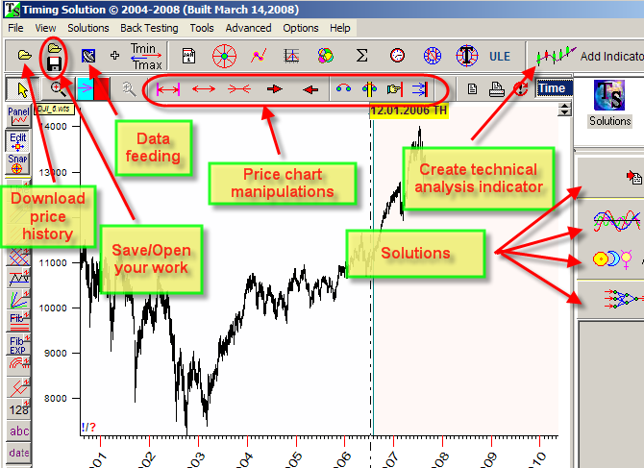

This is the Main Window. There are several sets of icons here:
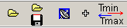- These buttons allow downloading price data, adding one or more new price bar/bars, save/open your work, setting the analyzed time frame.

- This set of buttons helps to manipulate the price chart, i.e. magnify any area of the chart, shift it, and shift/reset the Learning Boarder Cursor (LBC).
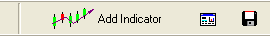 - These buttons serve to create the indicators (like MACD, RSI, and Oscillators) on the chart.
This button: activates the "Main Window View":
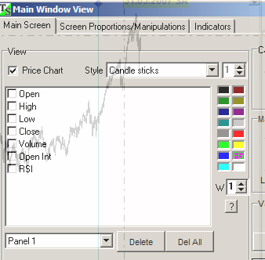
Here you can define the view of the price chart: size and the color of the line that represents the indicator on the diagram. The last button in this row, , allows to save previously created indicators as a default option.
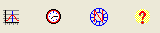 - These buttons serve to activate the Statistical Information window, Natal data and Natal chart.

Timing Solution Interface at the Second Glance - Downloading the price history data
Let us look at the program's functions in details.
To download the price history data, click on this button . This window will be displayed:
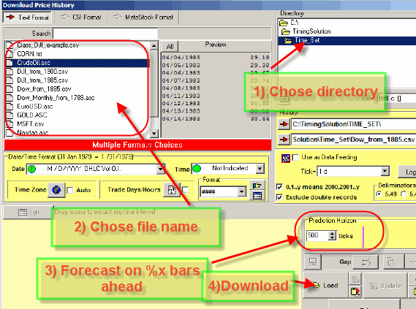
You need to choose the directory where this file is located, define the file and click "Load" button. Also define the forecast horizon, i.e., the length of your forecast.
To download CSI or Metastock data, use these tabs:
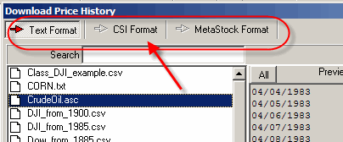
Clicking “Load” button you will get this dialog box:
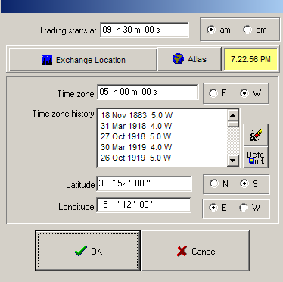
This information is necessary if you use the model based on astronomical cycles. In this case, it is necessary to synchronize the trade time with the real time.
Type here the time when trading starts: 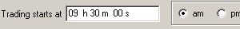.
Also the program should know the time zone and the history of its changes (Daylight saving time). In most cases you can set it clicking “Exchange Location” button:
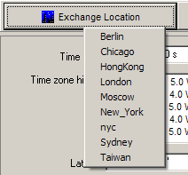

If you mostly use data from some particular exchange, we recommend setting this “Time Zone “by default:

If you plan to use the Natal Chart (first trade chart) click this button to set it: 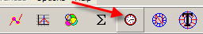

Now we are almost ready for the analysis. Click on "Calculate" button to produce the necessary calculations before the analysis:
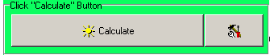
Now all ready Solutions of the program are available for you. They are combined into some groups – modules (see Modules descriptions in the proper parts of this Documentation):
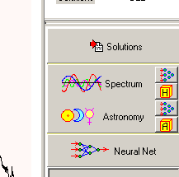

Price Chart Manipulations
The set of buttons to your left serves to define the operations that may be produced by dragging the mouse:
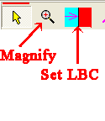
This button serves to magnify a part of the price diagram to see more details. The next button is for setting the Learning Border Cursor (LBC).
Operations with LBC. If you click on this button , you can set the Learning Border Cursor to any place on the price chart; simply move the mouse to appropriate position and click it there. When LBC is set, all the data to the left will be used for training and learning purposes while the data to the right will be used for testing the models.
Other buttons related to LBC are: 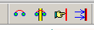. The first button serves to shift LBC on one price bar ahead. The second button shifts LBC on one price ahead and it shifts the viewed interval at the same time. The third button allows to set LBC position manually, while the last button sets the LBC on the last price bar. This option is especially valuable when you do the final optimization (not the regular training and Back Testing of the models); in other words, when you use ALL available price bars to produce the projection line.
Magnifying Viewed Interval To magnify any interval, click on this button and drag the mouse cursor. The other way to activate this button is by clicking and then pressing the right mouse button and dragging the cursor; thus you select the time interval to be magnified.
Shifting Viewed Interval To shift the interval, click on the left mouse button and drag the mouse along the price chart.

These pictures explain how to manipulate with the price chart using right mouse button to select any part of price chart:

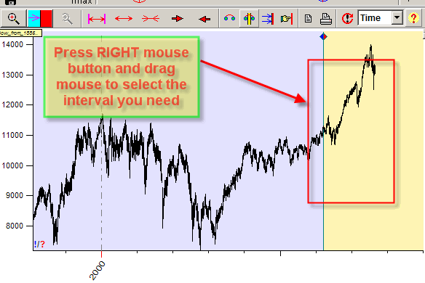
and then the left mouse button to move it:

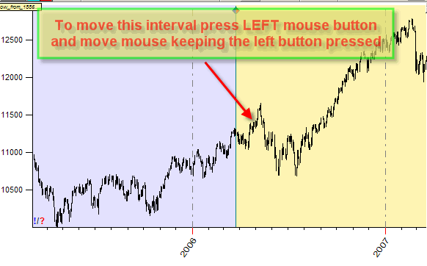

You can use these buttons as well to manipulate the viewed interval:
- maximize the viewed interval, i.e. display all available price points;
- expand the viewed interval;
- narrow the viewed interval;
- shift the viewed interval to the right;
- shift the viewed interval to the left

There are several additional options there that allow to customize the display of the price chart on your screen:

Using these buttons you can vary the top/bottom margins:

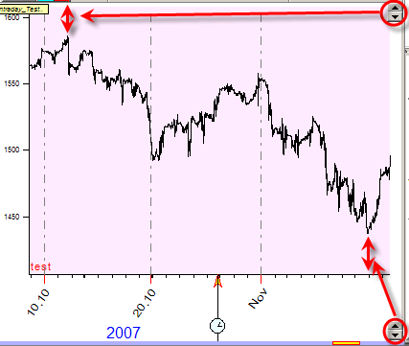

If you intensively work with charting tools and need to have the maximum room for price chart, you may disable control panels through “View” menu:

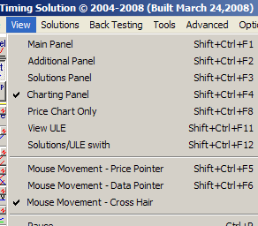

Also you can use Shift-Ctrl-F1 (F2,F3…) key combinations.

In this case the Main Timing Solution will look (just the price chart and the panel for charting tools):

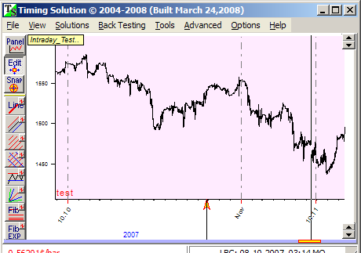

Also you can enable/disable the mouse pointer to see price, date and the cross hair.

Trading days/hours
As the main purpose of Timing Solution is creating the projection line, we need to know the trading days and hours that the projection line is calculated for.
You can set these parameters through “Options” window (“Trade days (hours)” tab) or when you download the price chart using this button:
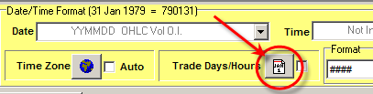
There are three kinds of data: daily data, daily intraday and weekly intraday.
1) Daily data – we have one price bar per one day. The sample of such data looks like this:
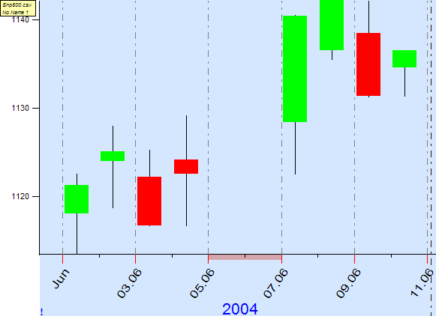
Working with this type of data, we need to exclude weekends and holidays in "Options":
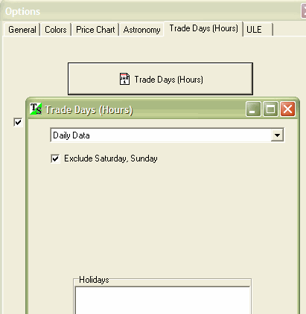
The projection line generated for this data sample is shown here:
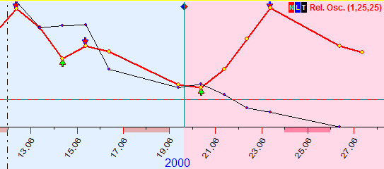
In this case, the program generates a projection line on a daily basis and skips weekends/and holidays automatically.

2) Daily Intraday data - we have intraday data stream during the day. Let say it is measured by 5 min ticks. We will get for just one day so many 5 minutes price bars. In other words, this type of data allows observing the intraday dynamics of the price change, and this dynamics is limited by trading hours (i.e., from 9:30 am to 4:00 pm for NYSE).
This is the typical example of such kind of data:
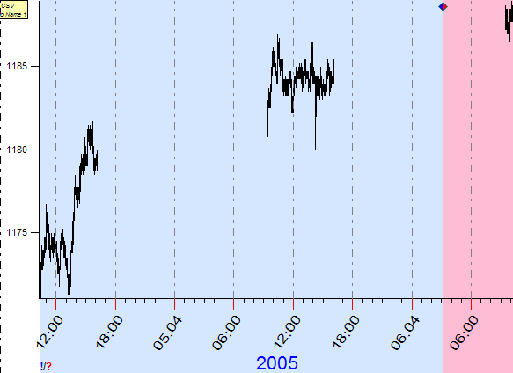
For any day (except weekends and holidays), we have 6:30 hours bunches of price data. In this case, you should set up the time when the trading starts and ends during the day:
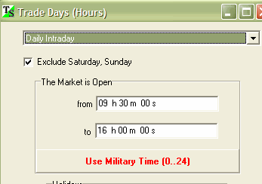
Look how the Neural Net generates the projection line under these options:
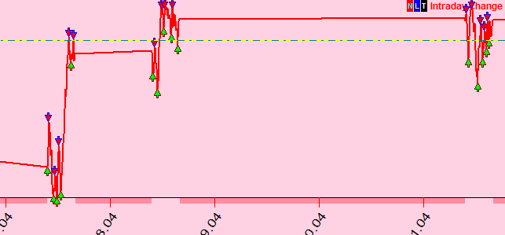
The program skips non trading days and non trading hours (these periods are marked by red stripes under the time scale). If you will try to set daily options for this kind of data, you will not get the intraday projection curve. The program must know what kind of data it operates with.
3) Weekly Intraday data - this kind of data correspond to intraday data within trading hours. The trading begins (as an example) at 9:30 am Monday and stops at 4:00 pm Friday. During this five day period (nights included), we have an intraday data stream (like for Forex). This is the typical example of weekly intraday data:
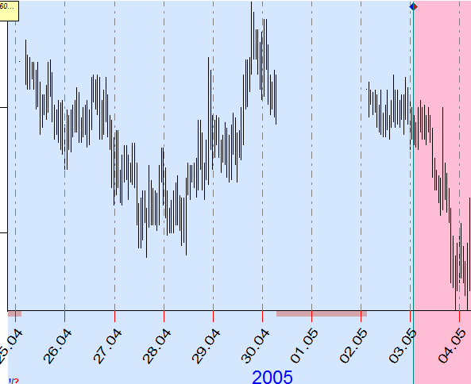
Here we have the data where the trading begins at 3:00 am every Monday and ends Saturday at 7:00 am (local time) every week.
For this particular example, set these options:
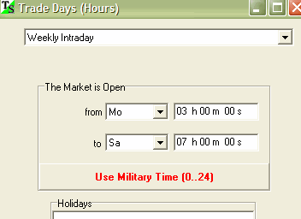
This is the projection line generated by Neural Net under these options:
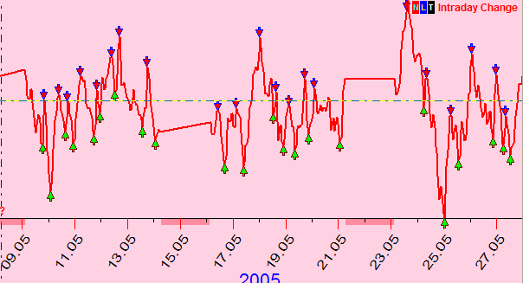
We have series of continuous 5 days data. If you try to use Daily-Intraday for this kind of data, you will not get the projection line for non trading hours (like on Wednesday from 4:00 pm to 9:00 pm).

Creating Indicators
Timing Solution is able to create different Technical Analysis indicators. Any of these indicators can be used as a target (output) for the Neural Network. In other words, the program can create forecasting models for these indicators.
To create any indicator, use this set of buttons: .
Clicking on "Add Indicator" button, you will get this window:
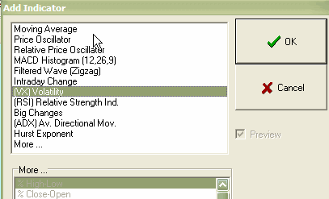
Choose the indicator to create and click "OK".
Choosing "More ..." option, you will get the access to the additional list of indicators. Here they are:
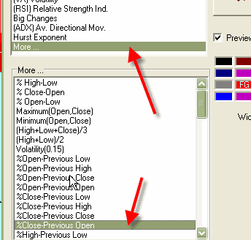
As an example, let us make the indicator "% of changes current Close relative Open one trade before". The indicators like this one are very suitable in making of auto regression models, when we forecast future price movements using the price information from several earlier trades.
When the indicator has been created, you will see the additional panel on the price chart to display this indicator:

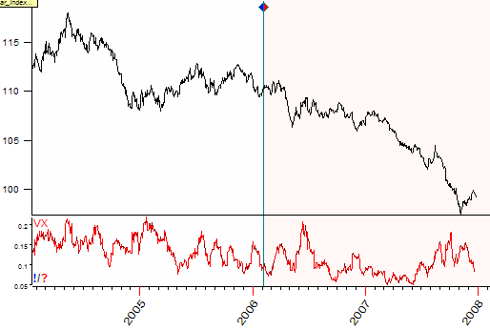
In Main Window View (clicking button or by right mouse click), you will get the dialog window to adjust the visible parameters for the created indicator:
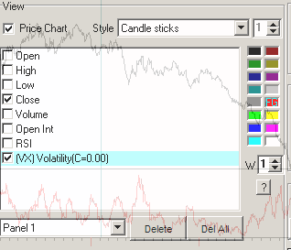
Here you can change the width and color of the created Volatility line. Also there is a possibility to display this indicator over the price chart or display it on a separate panel:

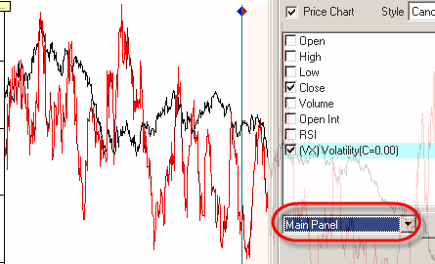

Here in Main Window View you can adjust the height of this indicator’s panel:

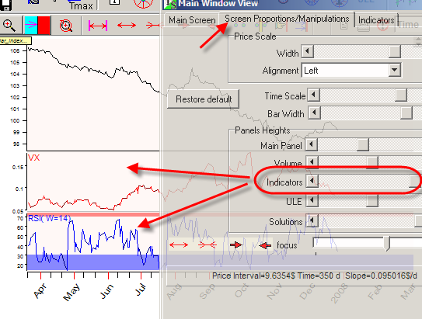

Some indicators (such as moving averages, zigzag, etc.) are displayed on the price chart itself:

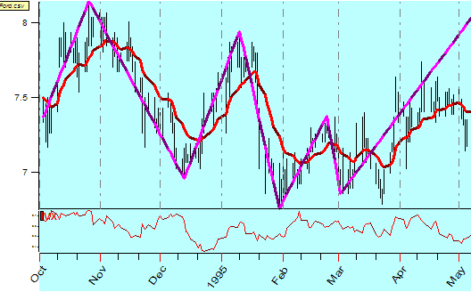

To create the reliable projection line, sometimes it is necessary to use the special indicators that are different from common Technical Analysis indicators. An example of such kind of indicator is the detrended zigzag. See the chapter "Detrended Zigzag Index - the best indicator to reveal turning points".

Easy Start
  - Learning the Timing Solution software
  - Timing Solutions
  - Going into Depth: Fast Solutions

Learning the Timing Solution software
We recommend start learning this software with Timing Solutions module (see the description below):
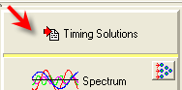
This module does the whole job of creating the projection line automatically. You do here minimal choices of appropriate solutions for your data.
Next step is to use Fast Solutions modules:
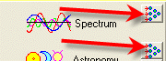
Here you will learn how to vary the projection line by varying different parameters. Read Timing Solution Styles regarding this issue.
When you become familiar with the most important parameters and main ideas of the program, you can create more sophisticated forecasting systems. See the chapters related to Object Oriented Neural Network.

Timing Solutions
Timing Solutions is the easiest and yet a very sophisticated module of the program at the same time. "The easiest" - because all you need to do is to click on just a few buttons. "Very sophisticated" - because the proportion of the amount of the information revealed per one mouse click is maximized here. Your click on just one button runs a sequence of operations that is a result of several years of searching, developing and testing for different modules of the program. You will find here:
1) Spectrum module to extract fixed cycles;
2) a specially developed Object Oriented Neural Net module (this is our "know-how");
3) Composite module that reveals the presence of astronomical cycles very precisely.
The Back Testing procedure alone took many months of hard working. A lot of time and efforts are hidden behind this button; it has been developed with one purpose only - to find and make available for you the best initial parameters to be recommended for creating the projection line.
You can run this module in "step-by-step" regime. Thus you can see step by step how this forecast has been created. This feature may serve as a learning tool. If you like, you can participate as well in the process of creating the projection line (while in the "step-by-step" regime).
First of all, download the price history data. Click "Calculate" button; in an instant, this set of buttons will be available for you:
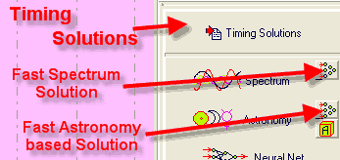
Let's begin with "Timing Solutions" button. Click on it; you will get this window:
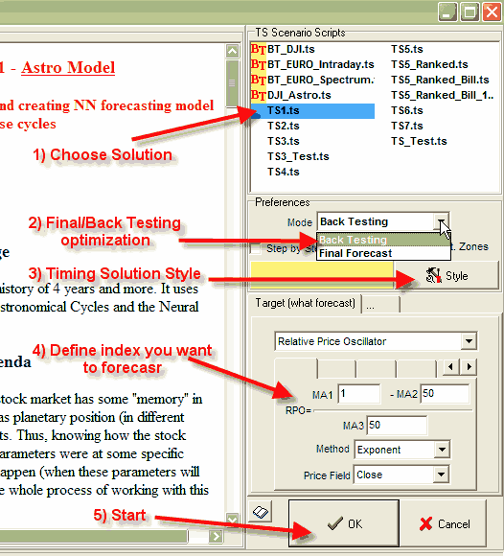
Make your choice of:
1) Solution. Choose one of the available Timing Solutions scenarios in the right part of the window. When the choice is made, the description of this solution will appear in the left part of this window. Each Solution represents a sequence of operations that has to be performed to obtain the projection line. The Solutions marked by BT sign represent the Back Tested solutions:
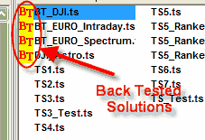
These are the Solutions statistically verified. They are based on back tested models. See this link regarding these models: http://www.timingsolution.com/TS/BT/
2) Style. Each model has several most important parameters. The projection line depends on these parameters very much. In the program, you either can define these parameters or use predefined styles: permanent, moderate and risky styles.
3) Final Forecast. If you select option, the program will set the Learning Border Cursor to the last available price bar. In other words, the program uses all available price history to make the forecast.
4) Target. Here you define the index (indicator) to forecast:
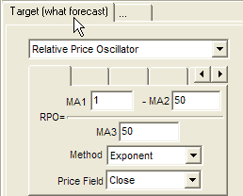
You can make forecast for any index you want - like RSI, ADX, Volatility and many others.
Whatever is your choice, click "OK" when it is done. In a few minutes, the program will produce a huge job of calculations related to this solution. You will see the results of this job on your screen:
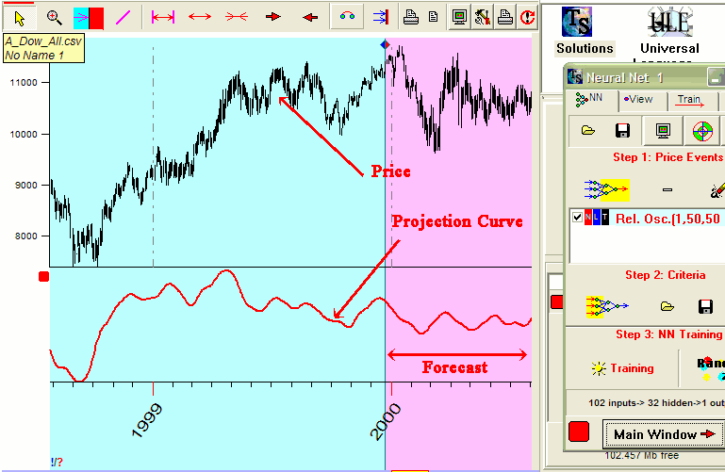
The upper part of this diagram displays the price chart. The red line on the bottom is the projection line for this solution as calculated for this data set (the solution in this example is based on a fixed cycles model).
You can select any piece of this diagram by dragging the mouse cursor. Then you can magnify it, expand or shift it (see Interface description for more details).
Also, you can show the price chart together with the projection line by clicking on this button: :
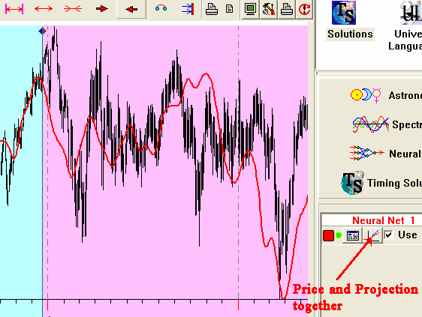
As an illustration, let us create the forecasting model based on some other index. Let it be the forecast for detrended zigzag (min swing=5%). You need to change the target this way:
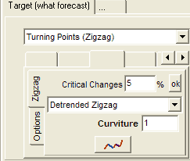
The forecast (red) curve will look like this:
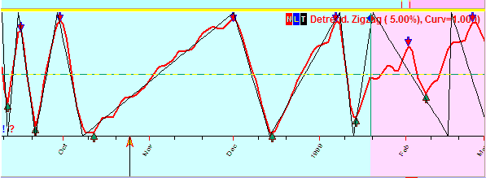

Going into Depth: Fast Solutions
Ready Solutions are a good thing. First of all, they save your time. Instead of spending hours and hours of learning the techniques, creating models and playing with their parameters, you can use the results of the job already done - by us, for you. Also, ready solutions give you a hint of a possible price movement of your stock, or futures, or index. But - there are no universal receipts in making a forecast. Each financial instrument has its own peculiarities, and from time to time it may not follow the average path. For that reason, we always suggest to check several different models (at least, three) that are related to your financial instrument. Timing Solution software provides the wide range of possibilities to play with different models. It helps to get the forecast that is closer to the reality.
As a first step to get acquainted with this variety, we would recommend to use Fast Solution buttons:
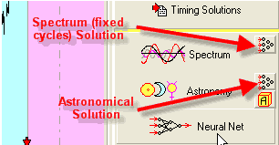
Here define the Style and Target:
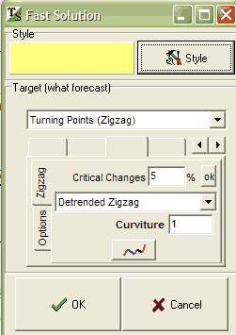
The process of finding the best models to create a projection line looks like finding a right path in the forest. It is easy to get lost there. Three standard Styles represent the paths that cross this huge forest. There are three main paths here - Permanent, Moderate and Risky. "Permanent" style deals with cycles that proved previously their importance (like the most used path in the forest or the yellow brick road), while "Risky" style allows to deal with not so well known/proven cycles (risky paths in the forest go through open lanes and dark places, so sometimes you should be very cautious and ready to face unexpected surprises any moment). "Moderate" style/path is something between the two. Generally speaking, the styles provide us with the guidelines in creating a forecasting and defining the leading parameters.
The Style collects together several parameters that are very important in creating projection line:
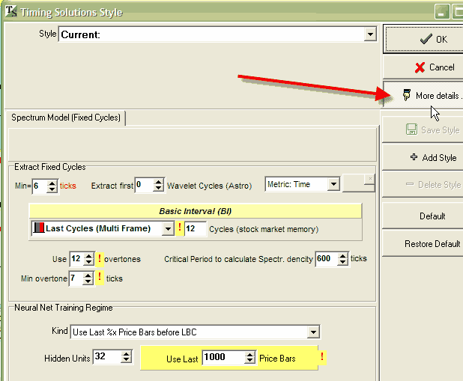
The most important parameters are marked by the exclamation symbol. Each financial instrument has its own habits, and the style parameters numerically describe these habits. We constantly provide the Back Testing to obtain the best parameters for them. Timing Solution Styles are described in the chapter "Timing Solution Styles".

Spectrum Module - Forecast based on fixed cycles

  - Basic Idea
  - Spectrum at a First Glance
  - Spectrum at the Second Glance
  - Going into Depth
  - Harmonic Box: The Simplest Forecasting Model
  - Spectrum + Neural Net Forecasting Model
  - Cycles Activity Diagram - improving results
  - Spectrum Options

Basic Idea
The basic idea of this model is that the stock might follow some fixed cycles, or, in other words, there are sinus waves hidden in the price data. If they are, we can extract them and apply for creating a forecasting model. The general scheme to work with Spectrum is:
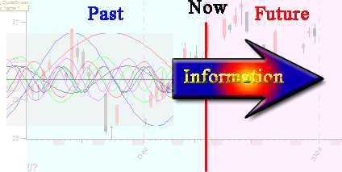
It means that we analyze data regarding the past performance of the stock market (futures/indices), create the model, test it and then apply the tested model to forecasting. This is a general scheme for all modules of the program. The following explains how this scheme works for Spectrum Analysis.
Spectrum at a First Glance
To calculate Spectrum, click on this button: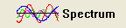. The following window will appear:
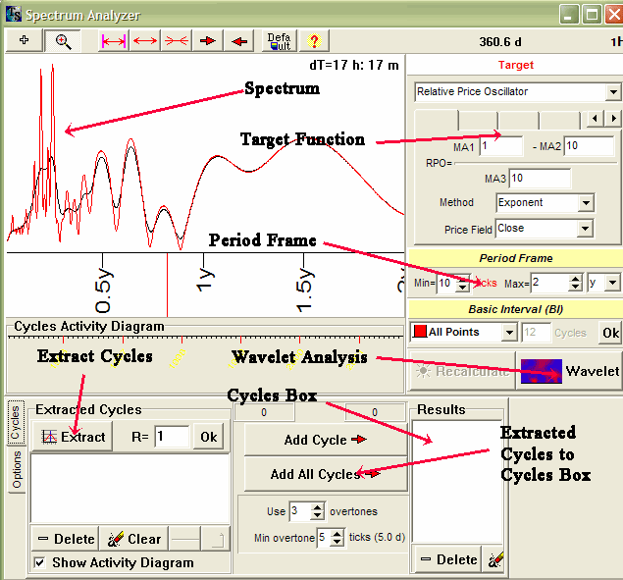
Window's Outlook: In this window, you define such important parameters for Spectrum Analysis as Target Function and Period Frame (minimum and maximum cycles periods that might work for the analyzed market). When these parameters are defined and the necessary calculations are done, the result of the analysis will be shown as a diagram. On the diagram, the periods of supposed cycles are shown as X-axis values. Y-axis shows the importance (magnitude) of the cycle. Higher amplitude means that the corresponding cycle participates in the analyzed market's activity with higher probability than the cycles with smaller Y-value. The cycle's period is shown by X-number.
Move the mouse along the X-axis. The number in the upper right corner is the cycle's periodicity.
The lower part of this window is designed to work with the revealed cycles. The program shows the list of cycles that are the players on the analyzed market regarding to the available price data ("Extracted Cycles" dialog box). Cycles from the list can be selected for the process of forecasting (see "Cycle Box" below).
The following is a brief description of parts of this window.

To provide Spectrum analysis, we need to define the Target Function and Period frame.
Target: Choose the target function from the list. As an example, the Spectrum analysis has been provided for "Relative Price Oscillator index (Period=10)".
Period Frame: Define the minimum and maximum cycle length (the cycle's period). In the example, we look for the cycles with the period between 10 days (it is the length of the smallest possible cycle) to 2 years (which is the length of the biggest possible cycle; the word "possible" means that we make our assumption regarding the cycles before any analysis).
To calculate Spectrum, we use all available price points within the training interval (Basic Interval option).
The spectrum diagram (shown as a red curved line) represents the strength of each cycle, its role in this market's activity. In our example, we can conclude that 0.5-year cycle is strong enough (one of the curve's maximums corresponds to 0.5 year period), though it is not the strongest. The black curved line represents the moving average (without the lag) for spectrum, this is necessary for extracting important cycles.

Spectrum at the Second Glance
Target: It is a very important feature for the Spectrum window; it shows what price index is used to calculate Spectrum. For example, while calculating Spectrum for Dow Jones index from 1975 to 1995, we cannot use the Close index directly, because in 1975 it was below 1000 though it was about 4000 in 1995:
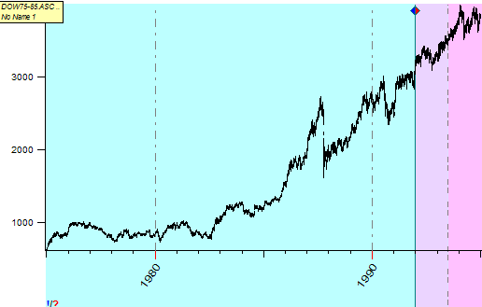
Calculating Spectrum, it is better not to use the Close itself (though it is quite possible), but normalized price (as an example, "Relative Price Oscillator"). Look at this diagram (the red curve represents the oscillator, the black one shows Close):
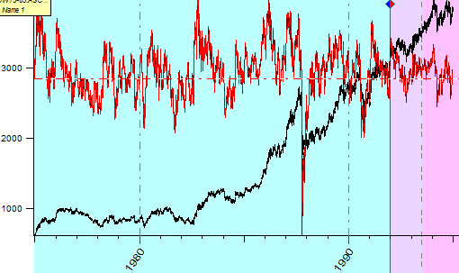
Though these two curves look different, their characteristic points (like minimums and maximums, upward and downward movements) coincide - this is a standard Math approach. Thus, we get a convenient way to deal with the data.
You can vary parameters of the oscillator:
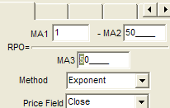
In this example, we calculate Spectrum for the Relative Price Oscillator with the period=50 (the formula for the oscillator is: (Close-MA(Close,Period=50))/MA(Close,Period=50)).
But you can do more interesting things. For example, reveal cyclic processes for True range (to be more precise, for a relative range calculated as 100% x (High-Low)/Close). Let us do it together.
Set these parameters in Target:
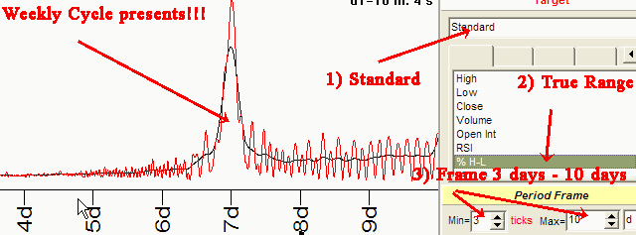
This diagram gives some ideas for creating a forecasting model.
By the way, trying to calculate Spectrum for a wider period frame (3 days - 1 year), you will get another diagram with regular patterns:
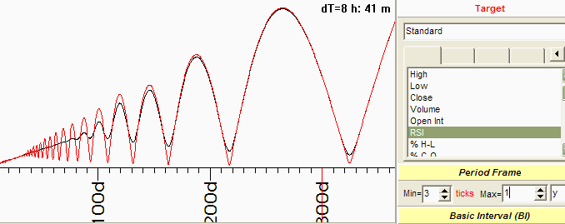
In this case, it is better not to use such a wide period interval, make it narrower.
The same way you can calculate Spectrum for Relative Strength Index:

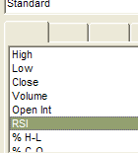

Going into Depth
Basic Interval 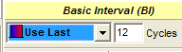
Let's look at one example. Suppose we calculate Spectrum for one year price history data (300 days). For this data, the maximum recommended cycle to be calculated is 0.33*300=100 days cycle. And we use all (300) price bars to calculate the strength of this cycle.
The program is able to calculate the strength of all cycles at the same time. See the strength of 100 days cycle and 15 days cycle together, on the same Spectrum diagram:
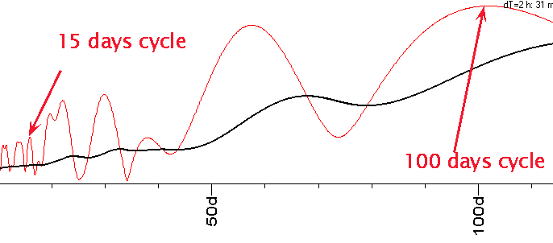
The problem is that for the 15 days cycle we do not need all 300 points. For 300 days we have 20 full 15-days cycles. What if we do not need 20 cycles? It is a fact that the effect provided by the cycle does fade with the time, and after some time the cycle that worked before does not work any more. It looks like the "cycles life" is shorter than 20 full cycles, cycles also have some conditions for their existence, and time frame (or time interval) for the cycle is also crucial. This phenomenon may be seen through the wavelet analysis.

Harmonic Box: The Simplest Forecasting Model
The process of creating a forecasting model based on fixed cycles consists of two steps:
1) extracting cycles;
2) put the extracted cycles into a harmonic box.
Extracting Cycles: In 90% of cases, all you need to do is just click the "Extract" button, and the program will extract the strongest cycles and mark them by vertical lines:
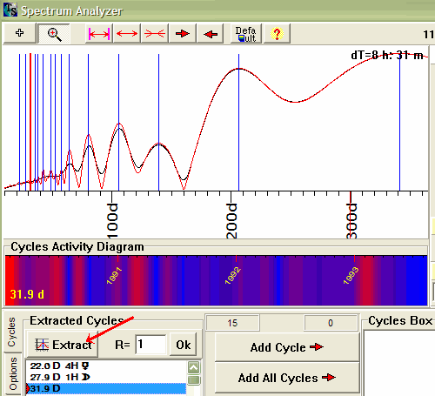
In the example, the program has extracted the strongest cycles that correspond to the top points of the moving average curve (the black curve on the above diagram). Increase this parameter: to pick only the highest peaks of the graph.
You can pick up these cycles manually as well. To do this, click on the "+" button and then click the mouse around the maximum point you want to pick up:
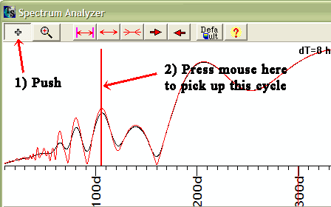
This way you will decide yourself which cycles are important and which are not.
Creating Harmonic Box. It is easy. Just click this button:, and you will get this window:
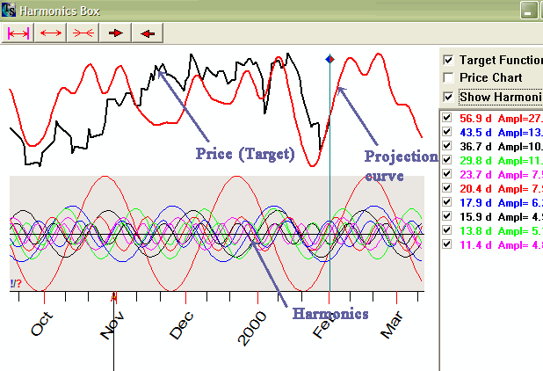
Here, in the upper part of the window, the black curve is the target we analyze (in our example, it is Relative Price Index). The red line is the projected line based on these extracted cycles. On the bottom, all participating cycles are shown, their amplitudes and phases are adjusted.
Spectrum + Neural Net Forecasting Model
Our research reveals that non-linear systems give better forecasting results. We can still use fixed cycles; however, exploring the non-linear relationships between them is rewarding. It means that several cycles work together as a totally new entity, not just a simple sum of all components (like it is under a linear approach).
Let us get together a NN forecast based on fixed cycles. All you need to do is just put all analyzed cycles into the Cycle Box (click on this button):
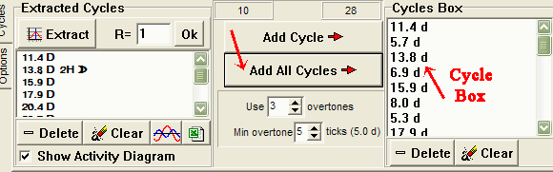
The program puts all these cycles into the Cycles Box and then moves them all into the clipboard using ULE format (ULE stands for Universal Language of Events). It means that now you can use these cycles to create the inputs for Neural Net:
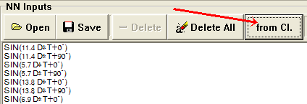
You may vary these parameters while putting the extracted cycles into the Cycles Box:
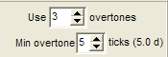
The bigger the first parameter and the smaller the min overtone, the more details can be seen by this model. (See Timing Solution #4 how to use these parameters to create a projection line.)
Cycles Activity Diagram: Improving the Results
The forecasting model based on fixed cycles can be improved by the application of elements of wavelet technology. Please be advised that all operations described below should be done manually, this feature is not one of the proposed Solutions.
The most important question in Spectrum analysis is to distinguish between important and non-important cycles. The wavelet technology provides a special approach to this problem. Look at this example:
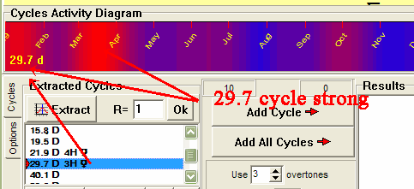
The upper red-and-blue colored diagram represents the cycle's activity (the cycle in question is selected from the list). Red zones correspond to the periods when this fixed cycle is strong. But we can see that this cycle is not so strong at the end of the learning interval (last price bars before the LBC - see the right corner of this diagram). It seems that the cycle was playing its part somewhere in the past, but it is not working the same way any more. Would it not be better if we eliminate this cycle? There is no indication that it will work in the nearest future.
As a contrast, look at another example:
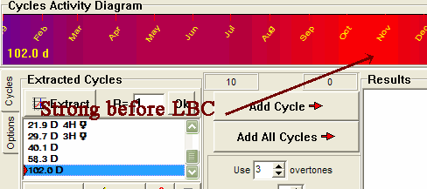
This 102-days cycle is strong within last 10 months. So, we can suppose that if it is strong enough now (now means "close to the Learning Border"), it may work the same way in the nearest future. Thus, this cycle might be of some help to create the forecast.
You can also use the diagram of the cycle’s activity (the complex Morlet wavelet). Here is the illustration:
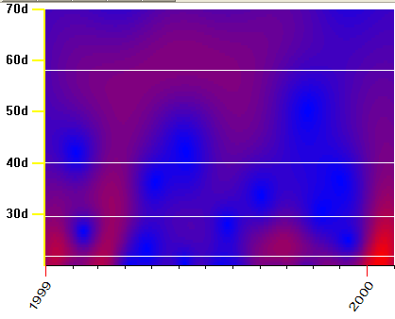
X - means time; Y- the period for the cycle. The red zones correspond to periods when the cycle is strong. While working with this diagram, use this parameter:
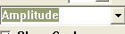
Also, the program provides the ability to analyze the bifurcation points (i.e., points of non-stability where some kind of the possibility to "choose" exists). We do it by means of phase wavelet (it is one of the themes of our research).
Spectrum Options
There are two categories of options in the Spectrum module: 1) parameters responsible for the calculation of Spectrum diagram, and 2) parameters for cycles used in the Neural Network. Let us begin with spectrum options
: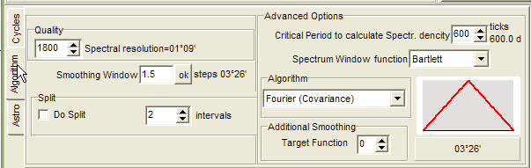
I would not recommend changing these parameters significantly. They are adjusted according to the analysis of different financial instruments.
The Quality parameter 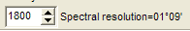defines the spectral resolution, the accuracy of cycles’ calculation. It is not recommended to increase this value too much, otherwise you can face the noise cycles effect - the program extracts a lot of non-important cycles.
The Smoothing Window 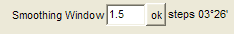. This is an extremely important parameter. To diminish the noise, the program calculates the spectrum density. Visually it looks like smoothing procedure. The usage of bigger value for smoothing window makes the spectrum diagram smoother, though we can miss many minor and not so strong cycles.
. For long-term cycles, we do not need the smoothing procedure, because the spectrum diagram for long-term cycles is smooth enough.
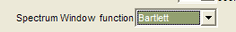: Here you can define the type of a smoothing function. For example, the Bartlett function 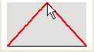makes the spectrum more sensitive to minor cycles than Hanning function: 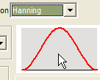
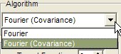. For financial data, the Fourier (Covariance) algorithm is more preferable. It calculates the spectrum as Fourier transfer for auto covariance function.

Another group of parameters defines the cycles used by the Neural Network to make a forecast.
The Back Testing shows that these parameters are extremely important and have a tremendous impact on the quality of the projection line.
Here they are:
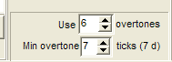
The first parameter shows how many overtones the Neural Net uses to make the forecast. For example, if the Spectrum shows the importance of 100 days cycle, we can use these cycles as inputs for the Neural Network: 100 days cycle -1st harmonics, 50 days - 2nd harmonics, 33.3 days cycle - 3rd harmonics, 25 days - 4 harmonics, etc. Practically, it means the nature of short-term cycles. The short-term cycle can manifest the long-term cycle (like short 10-days cycle can manifest the long-term 100-days cycle as it is its 10th harmonics). The intensive Back Testing shows that high harmonics are very important. As an example for Euro/USD, good results are received for the model that uses 32 overtones; for Dow Jones, the better model should have at least 18 overtones. So this parameter is worth to play.
Min overtone - sets the minimum period of the overtone cycle.
Besides the fixed cycles, the Spectrum module is able to work with special Wavelet Cycles. This is another category of cycles, you can read about it in the article on the website www.timingsolution.com.
In this tab, we define the parameters for Astronomical Wavelet Cycles. The program calculates the importance of any wavelet for the astronomical cycle in respect to these parameters:
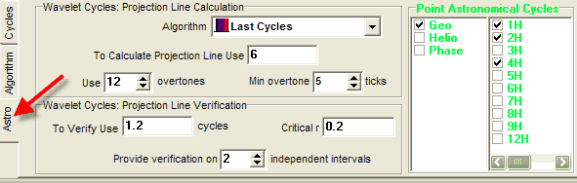
The "Point Astronomical Cycle" shows astronomical cycles and their harmonics that are marked in the Spectral diagram:
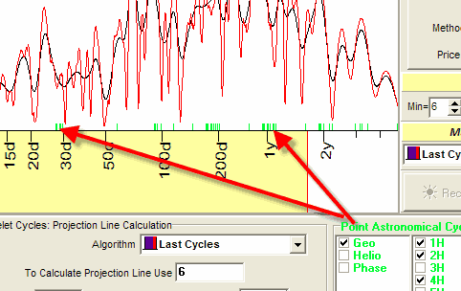
Here the lime strips represent the astronomical cycles against Spectrum diagram. The presence of the lime stripe nearby the maximum of the Spectrum usually indicates the importance of some astronomical cycle, like this one:
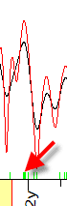
Here we have one maximum in the Spectrum diagram around 2 year cycle; that is very close to Mars geocentric cycle.

Composite Module - forecast based on astronomical cycles

  - Basic Idea
  - Composites at First Glance
  - Composites at the Second Glance
  - Going into Depth
  - Active Zones (AZ)
  - Predictable Zones (PZ)
  - Composite Box: Forecast based on Composites
  - Composite Report

Basic Idea
The basic idea of this module is that the stock market has a kind of "memory" in regards to astronomical parameters such as a planetary position (in different coordinates) and an angle between the planets. Thus, knowing how the stock market has behaved in the past (when astro parameters were at some specific values), we can assume what is going to happen (when these same parameters have same values again). In brief, the whole process of working with this module is shown here:
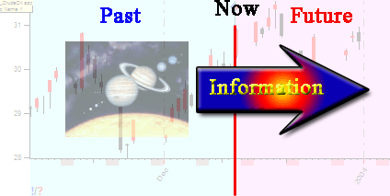

Composites at First Glance
The Composite module serves to identify the presence of astronomical cycles in analyzed data. As an example, download the price data for crude oil starting from March 1983 to May 2004. Click on this button:
Window's Outlook: You will get this window:

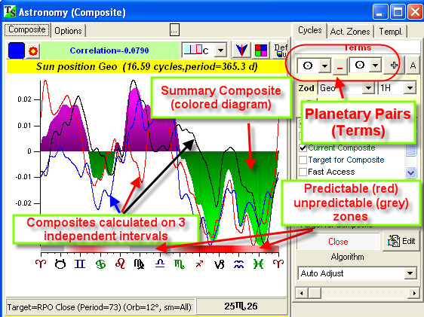

In our opinion, this window represents the maximum information regarding the annual cycles for the crude oil price. The colored diagram (called "Summary Composite") shows how the price changes when the Sun moves through the skies.
You will get a similar picture after all necessary parameters are defined and the calculations are performed. In the right side of this window, define the planetary pair to be analyzed. In the example, it is the Sun-Sun (this means that the program is considering the position of the Sun in Zodiac; to consider the angle, define two planets). It is possible to use different types of Zodiacs in this program. For example, it might be more convenient to use heliocentric coordinates for planets while creating some models.
For example, setting options this way:
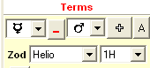
means that we will research the influence of Venus-Mars heliocentric cycle.
The central part of this window shows a diagram for the composite and three lines (red, blue and black). Each line represents the same composite, calculated on different independent intervals. The number of lines corresponds to the number of independent intervals for calculation. It helps if you choose the one you consider more reliable or preferable. There is a narrow gray-and-red stripe along the bottom area (right under the composite diagram). It shows the "predictable zones" - these are the regions where your forecast is more reliable. Look at the red zones; you will see that there all three composites point at the same movement of the analyzed data, so these zones are preferable when you are making a forecast.

Projection Line: Choosing any astro cycle, you can immediately see the projection line based on this cycle in the Main window:

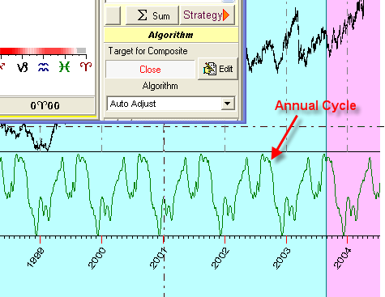

Composite Diagram: Let us look closer at the central area of this window, the composite diagram itself:
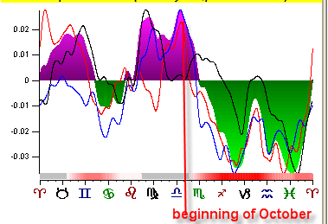
The program calculates it by comparing the price data and the Sun position in the selected Zodiac (as in our example - in other cases, the price may be compared to the changing angle between two selected planets.). From this diagram, we might expect that, when the Sun is in the beginning of the Libra sign () - it happens at the end of September, - the price reaches its maximum. Thus, it might be a turning point; however, is it really so? To answer this question, look at those three colored lines. If they all point in the same direction, the answer is "yes".

Predictable/Unpredictable Zones: In our case, two composites (the red and blue ones) confirm the turning point (look at the vertical line that marks the corresponding time point). However, the third line (the black one) goes in the other direction. It means that this conclusion is not confirmed at least inside one of the chosen intervals.
This area is marked on the "predictable zones" line as unpredictable. In other words, to make such a conclusion (in regards to the maximum price for crude oil when the Sun is in Libra), we have to analyze other factors.
Now, look at the December area. Here all three lines go down. So, this area is marked as a red one - i.e., predictable. We can make a conclusion based on the analysis of three independent data intervals. It is stated that every December crude oil prices go down (in the very beginning of that month):
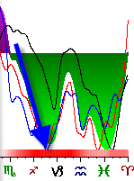
In brief, looking at such a diagram and predictable zones, it is possible to make a reliable conclusion. The more intervals we take, the more reliable is our conclusion - when the projected lines for every interval will go in the same direction. The price diagram itself (a purple-green area) also shows downward movement in December. In other words, we have found some factors that coincide with changes in crude oil prices at that time of the year and can use them for making a forecast.
Correlation – quality of projection line: You can see how the projection line fits the price chart here:
This line shows the correlation between the projection line and the price (to be exact, the target, usually this is a detrended oscillator); in our example, it is 0.26. If the correlation is closer to 1.0, this means that this projection line reflects the price movement very well; see more in Definitions chapter. Next parameter is the interval that is used to calculate the correlation coefficient. You always get a good correlation on A interval, because we use the price information from this interval to calculate the Composite (and the projection line as well). To estimate the real performance of our model, it is better to use some independent interval (B or C). See more about these intervals in Definitions chapter.

Composites at the Second Glance
Let us take a more complicated example: analyze how the Moon phases affect crude oil prices. Does this relationship really exist?
Composite for the angle between planets: Before making any steps, let us understand what the Moon phases are. In a core, they reflect changes of the angle between the Sun and the Moon. For example, the New Moon takes place when the Sun, the Moon and the Earth are situated at the same "line" in the space, and the angle between the Sun and the Moon is zero. The Full Moon is very similar to the New Moon, the difference is that the Earth is situated between the other two, and the angle between the Sun and the Moon is 180 degrees. Thus, in the program, we will create a composite of the angle between the Sun and the Moon. To do this, set up the following terms in the upper right part of the Composite window:
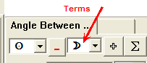
Here is the composite diagram for the angle between the Sun and the Moon; it looks extremely interesting:
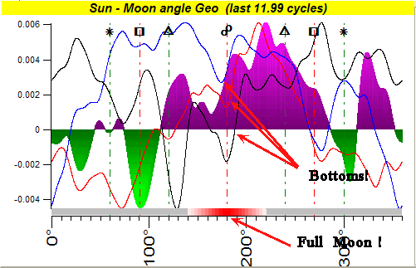
First of all, note that all three composite diagrams (red, blue and black - calculated for different data intervals) move in totally different directions everywhere except the area where the angle between the Sun and the Moon reaches 180 degrees. In other words, we may conclude that around the Full Moon the crude oil price reaches its local minimum. For any other periods, it looks like the Sun-Moon angle has no effect upon the price.

Basic Interval: The feature discussed here has been observed only for one year (May 2003-May 2004; it is a month when this feature has been added to the program). To make it more understandable, we have to use a new definition: a basic interval. It is the smallest data amount that is sufficient enough to make a primary conclusion. A basic interval is a very important definition. We have found experimentally that the same phenomena have different effects, and these effects depend on the time frame. In other words, the effect of the Moon’s aspects on the same stock market is different now than it was 10 years ago. So, the basic interval is the interval with enough data to make a conclusion. For example, to calculate the Sun - Moon composite, the last 12 cycles are enough. This approach gives better results than taking a huge amount of data and facing the impossibility to make any conclusion..
This is a new and very important feature of the Composite module.
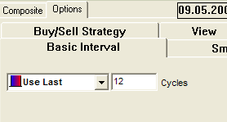
This option allows you to specify the period to calculate the composite curve.

Going into Depth
In this section, the different parts of the Composite window are described. Each one of them provides enormous possibilities.
"Terms" panel : Here you can define the planetary pairs and types of Zodiac to use as well as the harmonics number. For example, here are settings to search the effect of the angle between Mercury and Venus, in Heliocentric Zodiac, for 3H harmonics:
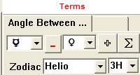
While defining the harmonics number, we simply point out that some harmonics are important for this set of data. It means that there is a kind of cycle symmetry. For example, 2H harmonics means that the data change for the angle between these two planets in the range of 0° and 180° is similar to the data change for the angle in the range of 180° and 360°. If 3H harmonics is significant, it means that the effect of the angle of 0º will be the same as for 120º and 240º.
"Algorithm" panel : First of all, you should not change the settings of this panel often. It looks like this:
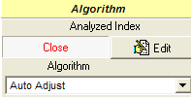
The "Analyzed Index" means the index you use to calculate the composite. For example, you can create the composite for "High" only. There are some recommendations; let's start with two of them. These recommendations are based on our own experience:
1) For High, Low, Open, Close and all indices that possess a natural trend, use algorithm.
For example, to create the composite for "High" index: 1) click “Edit” button and chose “High” index; 2) highlight the "Auto Adjust" option. The program normalizes the "High" index according to the period specific to the composite's planetary pair and uses this index to calculate this composite:
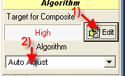

2) For free of trend values (like Volatility, RSI, ADX) use this algorithm: .
You can easily create the composite for ADX index (as in the example) and analyze how the planetary position (or the angle between the planets) impacts this index:
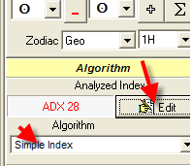
As an example, we consider the composite for Mars-Jupiter angle calculated for Dow Jones Industrial index (1970-2005):
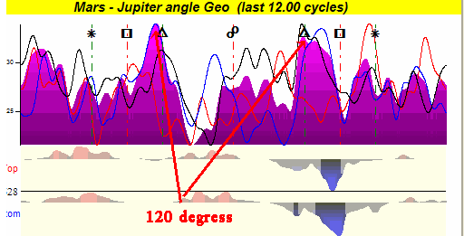
As you see, when the angle between Mars and Jupiter reaches 120 degrees, the ADX index goes to 40% (these regions are shown on the picture). This tendency has been verified for three independent intervals.
According to Technical Analysis canons, the value 40 (and above) indicates the strong trend tendency (no matter, bullish or bearish). Then the ADX decreases. So we can specify these zones as "... potential changes in the market from trending to non-trending" (see more info here: http://www.stockchart.com).
3) This algorithm is original algorithm proposed by Bill Meridian.
This algorithm is used in his books to calculate composite diagrams. You can use this algorithm instead of “Auto Adjust”. IMHO, I think that for long-term cycles (like 12 years Jupiter cycle) “Auto Adjust” algorithm works better. In any case, you can work with both options.

"View" panel : This panel allows specifying indices displayed in the Main window:

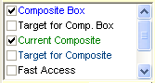

As an example, let's create the composite for Close index. The green line in the Main window corresponds to the projection line for the chosen astro cycle:

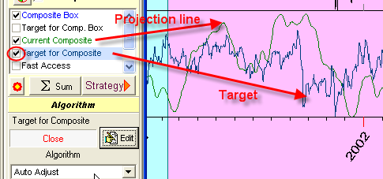

Checking "Target for Composite" option, you can display in the Main window the index that is used to calculate the Composite. For example, if we research the Annual (Sun) cycle for Close index, the program normalizes the Close using relative price oscillator with period=73 days. This is the target. For shorter cycles (like the Moon’s cycle), we need to concentrate on faster cycles. For the Moon’s cycle, I would recommend the oscillator with a 5 days period.
The 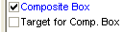 options are necessary when you create the projection line based on two or more astro cycles. It is explained further.

Active Zones
Let us explain what "Active Zones" are considering one simple example. Download the crude oil price from 1983 to 2004. Set these options in the "Active Zones" panel:
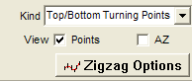
Click on "Zigzag Options" button. The window will be displayed where you may set these options for zigzag:
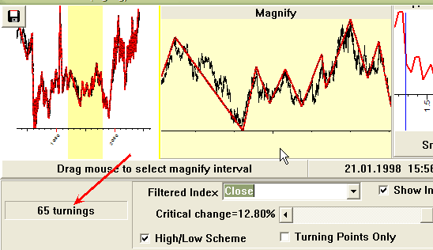
Set "critical change" parameter to 12.8% (this is the minimum height for a zigzag wing. In our example, it corresponds to 65 turning points).
In the "Terms" panel, set the Moon-Sun pair because we will analyze the Moon phases:
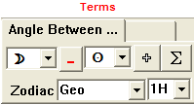
Here is the composite diagram for these settings:
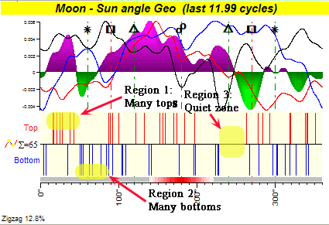
"Active Zones" explanation: From 1983 to 2004, we found 65 top and bottom turning points. The red/blue vertical lines represent how these turning points are located in respect to the Sun-Moon angle. In other words, the program calculates all turning points (65) found for the changing angle between the Moon and the Sun and draws lines corresponding to these angles (red lines for top points, blue lines for bottom points). Thus, the active zones show where most of the turning points are located. If there are no turning points in some area (or just a few), the area is called "Quiet Zone".
"Active Zones" reading: For this particular example, we can make some conclusions. The crude oil price reaches its top 2-4 days after the New Moon. On the diagram above, 0º corresponds to the New Moon. The "Region 1" (there are many top turning points) is located within the interval 10º-50º. Then, there is one more active zone: "Region 2". It is not so strong as the previous one and corresponds to the bottom turning points. The "Region 3" corresponds to the relatively quiet zone, it corresponds to 230º and happens 4-5 days after the Full Moon lasting for 2-3 days. In the quiet zone, the price does not reach the turning points, but just follows the existing trend.
"Active Zones" criterion: We can do this analysis for the turning points and for the points when big price movements happen as well. In this case, set the parameters of the "Active Zones" as follows:
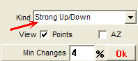
For these settings, the program will look for all days when price changes at least for 4% (within a day range of the HLOC price bar; otherwise, it compares today's price and the price one day before). The minimum change is 4%. The diagram follows (this is the annual cycle, or Sun-Sun, composite):
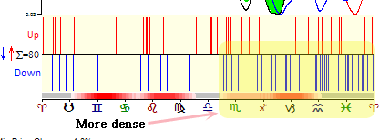
The region between Libra and Aries is marked by the yellow bar. This time period corresponds approximately to the interval from the end of September to the end of March. We can see that strong move points are located more often in this region. In other words, from October to March, the crude oil price makes more strong movements (may be because it is a cold period in the Northern hemisphere...).
"Active Zones" histogram: If we analyze the long-term data series, it might be impossible to see all related lines. Look at this diagram; these are turning points for Dow-Jones index from 1900 to 2004, minimal change 4%:
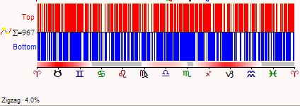
We cannot see it clearly because there are 967 turning points.
But we can display this information as a histogram and look at the density of the turning points. Set options as follows:
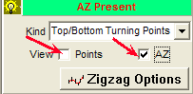
For these settings, the Active Zones Histogram for the annual cycle (Sun-Sun) will look like this:
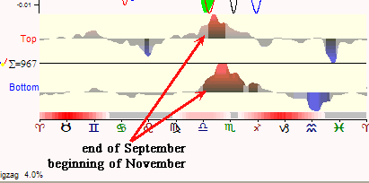
The brighter red zones correspond to the areas where turning points happen more often. For example, such a zone corresponds to the period starting from the end of September till the beginning of November. In other words, the very strong possibility exists that there might be trend changes at this period, especially for bottom turning points.
Some useful statistics options for this feature can be found in the "Options" tab:
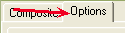
Go to the "Statistics" page:
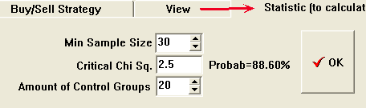
We have Chi sq=2.5, which corresponds to the probability of 89%. Putting it in a different way, we can accept this fact as a true one with the probability of 89%. To be exact, it means: "With probability 89%, we can assume that turning points happen more often from the end of September to the beginning of November".
In the "Statistics" window, we recommend you to keep the parameters for minimal sample size and the amount of the control groups as they are and change the "Critical Chi Sq" option only.

Predictable Zones
As mentioned before, the main idea behind the predictable zones is to calculate the composite for a few independent intervals and see how the projection line is changing in respect to each interval. For this program, we have applied and developed special math methods that will calculate these zones very fast. It is this "know-how" of ours that makes this program so advanced. Before any discussion, some useful options should be explained:
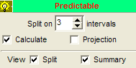
Split on %x intervals option allows specifying the number of independent intervals to use. The greater amount of independent intervals, the more narrow predictable intervals are (however, these intervals are more reliable). Adjust this parameter according to the data length for your analysis.
Calculate: if you do not need to use predicable zones, you can disable this option. The program will then calculate the composites significantly faster.
Projection: if this option is activated, the program uses predictable zones to make projection curves. As an example, here is the projection curve based on Moon phases cycle for crude oil:
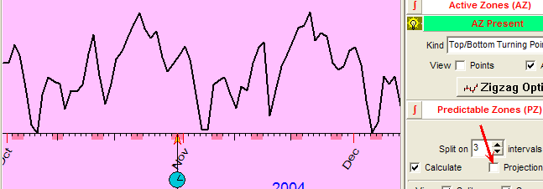
However, as we have mentioned above, the Moon phases give the best forecast around the Full Moon. Check the "Projection" option, and you will get this picture:
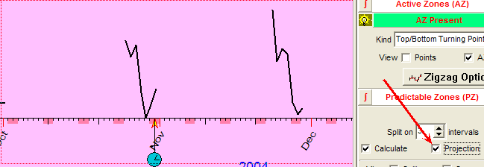
This diagram shows a part of the projection curve around the Full Moon. Other points are simply skipped.
Be careful using this option, especially for the Composite Box (when we combine many cycles). It is very difficult to distinguish between the true price gap and the area within the end of the previous predictable zone and the beginning of the next one.
The predictable zones are displayed in the bottom part of the diagram:
Bright red regions correspond to predictable zones, gray ones - to unpredictable.
Here you can specify what kind of the diagram you would like to see. "Split" allows displaying of the composite diagrams calculated on different independent intervals. "Summary" corresponds to the composite diagram (colored one) calculated for all price points of the optimizing (red) interval.
By the way, when the predictable zone is significant, the program displays this:

Composite Box: Forecast based on Composites
After finishing the analysis of different planetary pairs, you can put them in a special place called the "Composite Box". It is easy to work with the Composite Box. Let's say that, while analyzing some set of data, we have found that the annual cycle is important; save this cycle by clicking on this button: 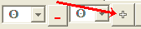. Further research shows that the Moon phase cycle is also important; put this cycle into "Composite Box" as well: .
Now, let us see how these cycles work together, what projection line might be produced by these two cycles. Click on this button: , and you will go to this window:
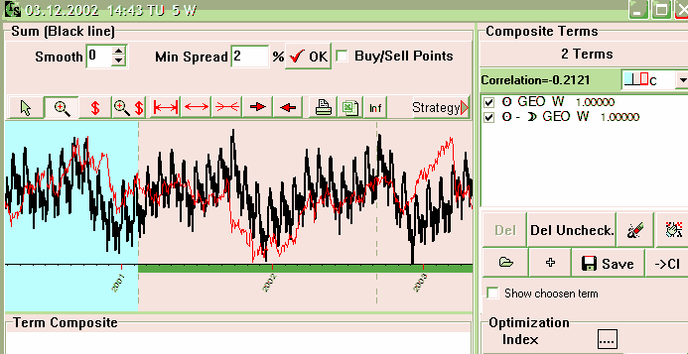
Here the black line is the summary curve - it shows the summary influence of two cycles: the annual cycle and the Moon phase cycle. We can magnify any part of this diagram dragging the mouse. It is also possible to save this model into a file and download it in the future. The program allows to manipulate by composite pairs: delete any term, delete several unchecked terms, clear model (i.e., delete all terms), rate these terms by weights, download/save the model, and put this model into the clipboard ("->Cl" button).
When the model is saved into the clipboard, it is saved in ULE format (the format of Universal Language of Events). After that, the model is available for the process of creating a forecast based on Neural Net (NN) technology. To create the inputs for NN, click on this button: 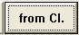(the program will take the model out of the clipboard).
In this window, you can see how the projection curve (a black line) fits the analyzed price index:
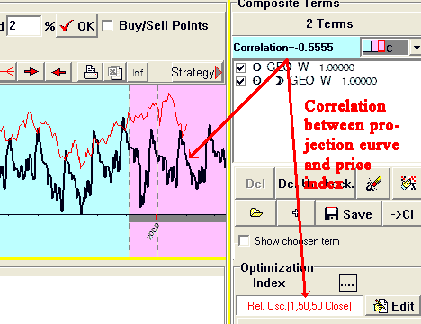
You can specify any index to be used to calculate the correlation (to do it, click on the "Edit" button). Please pay attention to the time interval used to calculate correlation (see details in the section "Definitions" of the documentation).

Composite Report
While working with the users of other programs for stock and commodities market analysis, our experience reveal that sometimes it is difficult (especially for novices) to make a decision as to what cycle is important and what is not important. To make this choice easier, in Timing Solution we provide a special procedure. This procedure allows doing this automatically. The program compares cycles and produces a report that is helpful in making this decision.
Click on the button . You will go to this dialog box:
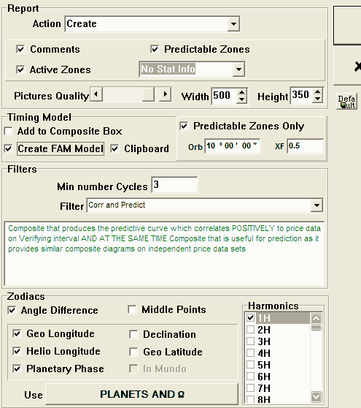
Here, in this window, define parameters of the report.

Report Options:
"Action": Specify here what you would like to do with this report. You can create the report, save it as *.htm file and later put it on the Internet (as an example, onto your web page or e-mail it to your friends/clients), or you can choose to not create any report at all.
"Comments": Check this option if you would like to get our hints about how to use this report better.
"Active Zones" and "Predictable Zones": These options allow you to specify the information regarding these zones. For example, for "Active Zones", it is possible to provide the statistical information.

Timing Model Options: You can use this report as a tool to create forecasting models.
"Add to Composite Box": If you check this option, the program puts the important cycles into the "Composite Box", and the summary curve can be used for forecasting.
"Create FAM model": Allows to convert the model based on planetary cycles to ULE format (*.hyp files) or to put this model into the clipboard (Clipboard option). Later you can use this model as inputs for the Neural Net forecasting model. The technology of creating such a forecast is described in "Timing Solutions" module. (FAM model stands for Floating Angle Model; it is the planetary cycle model converted into ULE format).
Parameters of FAM model These are parameters for the FAM model. First of all, a few words about what actually the FAM model is. Its purpose is to explore the active points of the Zodiac. The "Orb" parameter indicates the thoroughness of this exploration. In other words, if there is/are any active point/s within the orb's limits, the program will use this area as one input for the Neural Net. Thus, if the program chooses 8 composites as the important ones, the number of the NN inputs is more than 500 (550, to be exact; it depends on "Orb" and XF values).
The bigger Orb makes this model's diagram smoother, but some details might be skipped (when it is too smooth). The XF parameter defines the ability of this model to see details: the smaller XF, the more details this model can see. However, the Neural Net will contain more inputs for smaller XF, and it can cause the over-training effect. So, it is necessary to find a balance between the resolution of this model and over-training.
One practical recommendation for creating FAM model: If, while creating the FAM model, you get too many events for the Neural Net (like 2.000 inputs), the Neural Net will be training too long. In this case, we recommend increasing the Orb parameter (for example, make it 15 degrees). Also you can try different Filter criteria (see below).

Filters Options: This is a very important option that allows defining the criterion in regards to the composite cycle (we can specify this cycle as an important or non-important).
"Min Number of Cycles": Here you can specify what composites you take into account. It shows the minimum number of cycles to be analyzed to create a composite, regarding the analyzed data. For example, we analyze the annual cycle; this period should be at least 3 years, otherwise we have not enough information to reveal this cycle.
"Filter"
There are several criteria to estimate the degree of importance for each cycle. These criteria are defined by Filter setting. The program will choose the composites that correspond to the filter. The illustration shows three of them.
1) The first one is used as the default option:.
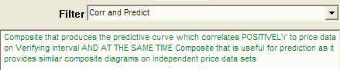
It means that two conditions are applied to the composite:
a) This composite should be predictable; in other words, it should show the same price movement on the independent time interval
AND AT THE SAME TIME
b) This composite should show a positive correlation between the projection curve and normalized price on B interval (a positive correlation means that the projection line fits well to the price line). The correlation between the target (which is the price or price oscillator) and the projection line provided by this composite is calculated on this interval:
2) This filter is based on another criterion:
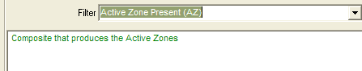
This filter allows us to choose the composites that are produced within Active Zones (AZ) only. In other words, we can choose (for example) the composites that are related to the turning points, and active zones will show some areas where the turning points happen more often. We recommend using these criteria if you create the model to predict turning points. See the explanation for Active Zones (AZ).
3) One more filter:
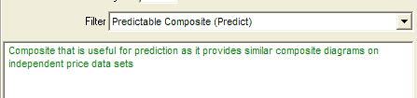
Under these criteria, the program will choose only predictable composites, i.e. those composites that provide the same diagram on different time intervals. See the explanation for Predictable Zones (PZ). In other words, this type of composites means that the planetary pair produces the same effect on the market no matter what time intervals are used.
All other variants are different logical combinations of the variants described above. Like this:
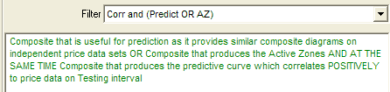

We recommend you to play with different criteria.

Zodiacs: In this section, you can specify the parameters of cycles used for the analysis:
"Angle Difference": The program analyzes composites for planets; when you check this option, it will analyze the composites for the angle between planets as well.
"Middle Points": Check this option to create the composites for middle points.
Also, you can specify different types of Zodiacs and Harmonics.

While producing the calculations, the program "Timing Solution" analyzes hundreds of astronomical cycles and shows you the most important ones. The results of the calculation look like this:
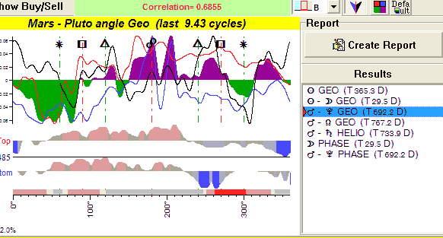
As an example, the program has found 7 important cycles. This is for crude oil data, 1983-2004. This feature of the program saves you a lot of time.

Object Oriented Neural Network (OONN) as a universal Forecasting system

- Basic Idea
- Neural Net at a First Glance: the Japanese Candlestick Model (Price Bar Patterns
- Neural Net at the Second Glance
- Going into Depth
- View Options 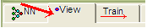
- When to Stop the Training Process
- Training Regime
- Final Optimization

Basic Idea
Generally speaking, the Timing Solution program is based on two concepts. The first one is the idea of ULE, or Universal Language of Events. Another one will be discussed now. It is the Object Oriented Neural Net (or OONN). Both concepts were designed to work together. ULE is the basis in this pair. It is nothing more than a special way of recording different events. In the future, as the users of the program request new types of events for analysis, this part of the program will continue to be developed. This special way of recording was designed in such a manner that the recorded events might serve as the inputs for our specialized Neural Network. Thus, in this duo, ULE and OONN, Neural Net is a second one as it uses the products of ULE.
Therefore, we can suggest this way of working with the program. This simple scheme explains it:
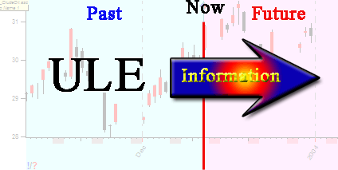
It means that we analyze some process, its past history, define the primary events for this process, and record them with the help of ULE. Then, we put the recorded events into some analytical module (in this case, this will be Neural Net). The module (i.e., Neural Net) does its job and makes its conclusions. Based on these conclusions, we can produce the forecasting model and project it into the future. This simple scheme allows us to solve a wide variety of different forecasting problems.

Neural Net at a First Glance: the Japanese Candlestick Model
Let us create the simplest forecasting model with the help of Neural Net. Let this model be based on the Japanese Candlestick technique (or price bar patterns).
It is quite simple to do that. Download price data of your choice (I did it for crude oil prices, from 1995 to May 2004):
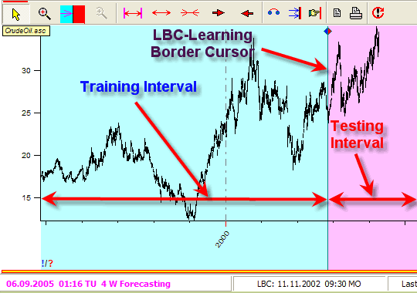
The whole price history is divided into two areas: a blue region and a red region. This division is a must, because we need to have data to train our Neural Net. The training includes the model's optimization (it is produced on the optimizing interval). Sometimes in the literature the training process is called "a learning process" because Neural Net learns the existing relations between the objects within this interval; so, the optimizing interval may be named "the learning interval" as well. These are two names for the same thing.
Therefore, a blue region is a training/optimizing/learning interval. A red region is a totally different area. It is called "a testing interval". Though it is formed as a part of the same data file, its price bars follow up the learning interval and do not belong to it. This is extremely important - otherwise we might always get a very good correlation (it will be explained later) due to future data leaks. It would be the same thing as somebody trying to guess winning numbers whilst actually looking at the file with winning numbers... The testing interval must belong to the same data file and starts exactly at the point where the training (aka learning interval) ends. The exact point between the training and testing intervals is called Learning Border Cursor (LBC).
The testing interval is the first attempt to evaluate the forecasting ability of our model. Our experience has shown that to find a model that fits very well within the learning interval is not really hard. At this stage, it is mostly due to the skills and professionalism of software designers. (It explains why so many products on the market are so good at explaining the past...) The testing interval demonstrates how this model actually works. Only if it fits well on the testing interval, can we apply this model to forecasting.
Actually, it is possible to apply the more complicated scheme and divide the price history in three intervals: 1) training interval - to train Neural Net; 2) validating interval - to stop training when we have a good fitness between the price and the projection line on this interval; 3) testing interval - to test the model's performance. But we use this scheme very seldom as we have other methods to evaluate the model's effectiveness.
There is one more feature in the program that reduces the possibility of mistakes. This feature is called "Back Testing Procedure", and it allows you to verify the model's performance on available data history. Only after that testing, I would recommend to apply the model and its projection line to the real trading.
Let us return to the problem that we have decided to solve; i.e., let us create the forecasting model based on Japanese Candlesticks technique. The main idea we will work with is that the price bar structure now has some impact on a future price. Please look at this picture:
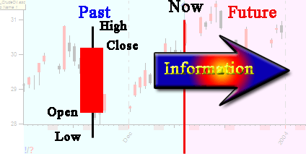
It is the graphic illustration of the idea that the price bar (which represents some relationships between the High, Low, Open and Close prices) has impact on the future price movement. If we could compare things happening on the market to the life process, it would mean that something born under the Sun grows up and some day ceases to exist. It might confront different circumstances, and the outcome of this confrontation depends on the situation. The same idea is applied here: a potential of the price bar defines its future to some extent.
Now, look how this simple idea ("the price bar has impact on the future price") is described by means of Neural Net science:
Neural Net Inputs :The first part of the sentence above (The price bar (which represents the relationships between the High, Low, Open and Close prices...) describes the Inputs of the Neural Net. We mark it as (the information goes into the system, to be analyzed). These are things that we know. The fact that we know them is the reason why we can use them to make a forecast. It is possible to do it because they can be recorded by means of Universal Language of Events (ULE).
Neural Net Outputs :The ending of this sentence (... the future price movement) belongs to Outputs of the Neural Net. We mark it as (some conclusion goes out of the system, based on the analysis and testing provided by the Neural Net). This is what we would like to predict; this is our final target.
Therefore, we have here two types of things: 1) things that go into the system (they always belong to the outer world, are provided by the outer world, and possess some information in respect to this outer world); and 2) things that are going out of the system (these are conclusions made by the Neural Net regarding to the processes in the outer world). The Neural Network is a universal tool (I would say - an incredible tool) that allows the user to find relationships between inputs and outputs; it is the middle part of that same sentence: ("The price bar (which represents the relationships between the High, Low, Open and Close prices) has impact on the future price movement). As inputs, we can use the whole palette provided by Universal Language of Events: it includes astronomical/astrological phenomena, fixed cycles, auto regression models, fundamental parameters, etc. Everything that really can improve the forecasting ability of Timing Solution is included or will be added to the program.
Let us take a look how it works.
Click on this button:. You will get this window:
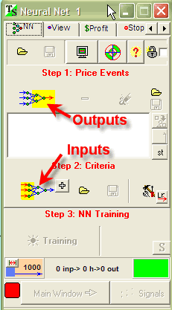
Here two buttons are presented. They serve as tools to define Inputs and Outputs.
Click on the button that corresponds to "Outputs": . You will get this window:
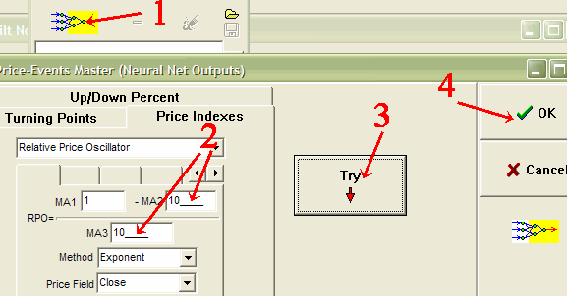
Here you can define the events that you actually want to predict. In our example, we define here price events. The program allows creating models that will produce forecasts for Close itself, or MACD, or RSI, or Volatility, or Top/Bottom turning points (calculated through zigzag). This window is described in details in the chapter "Object Oriented Neural Network - Outputs". In the example, we will try to create a forecast for the oscillator calculated as: (Close-MA(Close,Period=10))/MA(Close,Period=10).
In the formula, MA is the moving average. We choose this oscillator because it works with relative price changes. This is especially important when we have long price data history.
Set these parameters (see the fields pointed by the arrow "2"), click on the "Try" button (3) and then click OK (4). The oscillator is created:
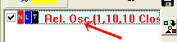
So, outputs are defined. (Remember that we will look for "future price movements", in other words - direction changes). Now, define the events that will be used for making a forecast - Inputs. Click on the button. You will get this window:
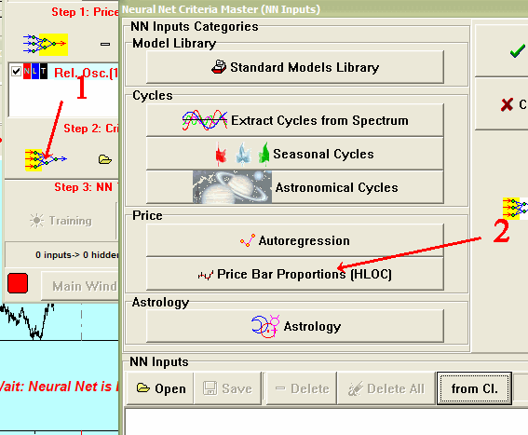
Here you can see the set of buttons that corresponds to different categories of events available for making a forecasting model. These categories are building blocks of ULE (Universal Language of Events).
You have two options here:
- You can use the standard events library (all of these models are created as the result of our thorough research); or
- You can create your own model.
If you select the second option, there are three major groups of events available:
- Cycles (or fixed cycles) - including cycles extracted through the Spectrum module of the program; seasonal cycles; and many different astronomical cycles;
- Price events (yes, there are events in respect to the price!) - price events are combined into 2 groups due to a mode of their recording: 1) auto regression and 2) price bar proportions as in Japanese Candlesticks;
- Different Astrological Events.
For our example, we are more interested in "Price Bar Proportions". This is the window you will get when you click that button:
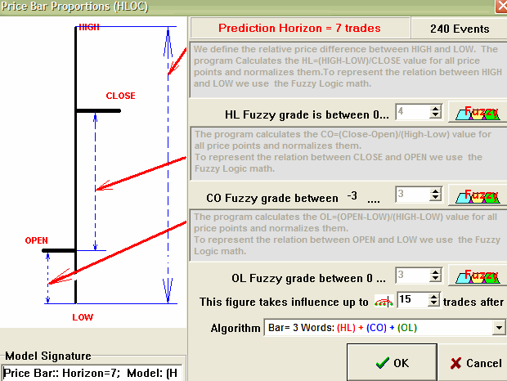
Just click the "OK" button for now. Later we can play with different parameters for this model (or, better, we will use the Back Testing procedure to find the best model).
When all these things are done properly, the Neural Net is ready to do its job. It knows what to predict (outputs) and what information to use for making a prediction (inputs). Let's ask it to begin the process of training/learning/optimization. Click on this button:
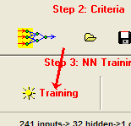
After 4.000-5.000 steps (it takes a minute), click the "Stop" button. We will look at the main screen:
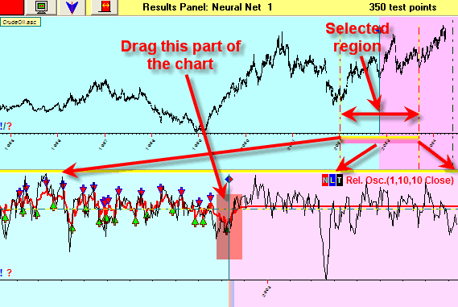
This is the Neural Net Information Panel. The upper part represents the price chart for all available data. The bottom shows any selected part of the upper diagram in more details. All you need to do is just drag the mouse in the area you would like to see. For the picture above, the area around Learning Border Cursor (LBC) was selected:
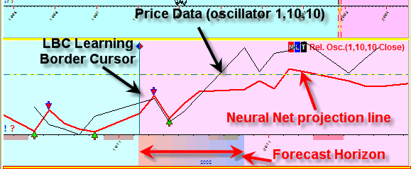
The black curved line represents the Price Oscillator (this is what we want to predict). Sometimes we call it "target". The red curved line is the projection line calculated by Neural Net.
The part in the red region is the real forecast. We do not use the price bars from the red interval while training the Neural Net; this helps to exclude any "information leaks". The LBC sets the border between the past and the future, Neural Net knows nothing what is happening after LBC. This is the main idea for the Back Testing procedure.
Looking at the diagram, we can tell that this model gives rather good results for several bars after LBC (this area is marked by the yellow oval). The black (price) and red (NN results, i.e. forecast) lines correspond well - as our purpose was to find "future price movements"; the change of the direction coincides well.
This particular model produces a forecast only for a week ahead, and this is its maximum. It is because we choose to create such a model - we set this parameter as:
. So, the program makes a forecast for a week ahead after LBC (2 trades per day). This zone is called
Forecast Horizon and is displayed on the diagram as a colored bar: 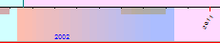.. We can only use this forecasting model inside the prediction horizon. The area outside of the prediction horizon is not trustworthy.
Colors. Look at the information string in the right top corner of the window: . There are colored bars that represent colors used in the displayed chart:
- The first Bar with "N" button represents the color for Neural Net projection line, in our example it is the red line;
- The second Bar with "L" displays the color for the projection line produced by the model based on Linear approach (it is not relevant for the module we are discussing now - Neural Net);
- The third Bar with "T" (Target) represents the color to display the output/target (what we want to predict). In our example, this is a black line.
Define Colors You can define colors yourself. Click on this button in NN window:
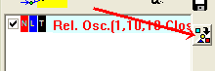
In the displayed window, define colors that you like by clicking on the appropriate button:
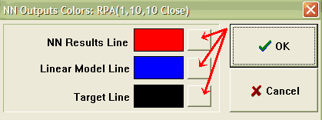
This is especially important if you use several different outputs like: Price Oscillator + RSI +Volatility. In this case, it would be better to display these indices separately by unchecking the options:
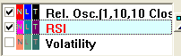
Thus, the Neural Net model has been created. We can finalize this process sending the projection line into Main Window. To do that, perform this set of operations:
1) Click on this button: . The projection line produced by this Neural Net model will appear in the Main Window of the program.
2) Click on this button,, to disable the Results Panel and make visible the Main Window.
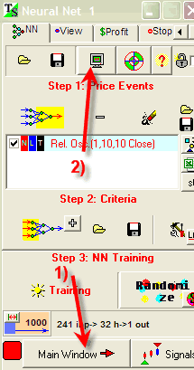
Now in the Main Window you can see Panels devoted to the created Neural Net model:
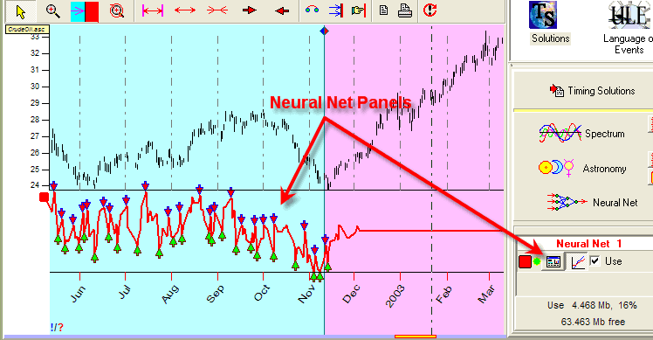
You can create as many Neural Net models as you need. The new panels will be added to the Main Screen. As an example I have created the Spectrum model that uses fixed cycles to make forecast. Now there are two Neural Net panels in the Main Screen:
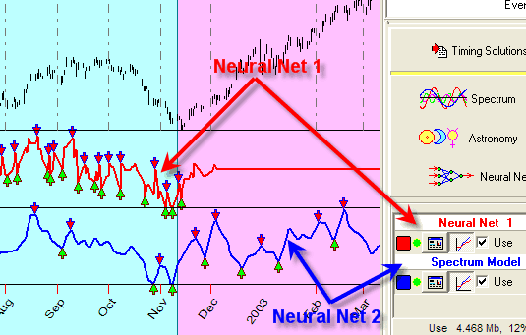
You can draw any projection line together with the price chart:
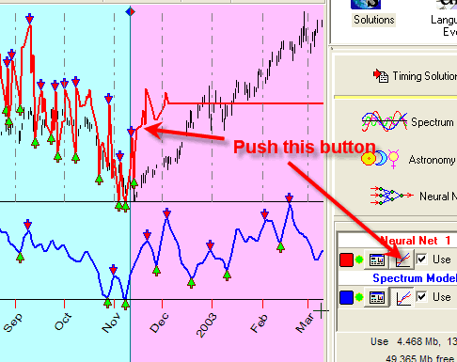

Neural Net at the Second Glance
When a Neural Net model is created and its performance is of an acceptable standard, you can save this model. Click on this button:
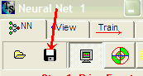
The window will appear. It is the form for storing the valuable information related to this Neural Net model:
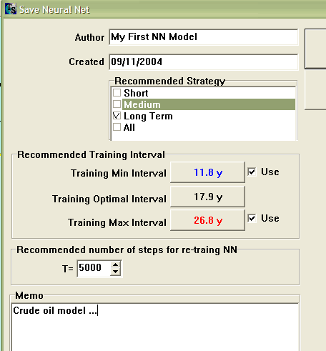
Type the author's name, the date when the model has been created, the recommended strategy (i.e., data length preferable for this model), the length of training interval (in other words, define how many price points are necessary to train this model), and the number of training steps that are necessary to re-train the Neural Net when new price points are added. You can record your own comments regarding this model. All these facts about the model will be saved.
Later, you can use this model whenever you like. To download the previously created Neural Net model, click on this button:
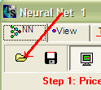
The window will show up with the list of all available NN models saved previously. Choose any record. The relevant information will be displayed:
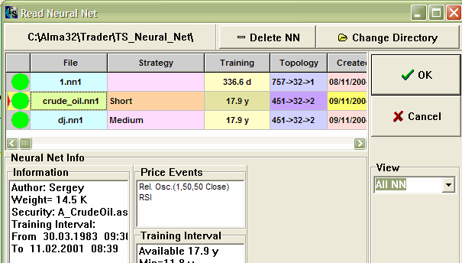
The button (see the small window above the download and save buttons) allows you to enable/disable the Neural Net Results Panel.

Going Into Depth
The following is a description of other useful features available through the Neural Net window:
Back Testing Module. The main purpose of this module is to provide the procedure of finding the best model for the chosen price data. It is described in the chapter "Back Testing".
Locking the Neural Net. If this option is checked, all attempts to change anything in the Neural Net model will be blocked. You will still be able to train the NN feeding it with the new data, but you will not be able to change anything in NN configuration (you can not change the inputs, outputs and Neural Net topology). Use this option when you find the appropriate Neural Net model and are not planning any changes. You will simply re-train it when additional price bars come available.

Buttons related to Outputs
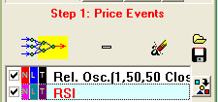
The process of producing the outputs is described in the chapter "Object Oriented Neural Network - Outputs". The following buttons are designed for manipulating the outputs:
- Delete any chosen output from the list. As an example, in a small window above, we delete RSI index from the output list;
- Delete all outputs from the list;
- Read/save the outputs’ list in a separate file. For example, if you work with your own price indices, save them into a special file and use these outputs for another Neural Net model.
Buttons related to Inputs: 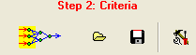
The process of creation of the inputs is described in the chapter "Object Oriented Neural Network - Inputs". The following buttons are designed for manipulating the inputs:
- Open or save inputs into a separate file.
Neural Net Options Any time you click on this button, the window will appear to set the parameters for Neural Net:

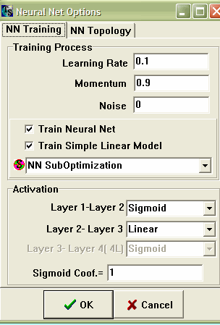
We do not recommend changing these parameters without our advice. In this case, please send us e-mail: tarassov@rogers.com
Just for your information, here is the description of these parameters:
Learning Rate - this is the speed of the optimization process. The smaller speed makes the process smoother though slower. The bigger value speeds up the optimization process, though sometimes it might lead to a jumping effect and, finally, to chaotic behavior.
Momentum, Noise - we do not recommend changing these parameters.
Train Neural Net/Simple Linear Model - the program is able to work with these two models at the same time: the model with a Neural Net approach and a simple linear model. By displaying two projection lines together, we can understand the level of non-linearity for the price data that we analyze.
We recommend keeping this option as it is. It runs the special procedure of sub optimization that improves the quality of the projection line.
Activation we recommend keeping these parameters as they are. The only thing you might try is to use Sigmoid-Linear for Layer 1-Layer 2 activation function.
Number of Hidden Units This parameter can change the quality of Neural Net projection line:
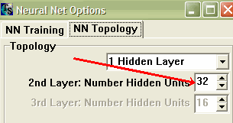
We recommend playing with this number only after the appropriate inputs and outputs are found. For example, we have found the Neural Net model that operates with Price Bar Proportions events as inputs and produces a projection line for some oscillator (it is the output); this Neural Net model gives a good projection line. Only after that, on the final stage, we can vary the Number of Hidden Units parameter, using the Back Testing procedure as a tool.

View Options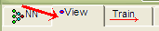
This tab allows you to change the view of the Neural Net Information Panel:
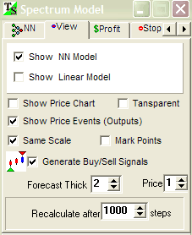
Show NN Model - enable/disable a Neural Net projection line;
Show Linear Model - enable/disable a simple linear projection line (i.e., a projection line produced under Linear approach);
Show Price Chart - display the price chart in the Neural Net Information Panel;
Show Price Events (Outputs)- enable/disable the price events/outputs/target;
Transparent - makes this window transparent;
Generate Buy/Sell Signals - generates Buy/Sell signals regarding the Neural Net projection line. The tab allows to set parameters for these signals.
Same Scale - display all lines in the same scale. Sometimes, especially in the beginning of the learning process, the projection line looks almost like a straight line. In this case, it is better to disable this option.
Also, you are able to set the thickness of the displayed lines.
The program re-draws the projection curve after every 1000 training steps. For huge models (with thousands of inputs), the process of recalculation may take some valuable time. In this case, we recommend increasing this value.

When to Stop the Training Process
Usually, when we train the Neural Net, we watch the Neural Net Information Panel. This way we can see how well the projection line fits the price data. To stop the process of training, click on this button:
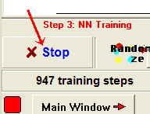
When to click on this button or what is the "Stop Point"? It depends strongly on inputs/outputs and the price data we analyze. There is no rule yet in regards to the "Stop Point". What we can do now is to estimate this "Stop Point" for any particular stock and for the Neural Net model applied. Based on our research, here are general recommendations when to stop the training process:
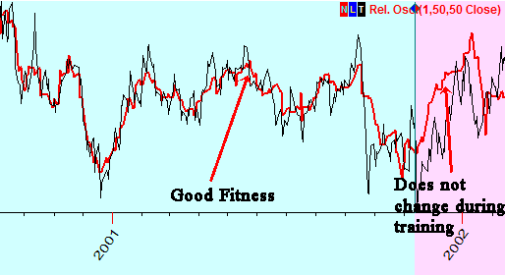
Click on the "Stop" button if these two conditions are met:
1) You observe the good fitness between a projection line (the red one in our example) and price data (the black line) within the training interval (blue area);
2) While on training, the projection line does not change much on the testing interval (red area).
You can use the Stop criteria as well. Open the Stop tab; check out the option "Stop when":
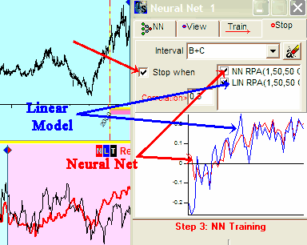
The program calculates the correlation between the price data (target/price index) and the Neural Net projection line (red line) and also the correlation between price data and a simple linear model (blue line). (The explanation regarding the correlation coefficient is in "Definitions".) The diagram above shows how these correlation coefficients change during the training process. When the Neural Net Model OR Linear Model reaches , the program automatically stops the training process. To calculate the correlation, we use this .
To analyze the Neural Net only, uncheck the linear model: 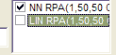. In this case the program will calculate the correlation for Neural Net model only.

Training Regime
Open "Train" tab. Here we deal with the price points of the training interval treating them according to their relevance to the analyzed data samples. We can use either all available data, or part of it. Our options are: to pick price points manually, use price points closer to LBC, and use the closest to LBC points as they are distributed linearly.
Click on this button: or for faster access to this window use this button:
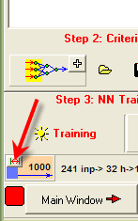
There are 3 tabs there that correspond to different regimes of optimization. Let's look at each of them.

Use all price bars
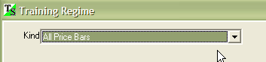
In this case, the program takes for analysis all price bars from the training interval (all price bars prior LBC)

Use last %x price bars
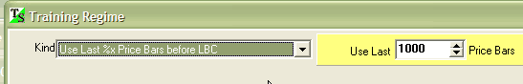
In this case, no matter how many price bars are in your data file, the program will use the last 1000 price bars prior to the Learning Border Cursor (LBC) to train the Neural Net. When you do this, all of the price history prior to these 1000 bars is of no use. We provide this option because we know the examples when similar conditions lead to different results in the market. It is especially true for long data files that cover many years of price history data. The best assumption for such cases is that it is probable that new factors come on the stage that change the impact of previously involved factors. It is the reason why we choose price bars closer to the LBC.
Note: "%x" means a number (amount) of price bars.
Use last %x Linear Distributed points
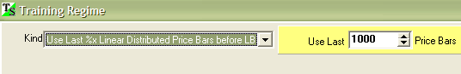
This is another variation of the second method. Under this condition, the program uses the last 1000 price bars (prior to the LBC) to train the Neural Net, but "sees" these bars as linear distributed: price bars that are closer to the LBC are used more intensively than the price bars farther away from the LBC. It is the way to tell the Neural Net that the latest price bars are more important in creating the forecasting model.
Multiframe training
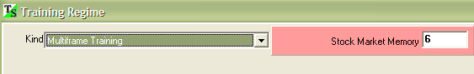
This method of training comes from multiframe technology. The training period here depends on used events. Let say that we would like to create the Neural Network that applies fixed cycles to making the forecast model. As inputs for this Neural Network, the program uses 10 days and 50 days cycle. In this case, each Neural Net input will be trained individually. To train the inputs that correspond to 10 days cycle, it will use 10*6=60 price bars; to train 50 days cycle, 50*6=300 price bars are necessary. The coefficient "Stock Market Memory" is nothing more than just a proportion between the training interval and the cycle's period.

Manual Regime
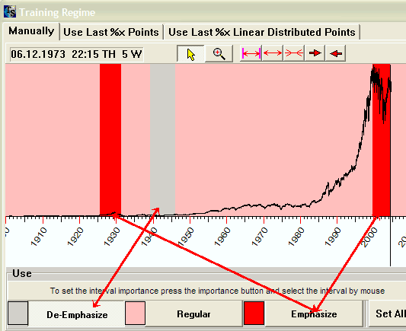
It is the first of the tabs, "Manually". Here you can select manually the intervals that are more or less important for Neural Net training. Look at the example above. We analyzed the Dow Jones Industrial, 1900-2004.
Let assume that those intervals around the Great Depression and also the last 4 years (2000-2004) are important. We can "tell" this to the Neural Net. How? It is simple; click on the "Emphasize" button and select these two intervals by dragging the mouse. Thus, we have decided that these periods are very important for the American economy and have informed the Neural Net about this fact. The program will train the Neural Net using all price points from the training interval and at the same time it gives special attention to these two selected intervals. We can do the opposite: "De-Emphasize" the intervals that we do not want to include into consideration for any reason. For example, we might decide that within the time interval that covers World War II the American economy was directed by some other rules (the war might be seen as forth-major period). In this case, we recommend de-emphasizing this time interval. The program will look at the whole data range, but it will exclude de-emphasized periods from its consideration. While being trained, the program will use emphasized intervals more intensively and not use at all de-emphasized intervals.
There is no theory behind such a consideration; it is just an example how these buttons might be applied. It is you who decide what data periods are important (relevant) to your research.

Final Optimization
Final optimization is the process when we use ALL available price bars to produce the projection line. In this case, the Learning Border Cursor should be set to Last Price Bar (click on this icon ). After that, train the Neural Net once again (i.e., repeat the process of training).

Object Oriented Neural Network - Inputs
Any forecasting model is based on some assumption. The assumption is made in regards to events of any nature: auto regression, fixed cycles, supporting lines, astronomical parameters - anything. The only thing that must be presented is the connection between these events and the process that is analyzed. We can call the assumption a hypothesis. If methods of testing prove that this hypothesis is true under certain conditions, it means that the supposed connection between the events and the analyzed process really exists. Thus, we can use the basic assumption as the model to forecast future happenings of the same process.
Therefore, in forecasting these things are important: 1) at least, two different types of events (A and B); 2) the existing connection between these events. If we know that some connection takes place, we can always predict what will happen to B if this and that happens to A. This is a core idea of any forecasting. And the forecasting model is the connection between two types of events.
Why do we apply Neural Network to create forecasting models? The main reason is that many processes we deal with in our lives still have no adequate theoretical explanation. In this situation, all we can do is to make assumptions and test them; in other words, we need to find the connection between different types of events. This is exactly what any Neural Network does: it takes some initial information (we may call it inputs) and compares it to some other facts (we call them outputs) trying to find the connection between the two. The Timing Solution's Neural Net is of a special kind: we use events as inputs, not numbers as in a classical Neural Net. Because of that, this Neural Net is named "Object Oriented Neural Network" as events are the objects of our interest.
The creation of such a Neural Network became possible due to our original idea of creating the Universal Language of Events. This is a special way of recording the events when the main things that describe the event are arranged in a special manner. This unique way of recording has made possible the usage these events in the research process.
Let's look at the details of how the Object Oriented Neural Net works.
We start with inputs.
When you click this button: , the window will appear:
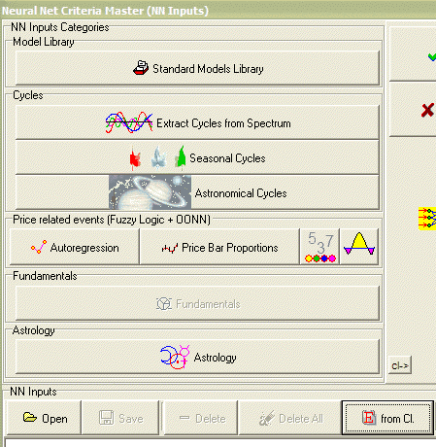
The buttons in this window correspond to different categories of events that may be used to create a forecasting model.
Let's look at each of them.

Standard Models Library
The "Standard Models Library" button allows downloading the models created previously:
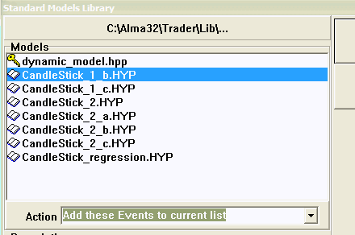
If any model is marked this way: , it means that this is a protected model. You can use this model, but you cannot edit it. This is done to protect our interests as such models are developed by our team and will remain our intellectual property. We test these models on all available data and plan to continue this job into the future.

Extract Cycles from Spectrum
Click on this button: 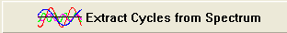. You will run the Spectrum module that extracts the most important fixed cycles and converts them into ULE format. (ULE stands for "Universal Language of Events".)
You will get this window:
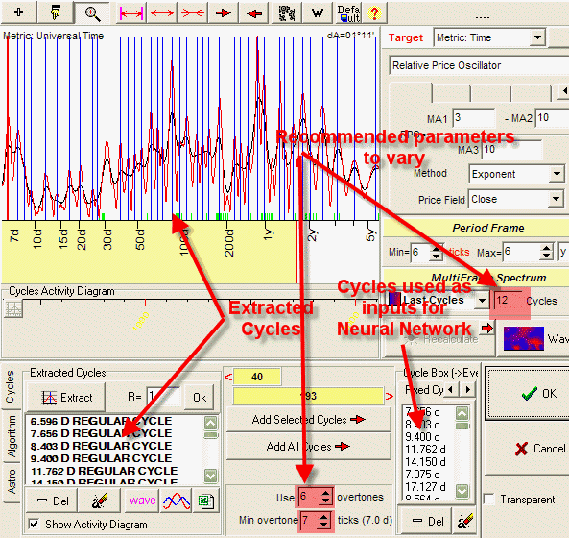
By default, the program has extracted important cycles (see the left list) and has put these cycles and their overtones into "Cycles Box" (the right list). This procedure may be conducted manually as well. In the program, any combination of cycles can be extracted: all cycles or, for example, only "good" ones. Look at these two illustrations:
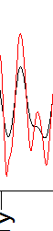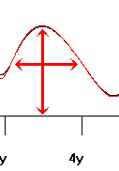
The first cycle is a "good" one, while the second is not so good; it should be higher and as narrow as possible.
So, if you decide to pick up cycles manually, do this:
- Click on the "Clear" button to clear the cycle's list:
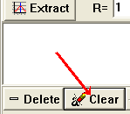
- Click on the "+" button:
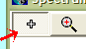
- To pick any cycle, just click the mouse around the peak that corresponds to this cycle:
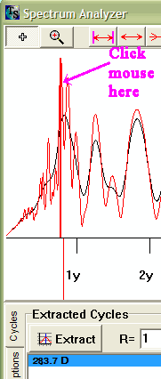
- When you pick up all cycles you want to use in the Neural Net model, click on the "Add All Cycles" button:
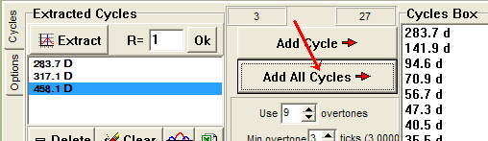
Thus, you put all these cycles and their overtones into the "Cycle Box". More info about the Spectrum module can be found in the chapter "Spectrum Module".

Seasonal Cycles
This button allows you to use different seasonal cycles for Neural Net modeling.
In the appeared window, define what cycles you would like to use:
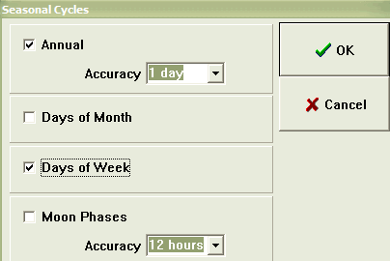

Astronomical Cycles
The button opens the block of the program based on the idea that astronomical cycles (i.e., planetary positions and angles between planets) have some impact on the stock and commodity market.
There is nothing mystic in this assumption, it is just math - pure math. We simply consider the planetary positions and angles between planets as additional inputs for Neural Net.
Why do we use the astronomical cycles? The most appealing feature of these cycles is the presence of irregularity. These cycles are very hard to reveal by regular spectrum.
Here is the window to set parameters for the astronomical model:
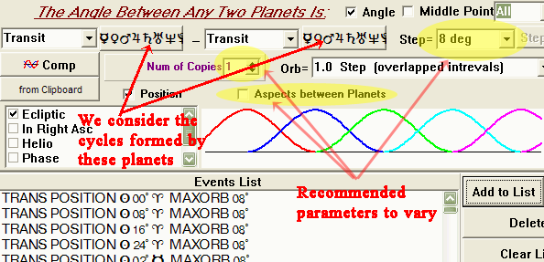
Here you should set the planets that form these cycles. (Note: the symbols on the button are symbols of planets. When you click on each, you will see the actual names of the planets. So, it is not a necessity to learn the astro symbols, at least, for now. To understand the meaning of some special terms shown in this window, see Glossary).
Do not bother yourself with a question of the correspondence of the available price history data to the periods of involved cycles. The program adjusts them automatically, while preprocessing inputs (i.e., while preparing inputs for the Neural Net analysis).
The Step parameter deals with the resolution of this model. You can play with it. Please be aware that you may find the over-training effect if this parameter is too small. The most typical values are 8, 12, 15 degrees.
Aspects between planets - This module works in two modes: we can use cycles due to planetary positions or due to the angle (aspect) between planets. See Glossary for more information on aspects and planetary positions.
Num Copies - (stands for Number of copies) sometimes we get better results when we use several copies of the same event. This feature is possible due to sub-optimization procedure (which means that during the training process each input event is optimized in a special way).
By default, we use here Floating Angle Model (proposed and developed by our team).

Auto regression Model (Fuzzy+OONN)
This button allows you to create the auto regression forecasting model.
This model is based on the idea that today's price is a function of the price yesterday, two days ago, three days ago, etc.
As the simplest variant of regression model is the linear regression (sometimes known as maximum entropy model), it states:
Price today = A1 x Price yesterday + A2 x Price two days ago + ....
Timing Solution provides an absolutely new approach to auto regression modeling. First of all, we apply the Fuzzy Logic math to the process of modeling. Plus our Object Oriented Neural Net provides a special optimization procedure (called sub-optimization) that increases the accuracy of this model and diminishes a possible over-training effect.
The Back Testing of this model definitely shows that this approach increases its forecasting ability.
Look at the window to set parameters for auto regression:
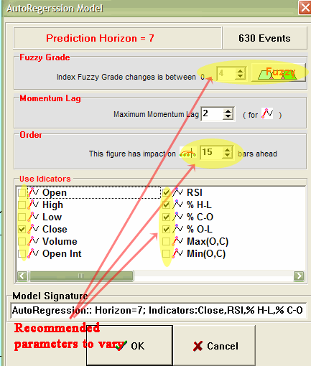
On the bottom, there is the list of indicators that you can use for auto regression model. Therefore, to create an auto regression model, you need to choose the participating indicators.
These are the parameters of auto regression model:
- - The number of grade levels; it is used in the fuzzification procedure. To avoid over-training, do not use big values.
- - This parameter is necessary for indicators that might have a trend component. For such indicators (for example, Open, High, Low, Close - they all are marked with this sign: ), we do not use the value itself but its rate of changes (as an example (Close-Close(lag days ago))/Close). Thus we exclude the trend component.
- 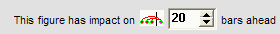- This parameter (auto regression order) shows how long any price movement impact lasts in the future.
This parameter is connected to another parameter, . This parameter shows the time frame (after LBC) where the forecast based on this model works.
On the screen, it looks like a colored bar:
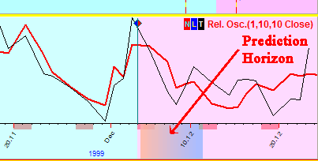
We recommend playing with different settings:
- First of all with all involved indices;
- Fuzzy grade (for example, =3);
- Auto regression Order (for example, =20 => Forecasting Horizon=10 bars)

Price Bar Proportions Model (Fuzzy Logic+OONN)
This model is based on the idea that the proportions of the price bar have an impact on future price movements. This model has the same advantages as the auto regression model (i.e., Fuzzy Logic + Object Oriented Neural Network).
Click on this button: . You will get the window to set the parameters for Price Bar Proportions model:
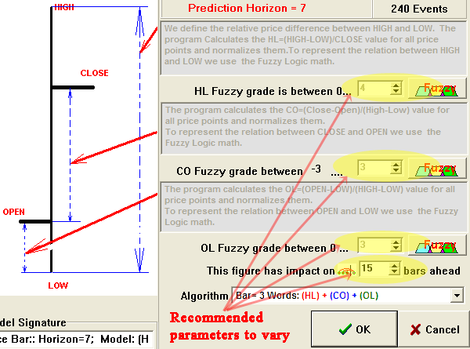
The information on each parameter is provided in this window. You can play with all optional parameters.

Astrology
If your version of Timing Solution has the astrology tools, use them as regular inputs for the Neural Net. To do this, click this button: :
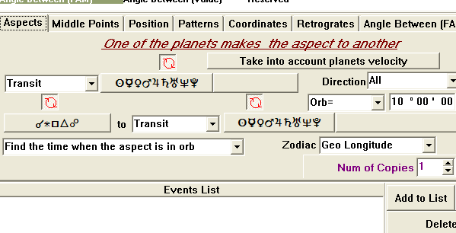
There are many different tabs in this window. They correspond to different categories of astrological events (planets in Zodiac, Aspects, etc.). We plan to start a special course on financial astrology (it will be advertised). For now, just choose the category to be used and click on "Add to List" button.

Object Oriented Neural Network - Outputs

"Output" is what we want to (and can) predict.
When you click on this button: , you will get this window:
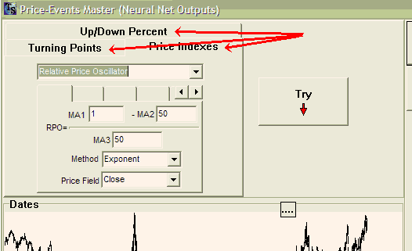
The different tabs in the upper part correspond to different categories of price events we can forecast. Let us look at these events closer.

Price Indicators
This is the most used feature. Here you can set different price indicators as the outputs for the Neural Net.
You can create the oscillator index this way: choose the appropriate item and click on the "Try" button:
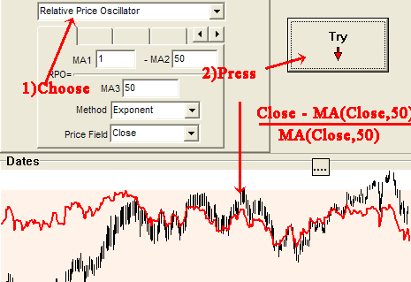
Or you can make the Relative Strength Index as the output:
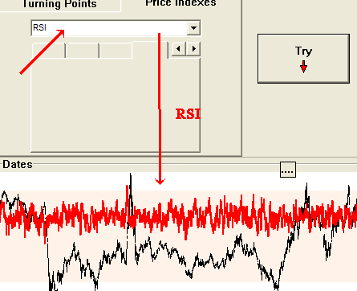
Volatility Index:
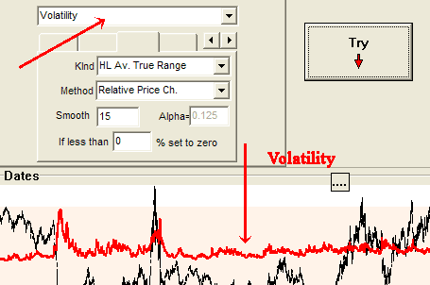

The "Standard" tab provides different indicators to choose from. As an example, I have chosen the true range (relative):
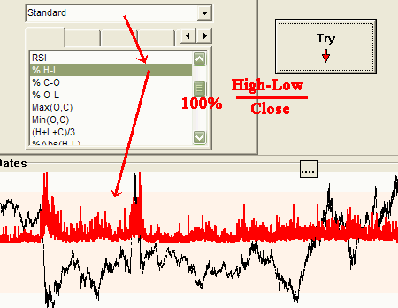
After your choice is made, click the "OK" button:
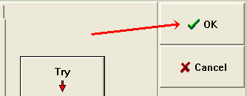
Now your chosen indicator is included as the output for the Neural Net:
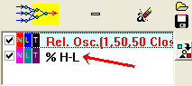
The program is not limited to one type of output at a time. It can produce the forecast for several different outputs at the same time. For example, it is possible to create a Neural Net model that makes the projection line for the chosen Oscillator and the Average True Range simultaneously. Here it is:
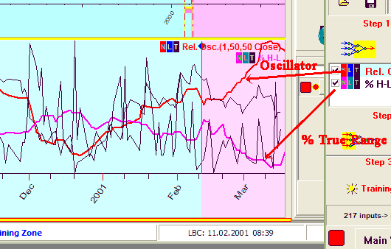
You can see two projection lines displayed: one for the Oscillator and another one for the True Range. This is a very useful feature as it allows using the maximum of the information regarding price behavior. You should not be concerned about the normalization (which is necessary for the Neural Net model) - Timing Solution does it automatically.

Strong Up/Down
This is another type of price events. In the "Price-Events Master", open the "Up/Down" tab:
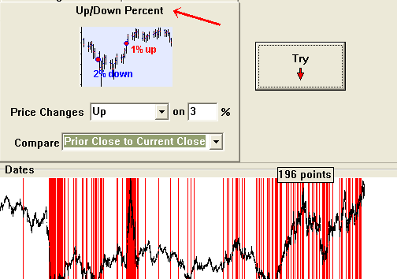
Set the minimum value of price changes and click on "Try" button.
If you create the output this way (as it is shown in the diagram), the Neural Net will predict the strong upward points. In this case, the Neural Net projection line looks like this:
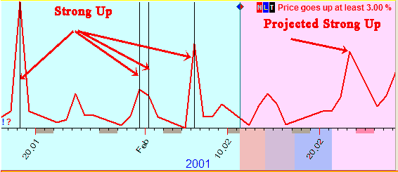
The black vertical lines correspond to the moments when the price goes up more than for 3%. The red line is the Neural Net projection line, the higher this line goes, the strong upward price movement will be more probable.

Top/Bottom Turning Points
The main idea of this type of price events is: focus on turning points and ignore what is going on between them (i.e. tops and bottoms of the price diagram only). To do this, the program creates Zigzag (Filtered Wave) to specify top/bottom turning points; we will try to predict the location of these turning points in the future. It works this way:
Choose the "Turning Points" tab:
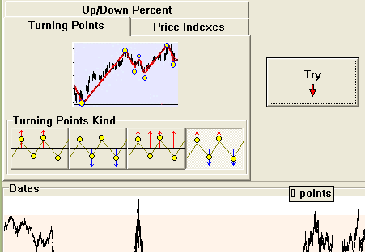
Click on "Try" button; you will get the window for setting up "Zigzag" wave parameters:
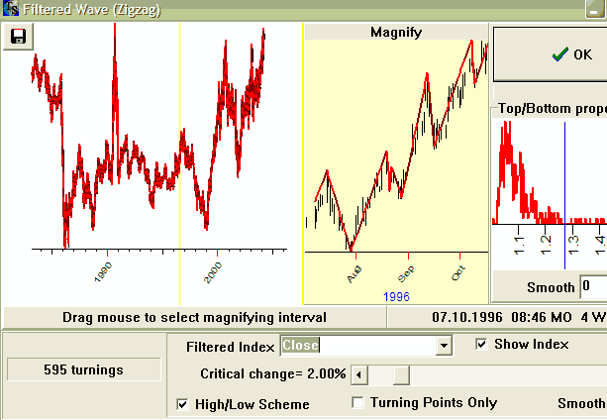
The higher the projection curve is, the higher is the probability for TOP turning pints; the lower the projection curve is, the higher is the probability for BOTTOM turning points.

Timing Solution Worksheet
Suppose you conduct the analysis of some financial instrument, i.e. you have created several models. For example, you have created four models: ULE model, Composite Model, Fibonacci Charting tool and Neural Network model. They all are shown here:

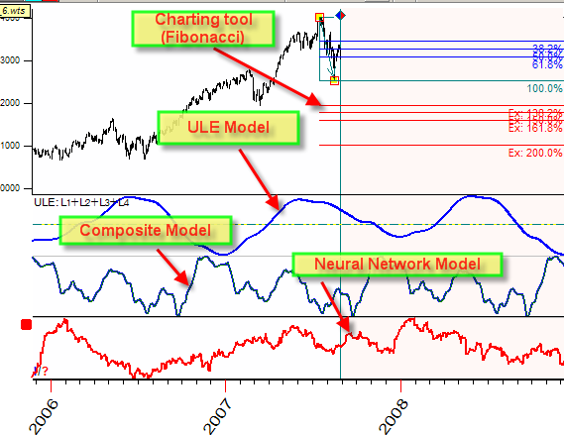

Now you need to save all this somewhere, to be able to continue your work some other day. In order to do this, we recommend using the Timing Solution Worksheet. These are buttons you need:

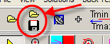

Clicking , you will get this dialog box:

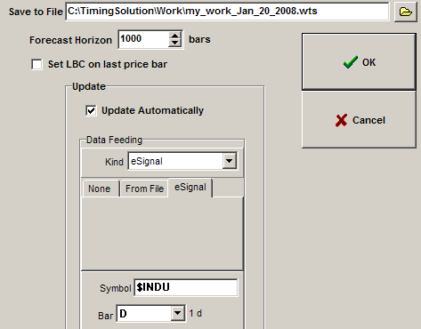

The meaning of these options is pretty obvious. You define here:
- The name of the file where you save your work;
- Amount of bars you want to forecast (Forecast Horizon);
- You can set the LBC on the last price bar automatically (if you concentrate on making the final forecast that uses all available price history)
- If you have some data feeding system to update your price history (like regularly updated text/Metastock/CSI files or eSignal software), you can use “Update” feature.
Next time when you run Timing Solution, you can restore your previous work clicking this button.

One more note regarding the worksheet is: when you save the composite models (“Astronomy” button) into the worksheet, remember that you need to have at least one cycle in the composite box. You can put any cycle into the composite box clicking this button:

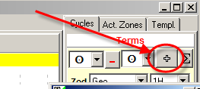

If there are no cycles in the composite box, the program understands it as no Astro cycle has been chosen, so it does not save any composites into the worksheet (a composite without a cycle has no sense for the program).

Timing Solution Styles

  - Basic Idea
  - Spectrum Model Style
  - Astronomical Model Style
  - Neural Net Style

Basic Idea
When you run any ready solution (like astronomical or Spectrum based fast solution:
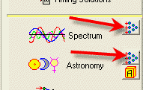),
the program provides a huge work extracting astronomical or fixed cycles and running Neural Net to produce the projection line based on these cycles. Each of these modules contains many parameters you may vary. By default, we set the most typical parameters, but each financial instrument has its own habit that is described by these parameters. To make the users life easier, we put all the most influential parameters in one place, so you can quickly modify the projection line changing these parameters. This is the main idea of Timing Solution Styles. We can store the most important parameters together, save/download them, and make the projection line. The most important parameters for each module are combined into styles - modes related to models' performance in time. You can find the description of each style right in the program.
Run "Timing Solutions" or "Fast Solutions". You will see this button: . It allows editing Styles:
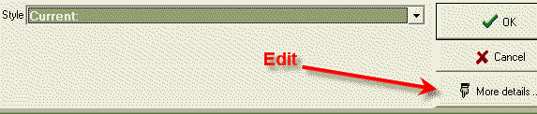
You can choose one of the standard Styles or edit it manually clicking "More details" button.
Let discuss the groups of parameters for each module of the program in detail.

Spectrum Model Style
We begin with parameters for Spectrum based models:
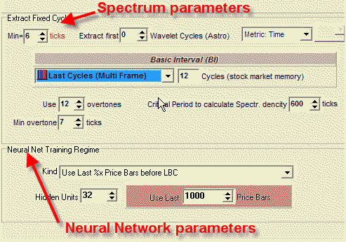
There are two groups of parameters in this window: the first group belongs to the Spectrum module itself; these parameters describe the method of extracting fixed cycles. The second group combines parameters for Neural Net module that produces the projection line based on the cycles extracted through Spectrum module.
As a method of extracting fixed cycles, we would recommend to use Multiframe Spectrum algorithm:
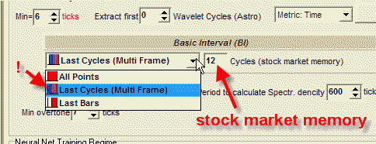
Definitely, the cycles extracted through Multiframe Spectrum describe the market movements better. This fact is quite obvious: if you compare the effect of 7 days cycle (as in the example), it works now in a different way than it has been working 20 years ago; however, it has its impact on price in both cases.
One more benefit of using the Multiframe Spectrum is that it handles nonlinear effects in the markets much better than the regular Spectrum, and this is very important. I believe that any fixed cycle has its own "life time"; this cycle impacts the stock market during a certain period, then the cycle disappears or interacts with other cycles in a nonlinear manner.
This parameter corresponds to the cycle's "life time", we would call this parameter as stock market memory (or, abbreviating, sm) in respect to the fixed cycles. Thus we define how long the stock market "remembers" and "recognizes" the certain cycle. This is the parameter of extreme importance.
Other important parameters for Spectrum module are:
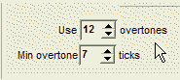
The amount of overtones shows how many overtones are used for each cycle extracted through Spectrum. For example, if we have found that 100 days cycle is important and decided to use 5 overtones, it means that we actually work with the following cycles: 100 days cycle, 50days cycle (2nd overtone), 30.333 days cycle (3rd overtone), 25 days and 20 days cycles (4th and 5th overtones accordingly).
Let's consider 11.7 years wave for monthly Dow Jones index. The pure 11.7 sinus wave looks:
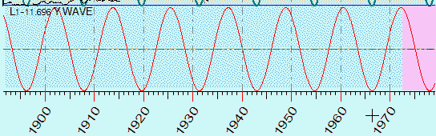
If we would like to enrich this wave, we can take into account 12 overtones, and the wave will look like this:
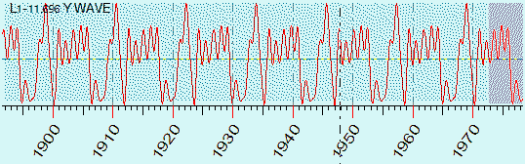
Min overtone parameter allows excluding short-term cycles. This parameter diminishes the short-term noise.
So, these parameters are recommended to vary:
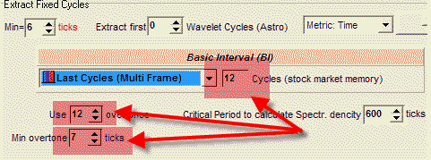

Astronomical Model Style
You can play with astronomy based parameters here, in this window:
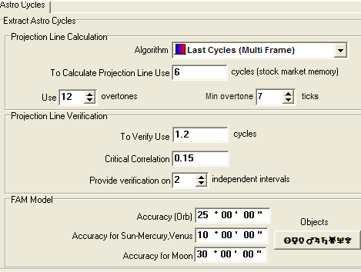
Let's consider how the program finds the most important astronomical cycle. As an example, let us take the Sun cycle (annual cycle). First of all, the program creates the projection line based on the Sun position. To calculate this projection line, we use 6 Sun cycles, or 6 years of price history: . This parameter has exactly the same meaning as the stock market memory in Spectrum module. The amount of overtones and min. overtone has the same meaning as in Spectrum as well.
Next step is to verify the projection line. The program does it itself - it analyses how well the projection line based on the Sun position is able to forecast the stock market. The program creates the projection line for several cycles ahead. You define the number of these cycles here: ahead.
In other words, when you choose "1.2", the program creates the forecast for 1.2 years ahead and calculates the correlation between the actual price and the projection line. The program performs this procedure as many times as you set it up here: . This number may start with "1" - it means that only one interval is used for verification, and it is important to know that this interval is NOT the same as the training interval - to avoid information leaks. You may use as many INDEPENDENT intervals as you like; and always the program will calculate the correlation on the intervals that do not coincide or interfere with the training interval.
Astronomical cycles as opposed to Spectrum extracted cycles (based on some periodicity that can be expressed as a formula) reflect the actual planetary movements. We consider an astronomical cycle as an important one if the projection line based on this cycle provides the good fitness to the real price movement. We use this parameter to evaluate the fitness of this projection line. If the correlation calculated on verified interval/intervals is higher than the critical value we consider this astronomical cycle as important.
The FAM Model parameters define the orbs for astronomical cycles. The lesser the orb, the more details this model is able to "see", though the noise level for this model is higher.
Astronomical cycles can serve as inputs for Neural Net, to create a projection line based on these selected astronomical cycles. The Neural Net parameters in this module have the same meaning as in Spectrum module.

Neural Net Style
Now let us look at the parameters for Neural Net module:
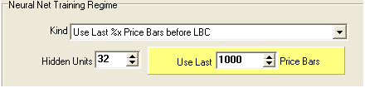
There are 5 different ways to train Neural Net:
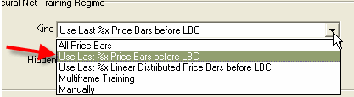
We can train it using all price bars (before Learning Border Cursor (LBC), naturally). We can use certain amount of bars before LBC. Choice #3 provides an opportunity to apply Linear Distributed training when the "nearby" price bars (the bars that are closer to LBC) are used more often than distant price bars; thus we use the latest information regarding price movements more intensively. Choice #5, Multiframe training, applies different training intervals for different events (more price bars to train Neural Net for long term events).
It looks like, for Dow Jones Industrial Index, the best results are provided by the model that uses last 1000 price bars. It corresponds to 4 years of price history. In other words, it is of the similar length as Presidential cycle (at least, we can assume that this cycle works for Dow Jones index):
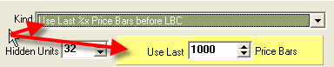
Some time ago I started the research as to finding the best training interval. Then I tried to apply different math methods to this problem. And it looks like a real help in finding the best training interval comes from "Chaos Theory". Now there is a new button in the program: 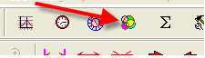. Clicking on it, you will get the following window. First of all, you will see the diagram, so called R/S analysis:
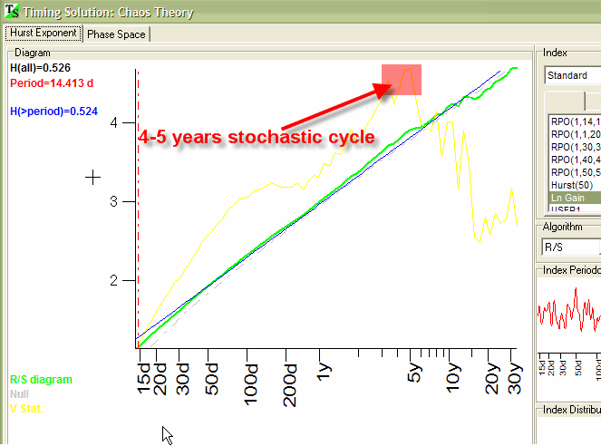
The maximum of the yellow curve (so called V Statistic) indicates the presence of a special kind of a cycle in Dow Jones index. This cycle is not a regular one provided by the sinus wave. It is not a periodical but a stochastic cycle. Its maximum corresponds to 4-5 years period, so I would recommend using this value as the length of the training interval. More information regarding this issue is provided in this book: Fractal Market Analysis, Edgar E. Peters, John Wiley&Sons, Inc.
As an example, look at this R/S diagram for Euro/USD pair:
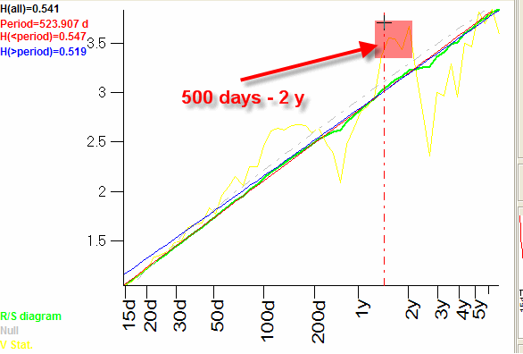
It seems that this pair has the 500d-2 years stochastic cycle. This fact has been provided by one of Timing Solution users who obtained this result using Back Testing module of the program.

Timing Solution - Back Testing
This module is for advanced users, so we recommend studying it only if you are comfortable with the Neural Net module

  - Back Testing at a First Glance: Main Principle
  - Back Testing at the Second Glance: Example
  - Back Testing: Different Variances

Back Testing at a First Glance: Main Principle
Back Testing allows you to:
  - Estimate the performance of any Neural Net for any particular financial instrument;
  - Find the best Neural Net model for any particular financial instrument;
  - Find the best training interval for any model;
  - Find the best forecasting interval for any model.
This is a very hard task to do manually. The Back Testing module will make your life easier.
Let us show you how Timing Solution can help you with the first task (i.e., estimating the model performance). The scheme looks like this:
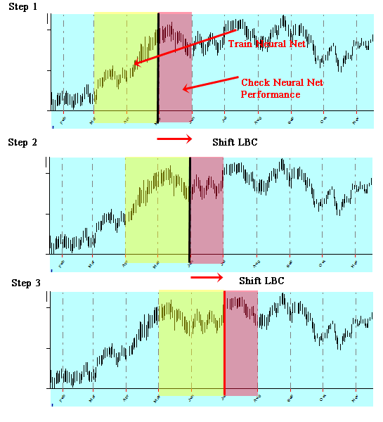
Here is the illustration for one typical example:
Step 1: The program trains the Neural Net using the price points from the yellow region (see the upper picture). After training, it checks the Neural Net performance using the points from the red region. In other words, the program creates the Neural Net projection line using the points from the yellow interval and then it observes how well this projection line fits to the real price data from the red interval. These two intervals (yellow and red) are independent, so any "future leaks" or “information leaks” are excluded.
Step 2: We shift the Learning Border Cursor (LBC) for several price bars ahead. Therefore, we shift the yellow and red regions as well and repeat the whole procedure again (optimization and evaluation of performance).
Step 3: Shift LBC and do the same again.
You can set yourselves the amount of steps and the length of shift option for LBC while creating the Back Testing Script:
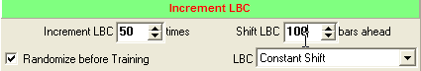
Here LBC will be shifted 50 times for 100 price bars ahead. In this case, the program will estimate the model's performance for 50 different intervals. The results of the Back Testing procedure look like this:
Mode: Neural Net
Price Events: Rel. Osc.(1,100,100 Close)
Criterion: Correlation 365 pt. after LBC
Model | dynamic_model.hpp
NN Topology | 32 hidden
NN Training | last 1250; 15000 st.
Statistics | +35 / -15 ChSq=4.0
Average | 0.146
21.07.1978 09:30 | -0.185
29.01.1979 09:30 | -0.005
06.08.1979 09:30 | 0.153
12.02.1980 09:30 | 0.385
20.08.1980 09:30 | 0.071
.... | ...
This is the sample report of the Back Testing procedure we have actually provided. It means that the program has trained the Neural Net 50 times. For each training interval and LBC position, it compared the projection line and the price (to be precise, the price oscillator) and calculated the correlation coefficient between them using 365 price points after LBC. 35 times the correlation happened to be positive while 15 times it was negative. The average correlation is 0.146. The explanation regarding the correlation coefficient read in the "Definitions" chapter. It means that this model can be accepted as a working one. Besides the correlation, there are other criteria to estimate the model's performance: the direction of price movement for the next day and the direction for price movement for %x days ahead.

Back Testing at the Second Glance - Example
Now we will demonstrate the Back Testing procedure itself using one example.
First of all, download the price history file. The amount of price data should be enough to produce the Back Testing. In this example, we use Dow Jones index from 1940 to November 2004.
Run the Neural Net module, click button and choose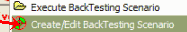.
You will get the window that allows you to create the Back Testing Scenario Script. Here it is:
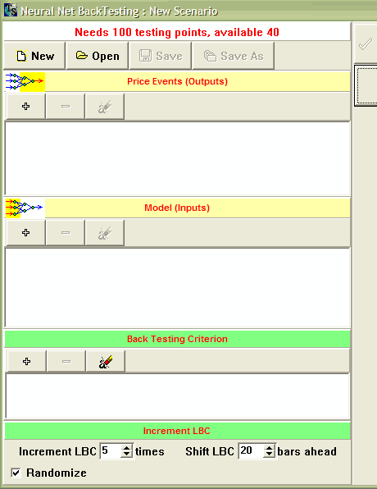
Look closely at this window. The following describes the components:
Back Testing Scenario - Outputs for Neural Net (what we want to forecast): It corresponds to this part of the window:
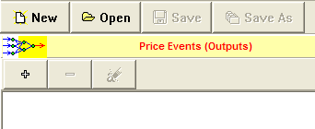
Click on button; you will go to exactly the same window as seen in the Neural Net module:
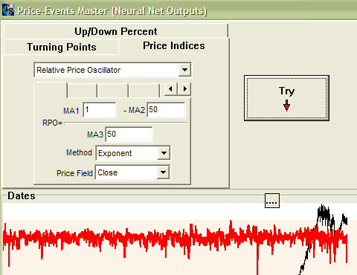
It works exactly the same way as in the Neural Net. Here you can define any price indicator you want, and the Neural Net will create the projection line for this indicator.
You can create several outputs like this:
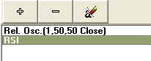
In this case, the Neural Net will produce the projection lines for Oscillator and RSI.
Back Testing Scenario - Models (Inputs) for the Neural Net (what this forecast is based on): Set the inputs in this part of the window:
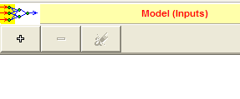
Click on button; you will go to this window:
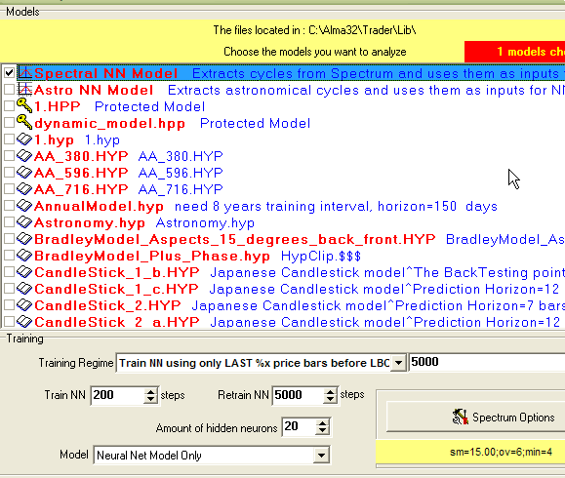
Here define these parameters:
- In the upper part of this window, choose models (a standard model or the model created and saved earlier; see *.hyp or *.hpp files located in c:\TimingSolution\Lib directory).
Also there are extremely important models that are created by the program in response to the position of LBC; these are "Spectral NN Model" and "Astro NN Model":
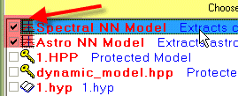
If you choose one of these models, the program will extract fixed (Spectrum model) or astronomical (Astro model) cycles and will create the projection line regarding these cycles. Because the extracted cycles depend on LBC position, the program will recalculate these cycles after each changing of LBC. In other words, in this case we analyze not a fixed model, but rather a kind of algorithm "to extract an astro cycle, use these parameters and then use these cycles to create Neural Net projection line based on those parameters". In this case, the involved cycles depend on LBC position, and we try to catch the strongest recent cycles. You can define the parameters for Spectrum and Astro modules here:
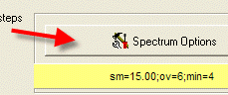
These parameters are described in "Timing Solution Styles".

- The training regime. You can use all price points before LBC, or you can use a part of them (closer to LBC). Our research shows that very often a lesser amount of price points provides better results. For example, while back testing some model for Dow Jones index, we have found that training on 4000 price bars (16 years history) gives worse results for this model than its training on the last 1000 price bars (4 years history). It is very important to find the best training interval for each model. See notes regarding this issue at the end. You can also define several training intervals, like this:

(1000,1500,2000,3000,4000 price bars). In this case you may find the best training interval for the particular model (do not forget to click on "OK" button).

- Set the number of steps that are necessary for the Neural Net training. As a rule, you can use this formula:
Num Steps=10 x Num Inputs
But it would be better to find this parameter by optimizing the Neural Net several times.
- This parameter strongly depends on the model (inputs). Usually this amount is enough, but you can play with this parameter.
- Simultaneously the program produces Neural Net training and the optimization of the simple linear model. You are able to make a forecast based on linearity only. But it looks like the Neural Net gives the better results.
As models, the program uses *.HYP and *.HPP files located in \LIB subdirectory. You can create these files through the inputs editor (click on "Save" when the files are created):
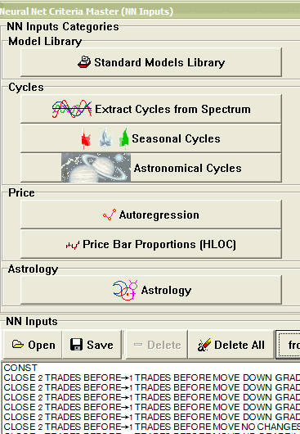

Back Testing Criteria - Outputs (how well the model fits) This is a very important question - how to estimate the performance of the calculated projection line.
You can define these criteria here:
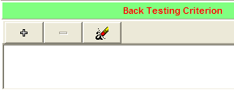
Click button. There are three possible variants to estimate the model's performance:
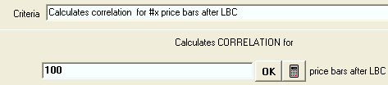

You can also define several testing intervals, like this:

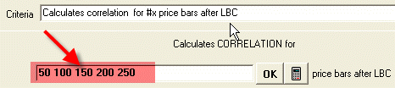
(50,100,150,200 and 250 price bars after LBC). In this case you may find the best forecasting interval for the particular model (do not forget to click on "OK" button).
If you set this parameter this way, the program will calculate the correlation coefficient between the projection line and the price (or, more precisely, price indicators defined as outputs). It uses % x price bars after LBC (100, in our example).

If you choose this item, the program will analyze the price movement for the next bar after LBC. This works well when we are more interested in catching the next price movement.
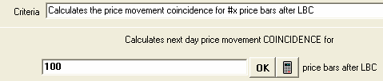

Setting this parameter, the program looks for the price movement for % x price bars (100 price bars after LBC in our example). It compares the price bar with the price for the next trade, and it does the same for the projection line. The results can sound like this "the projection line has shown the price movement for the next trade the same as the real price 70%, while the opposite direction is 30%".
Algorithm of setting LBC Actually, there are three variants of setting LBC during the Back Testing process:
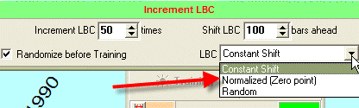
Constant Shift: in this example, we constantly shift LBC for 100 price bars ahead. And we do it 50 times.
Normalized: as LBC, we use “equilibrium points” – points where the oscillator crosses zero:
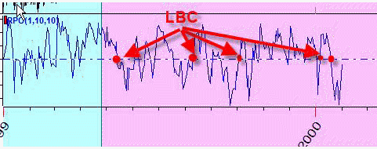
Random: sets LBC in a random way
When the scenario is chosen, run it by clicking this button:
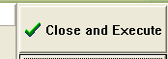
You can also save this scenario into the file (click "Save"):
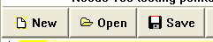
Next time when you decide to run this scenario just choose this item:
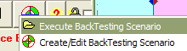
You will get the window where you can choose any scenario file from the list:
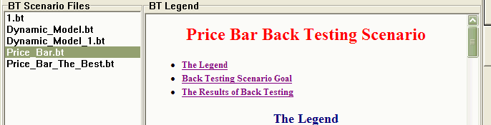

Back Testing - Different Variances
In reality, we have used several different variants of Back Testing scenarios. The example above was oriented mostly to estimate the performance of some particular model for a particular stock market.
Now we will demonstrate other possible variants of Back Testing.

Finding the Best model for any particular security
Choose several models. Like this:
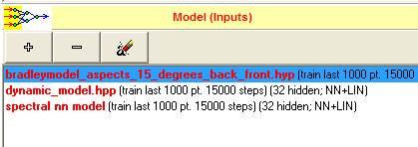
We will check three models at the same time.

Finding the Best training interval for any particular model and any particular security
Choose the same model, but use different parameters of the NN:
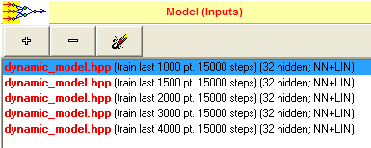
Here we check the dynamic model based on different lengths of training intervals: 1000, 1500, 2000, 3000 and 4000 price bars before LBC.

Finding the Best forecasting interval (particular model + particular security)
Define several Back Testing Criteria:
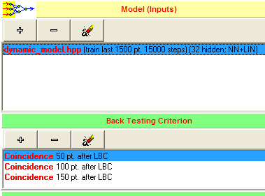
Here we check the dynamic model's performance for 50 price bars after LBC, also 100 bars and 150 bars.

Finding the Best training and forecasting interval (particular model + particular security)
This scenario looks like this:
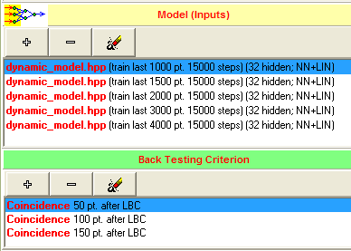
Here we look for the best training interval and the best forecasting interval at the same time.

Optimize Everything
Also, you can play with different price events:
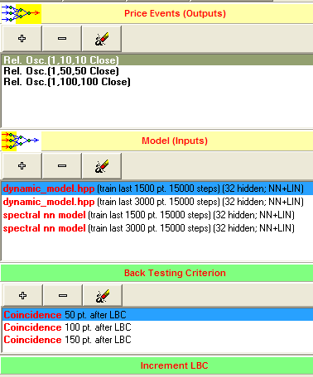
Here we forecast different indicators applying two models based on different training intervals.

Turning Points Analyzer

- General Idea
- Easy Start
- Going into Depth
- Astronomical Model
- Options
General Idea
The main idea of this module is finding the price levels where the price movement changes its trend. To do that, we create the zigzag and look for these levels by analyzing different proportions of zigzag swings. Actually, this idea is very close to Elliot Wave Theory, but our goal is to provide the universal tool that allows to reveal hidden patterns in zigzag.
Let's consider the zigzag created for IBM shares. This picture shows 8 months interval:
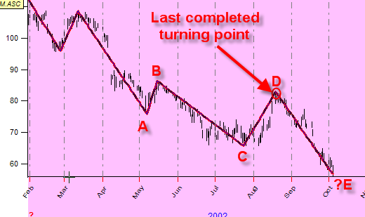
Here you see that the turning point D is the last known turning point. This is TOP turning point, so we are looking for the end of downtrend movement. We need to know the height of D-E swing. In technical analysis the D-E swing is called retracement. Our target is to find the height of this retracement swing to anticipate the next Bottom turning point E.
The most obvious solution is finding the height of D-E swing by analyzing all proportions related to TOP turning points. As an example, we can analyze the proportion for another TOP turning point, B: BC/AB. If this proportion has some typical value for this stock, we can assume that the same value might work for the turning point D and thus find the height of D-E swing through the height of D-C swing.
Here we have two possible ways:
- We can use classical ratios (the most well known ratio is Fibonacci ratio) and see how they work for our stock;
- We can do a statistical analysis of the ratios occurred in the past history of our stock and then make decisions supported by solid math base.
Both approaches are available in Timing Solution software, though we favor the second one. It gives you a clue to a real process. Moreover, you will be able to see when the classical ratios work.

Easy Start
Let us look how this module actually works. As an example, we use S&P 500.
I have downloaded S&P 500 index data from 1950 to the end of January 2006. While downloading the historical data, set the "Forecast Horizon" big enough to be able making a forecast for a long period ahead:
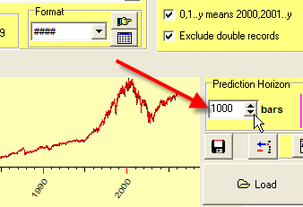
Run "Solutions"-"Turning Points Analyzer". You will get this window:
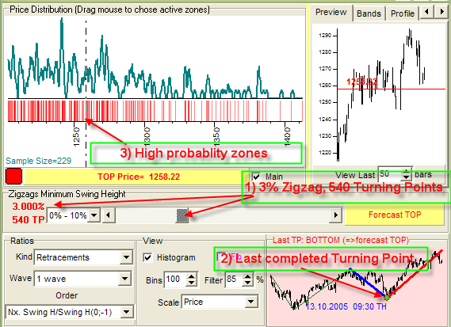
What options does this window provide to you?
1) The slider in "Zigzag Minimum Swing Height" allows you to adjust the analyzed zigzag. The bigger this value, the longer term waves we research. In our example, we use 3% zigzag that allows to reveal swings for several months. This zigzag shows 540 turning points, it is a pretty good material for the statistical research. Actually, this parameter is extremely important. It is the first parameter you should try to vary to get the most "predictive" zigzag.
2) The last completed turning point (according to this zigzag) was the BOTTOM in October 13 2005, and we are looking for the next TOP turning point. If we would choose other parameters for zigzag, for example let it be 2% zigzag, the last completed turning point would be TOP January 11,2006, and this zigzag is suitable to finding BOTTOM turning points:
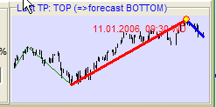
3) The central issue of this module is the histogram - "High probability zones". In the program, the same histogram is shown as a vertical one and a horizontal one. Just looking at the vertical histogram, we can assume the price levels where the TOP turning points are more probable. Looking at the details on the horizontal histogram, we can easily see four main clusters there corresponding to four different price levels:
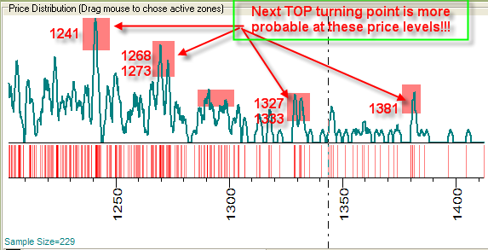
These price levels are based on statistical research, and the most interesting issue for us is that the TOP turning points "like" some price levels more than other ones. The existence of clusters at this diagram is the best proof of this fact. The upper diagram represents the histogram or probability: the higher histogram, the more probable is that the turning point will occur at this price level. The X axis corresponds to the price. The red stripes represent all available historical TOP turning points normalized to the current price. Drag the mouse to these four major clusters and look at the Main Window:
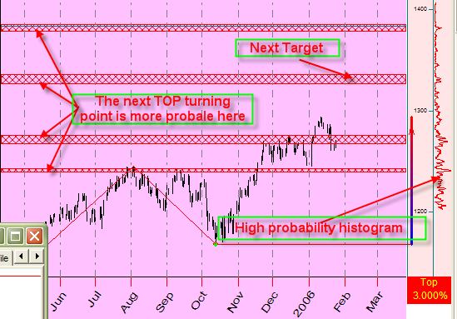
Thus, you can see the most probable zones for TOP turning points. The high probability histogram adjusted to real price scale is shown in the right corner. So you can see the most probable zones right in the Main Window:
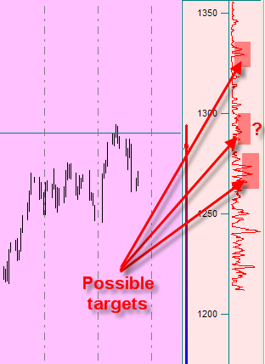
Using the pure mathematical approach (or "quantitative" approach), we can understand the risk degree in regards to our conclusions on turning points locations. Look again at this diagram attentively:
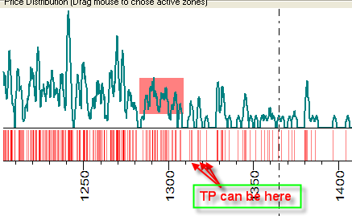
The red stripes are presented almost everywhere, even when the histogram value is very low. Look at the big cluster at 1285-1310. It shows many peaks, though the time interval is too wide. We can make an assumption regarding the DEGREE OF PROBABILITY that trend changes occur in these cluster zones. And the program can calculate these zones.
By the way, checking the "Fib" option you can see how the most used in technical analysis ratios for retracement swings correspond to real price movement:
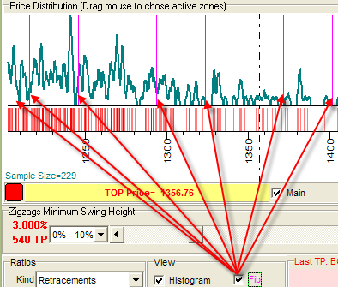
The purple stripes that correspond to these ratios do not hit maximums on the histogram.
The next question we need to answer is WHEN this turning point can happen. We can resolve this problem using the same approach, though instead of the price we will use the time length of these swings.
It is easy, just set "Retracement Time" option:
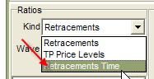
Now you can see the same histogram in Time scale:
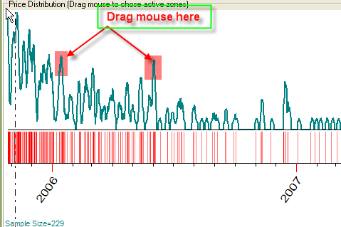
The higher the histogram, the more probable is the turning point's occurrence there. As you see, the time histogram is more even, however it gives us some hints regarding turning points time. Drag the mouse as shown at the picture and watch the Main Window:
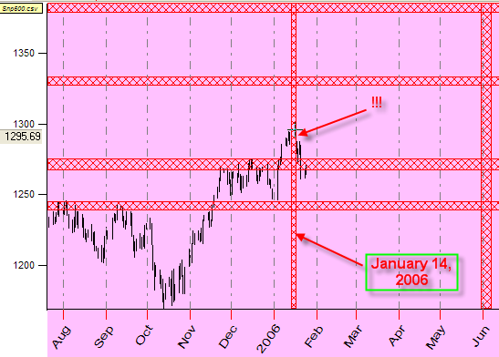
Vertical bars represent the high probability zones for time. One of this zones hits the probable top turning point around January 14, 2006.

Going into Depth
The Timing Solution allows analyzing zigzag from different points of view. These options:
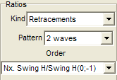
define what ratios to analyze.
"Kind" options: Retracements - analyze the retracement for a swing. Back to this picture:
To get the height of D-E swing, we analyze the ratios CD/DE, AB/BC,... where CD is the height of swing C-D, etc.
Option TP Price Levels: setting this option, we analyze not the swing's height, but ratios between price itself, we provide the statistical analysis for (Price E)/(Price D), (Price B)/(Price C) ..., where "Price E" is price at the E turning point.
Option Retracements Time: in this case we analyze the ratios for swing lengths.
"Order": in all examples above we have analyzed the ratios between neighboring swings. However, using Timing Solution we can make a forecast based on different ratios, like ratio between swing D-E and B-C (picture above). Both these swings correspond to downtrend movements in our case.
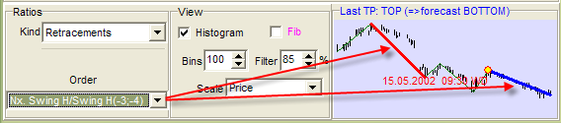
Actually, the swings used in ratios are marked in the right chart.
"Pattern": setting this option, we ask the program to provide the statistical analysis for different waves. In all examples above we used two wave model.
As an example, this setting: 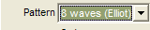 means analyzing 8 waves proportion. In other words, we assume that each 8th wave repeats itself:
Look at this chart:
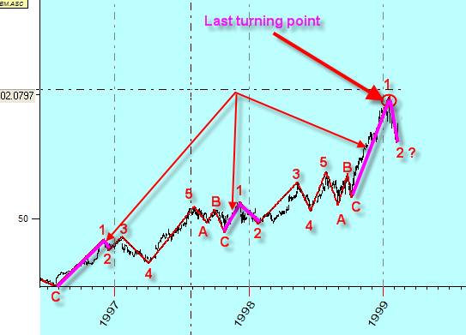
Suppose we have point "1" as a last turning point (as in the picture above) and we want to find the bottom turning point 2. Setting 8th wave model, the program will analyze the ratio between swings 1-2/C-1 (using Elliot notation).
But we need much more price history to provide this analysis.
To add to the theme of the most typical ratios, we have downloaded the Dow Jones Industrial index from 1885 to 2006 year. We have created 5% zigzag; it provides 789 turning points and, as we can see, the usage of 8 waves model gives us 82 ratios (Sample Size), and we can see the cluster 1.0 1.52 and 1.82. Somehow the stock market likes these retracement proportion:
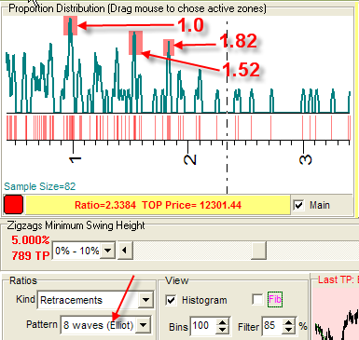
Thus we can find the most influential ratios statistically and see the actual ability of classical ideal ratios (like Fibonacci).
Astronomical Model
There is one more option related to astronomy. Regarding many sources, the Moon phases have impact on stock market, and we can use them in our analysis. Setting these options:
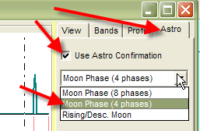
we ask the program to use NOT ALL turning points but the turning points that occurred on the same Moon phase. In other words, we assume that swing structure depends on the Moon phases. In the light of the Moon, the next target looks like this:
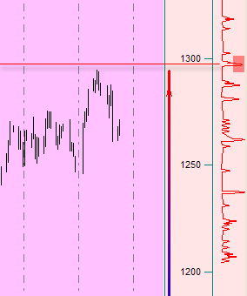
Here we use the 90 degrees for each phase division as the whole Moon cycle consists of 4 major phases. Also we can use the classical 8 division and use the rising/descending Moon as well. Remember that the usage of 8 phases division requires much more price history. We recommend to watch "Sample Size" parameter:
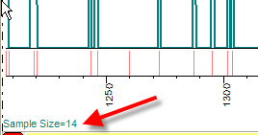
This is the amount of "legitimate" turning points used for the statistical analysis. The usage of 8 phases division makes this parameter approximately two times less.

Options
The "View" options allow varying the presentation of results:
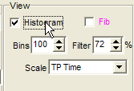
When Histogram option is checked, the histogram reveals high probability zones. In the case when we analyze long term swing or our price history is not long enough, we would recommend disabling this option. As in the picture below, we are able to see all 41 analyzed turning points as vertical stripes:
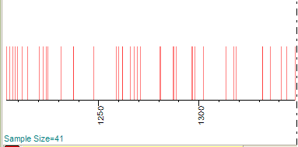
Each stripe corresponds to one analyzed turning point.
Bins serve to vary the amount of bins in histogram. The more bins the more detailed the histogram is. We can vary this option to make available clusters more apparent.
Filter allows to exclude extreme points. Some swings are too high or low, and we can exclude them decreasing this filter parameter. Sometimes this parameter has impact on Main Window view.
Sometimes it looks this way (we have analyzed short term swings in this example):
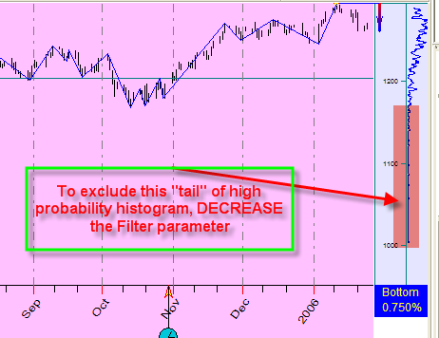
The price scale is too wide for our price data. Decreasing Filter parameter, we will exclude the extreme points from high probability histogram, and this window will look more appropriate:
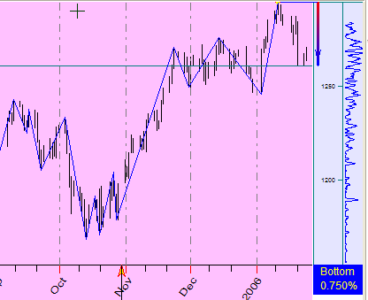

Scale: we can display the high probability zones using ratio scale and real price scale:
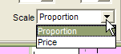
Choosing "Proportion", we can present the histogram this way:
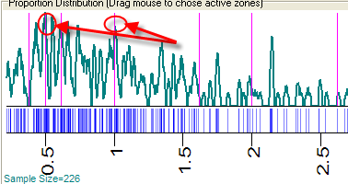
Here you can see what ratios between downtrend swings and uptrend swings are most typical for short term zigzag (0.75%). As you see, at least ratios 0.5 and 1.0 are presented. The other choice allows to see these proportions converted to price.
Profile options control the view of profile in the Main Window:
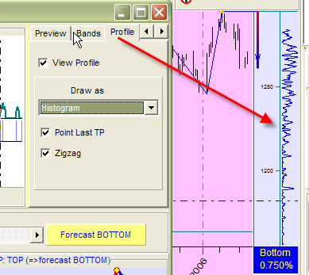
Try to vary these options and see how the view of the Main Window will change. Very often the "Colored Diagram" looks better than the simple histogram:
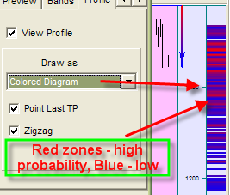
Here red zones correspond to high probability zones while the blue ones show low probability.
Band tab allows manipulating with active zones created before:
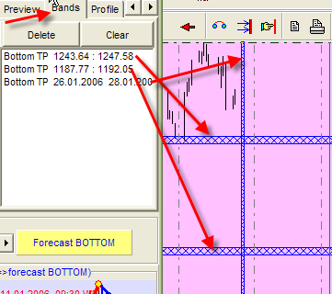
You can delete any zone or delete all of them.
Main options allow to synchronize the mouse cursor position at the high probability histogram in the Main Window:
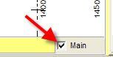
When you move the cursor over the histogram, the appropriate price or time marks are displayed in the Main Window:
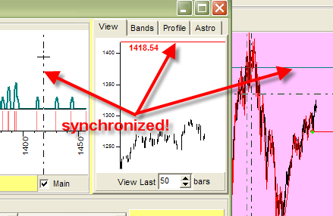

Leading Index: there is a possibility to use this technique together with technical analysis indicators. Let me show you just one example. Set these parameters in Profile tab:
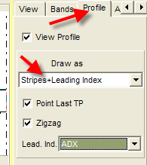
Look at high probability diagram in the Main Window:
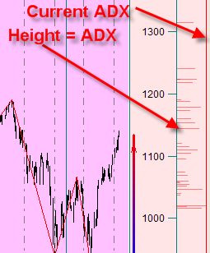
Now the program displays the price levels corresponding to previous turning points ratios as red stripes, but these stripes have different height. The height of these stripes corresponds to the value of ADX index at the turning points. The red vertical represents the last value of ADX index per downloaded data. This way we are looking for the double analogy between future turning points and previous ones - the analogy in market geometry and technical analysis indicator. When some red stripe reaches the last fixed ADX value, it means that this index now is equal to its previous fixed value.
For example using Percentage Volume Indicator (PVO):
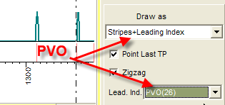
you can take into account the volume and see it right on the Main Screen. Like this:
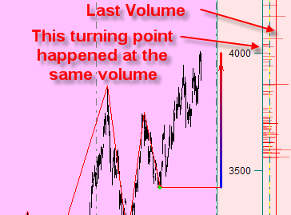
Here at the price level 4022 we have turning points cluster from one side and, from another side, the Percentage Volume Indicator (PVO) corresponding to one of these turning points is very close to the last PVO value.
Zigzag Options It is very important issue how to calculate the zigzag index that is used in this module. These options make this process pretty flexible:
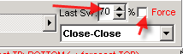
Last Swing parameter allows to handle the last swing for zigzag, and this is extremely important for forecasting.
Look at this example, this is 5% zigzag:
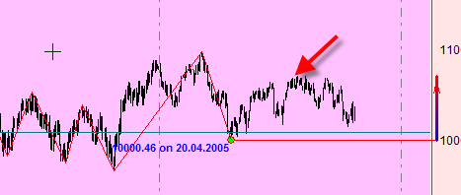
Here I set Last Swing to 100%; the program in this case calculates the swing in its usual way - the minimum height of each swing should be at least 5%. The last completed turning point is 20.4.2005. But looking at this chart, we can suppose that the price has already started its downward movement. However, this zigzag does not seems "seeing" this wave because the price range after 20.04.2005 is less than 5% and the next turning point cannot be calculated.
Set Last Swing on 70% and now this swing is visible:
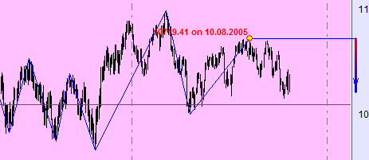
It is a good practice to use the less percentage for the last swing. It is risky because we deal with uncompleted waves, but it allows to reveal the early tendency.
Force: this option allows to set the last turning point manually. Look at this chart:
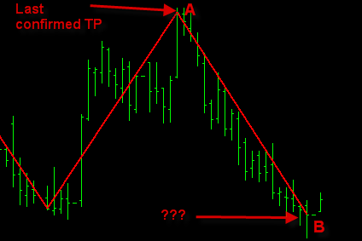

Here we have last confirmed turning point A. It is Top turning point, so under this condition we are looking for the next Bottom turning point. But we may suspect the B is real Bottom turning point. We have not enough information on the opposite upward movement to confirm this fact, because we have two trades of upward movement only.
But we can enforce to set this as a turning point. Check Force option and the program will set the last turning point on B thus giving us a possibility to analyze the uptrend scenario, in assumption that the B is a real Bottom. Checking this option, we ask the program to set the last turning point on the highest high (for Top) or lowest low (for Bottom) without confirming this turning point by opposite movement.
Close-Close/High-Low parameters point out what prices we use to calculate the percentage for zigzag.

Work Book
Composite Module - Examples
The following examples are based on questions asked by users and friends of the program.
  - The strongest price movements had happened when Jupiter came through the first part of Zodiac (from Aries up to Libra), but when Jupiter came through the second part of Zodiac the strong price movements were seldom. How to verify this observation?
  - Doing the historical research for DJI index, I have found that it changes the trend more often when the middle point between Jupiter and Saturn goes through these points of Zodiac: 7°30' 22°30' 37°30' ... 7°30' +N x 15°. How to verify this statement?

The strongest price movements had happened when Jupiter came through the first part of Zodiac (from Aries up to Libra), but when Jupiter came through the second part of Zodiac the strong price movements were seldom. How to verify this observation?
Download the DJI index from 1900 to November 2004. Run the Astronomy (Composite) module and set options as it is shown in this picture:
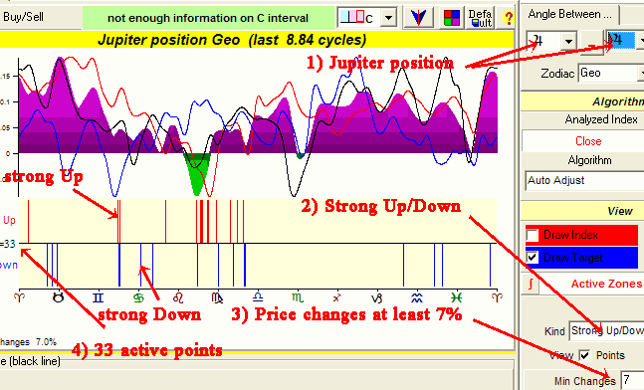
We will work with the "Active Zones (AZ)" area. Setting the parameters as above will start the analysis for the strong Up/Down points while the minimum price change is 7%. The program has found 33 such points during 104 years of available price history. The red and blue stripes correspond to the strong up (red) and down (blue) movements regarding the Jupiter position.
This diagram shows that 30 from 33 stripes are located in Aries - Libra area. So, this observation is a true one
Timing Solution allows analyzing more complicated combinations. For example, we can analyze NOT ALL points, but only those that have occurred at some special moments of time. Like to analyze the up/down points that occur during the fall only. Click on this button ("Context"):
: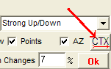
and fill in this form:
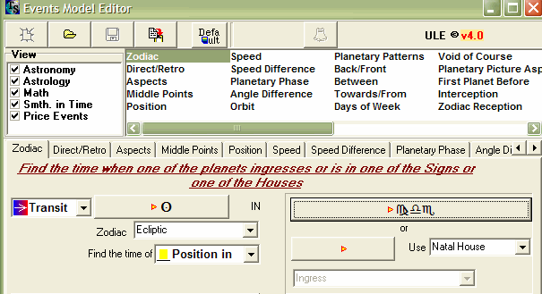
The program will analyze the up/down points that happen while the Sun is in Virgo, Libra or Scorpio. It is possible to analyze price movements in regards to any planet being retrograde as well as many other things. Try all options on the tabs in the middle of this window.

Doing the historical research for DJI index, I have found that it changes the trend more often when the middle point between Jupiter and Saturn goes through these points of Zodiac: 7°30' 22°30' 37°30' ... 7°30' +N x 15°. How to verify this statement?
Download the DJI from 1980 to November 2004. Run the Astronomy (Composite) module and set options as it is shown in this picture:
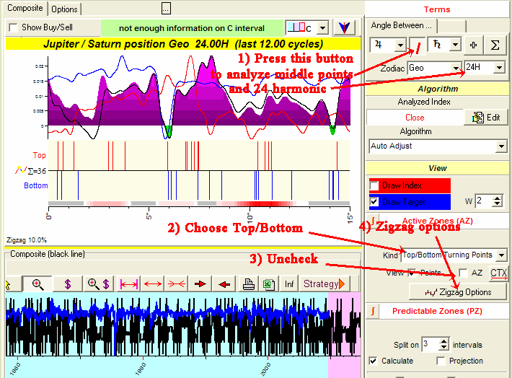
Do not forget to click on this button: 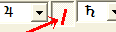 because we analyze middle points now (not the angle between planets). Then choose this option: 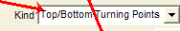, because we will study turning points now (not big up/down points). Next step is to specify what we understand under "top/bottom turning points". Click on the "Zigzag Options" button to define the parameters of zigzag to calculate top/bottom points:
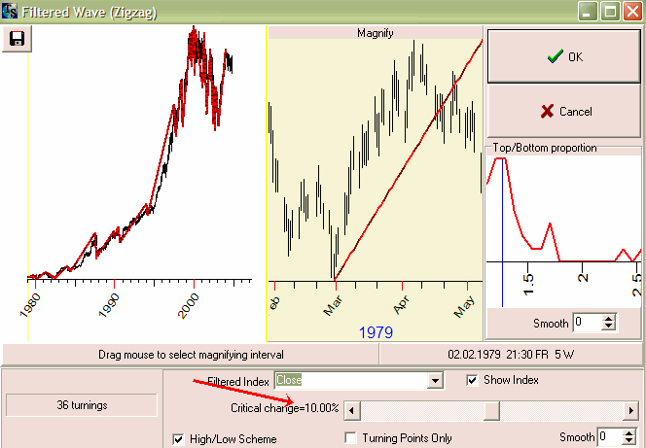
Let the minimum wing for this zigzag be 10%.
The last step is to uncheck this option:
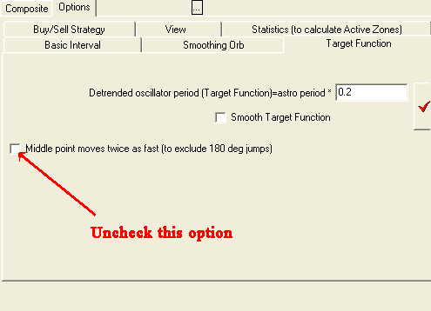
This is the result of calculation:

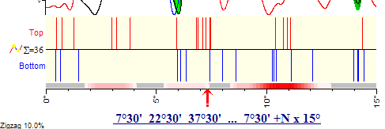

The program has found 36 turning points for 24 years of available price history. I marked the 7°30' point. The red stripes correspond to the top turning points, while the blue ones correspond to the bottoms. The turning points are located evenly within the whole 0°-15° area. So, the available data do not confirm the assumption.
If you analyze the longer time period of data or smaller zigzag wings, the result may look like this:
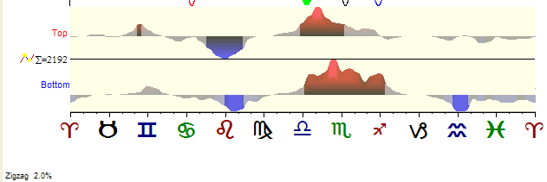
This is Top/Bottom diagram for DJI 1900-2004. The zigzag wing is 2%, and there are 2192 turning points within the analyzed period. The diagram reveals that Libra - Scorpio is the active zone (the turning points happen often here), while Leo is not the active period.

Timing Solution: Back Testing Examples

  - Example N1 - the best model for today
  - Example N2 - the best parameters for the Spectrum Model

Example N1 - the best model for today
Let us look at a rather simple problem. Assume that, while working with the program, we created several models. Which one of the models gives the best projection line for Dow Jones index in the year 2004?
To answer this question, I have started with downloading the DJ index data. The learning border cursor (LBC) is set at January 2, 2004:
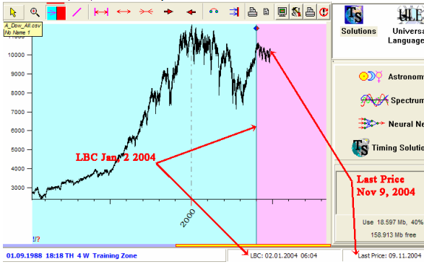
Before making any conclusions in respect to the models, let us provide the Back Testing procedure for each one of them. These models are saved and kept in the program as the files with *.hyp extension (or *.hpp). Usually, such files are located in \Lib subdirectory of Timing Solution directory.
You can create these files through the Neural Net module. Run the Neural Net and click on this button:
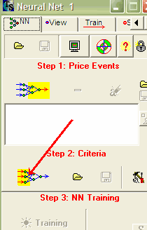
You will get the window that allows to create the *.hyp files:
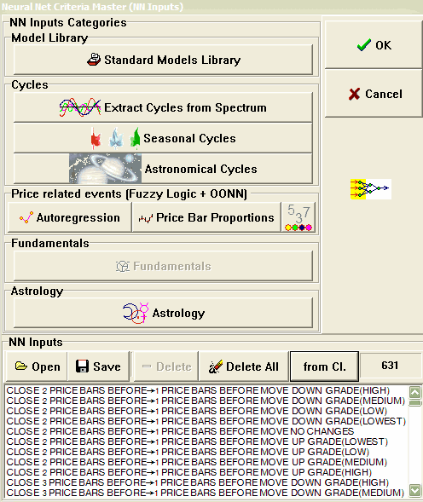
Here you can either choose the model from "Standard Models Library" or create your own model (using Cycles, Price Related Events, Fundamentals or Astrology modules). As an example, the auto regression model has been created. When the model is chosen or created, click on the "Save" button:
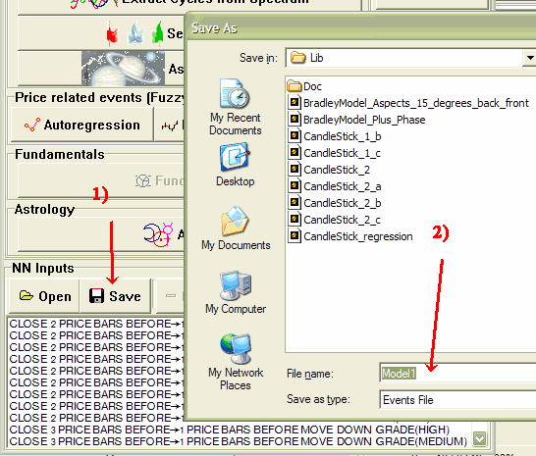
And save this model (Model1 file, for our example).
To create another model, click on this button: 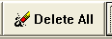; the program will delete all events participating in the creation of the previous model. After that, you can create and save the other model. For this particular example, three FAM style models have been created: Model1.hyp, Model2.hyp and Model3.hyp.
When all models are ready and saved, we should describe the Back Testing scenario. It is a plan of producing the Back Testing procedure.
It can be done by several ways:
1) through the Neural Net module:
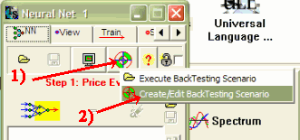;
2) through the menu of the Main Window (follow these items of the menu):
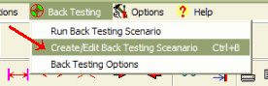;
3) or click on Ctrl+B buttons.
Anyway, you will get the window that allows you to create the Back Testing scenario:
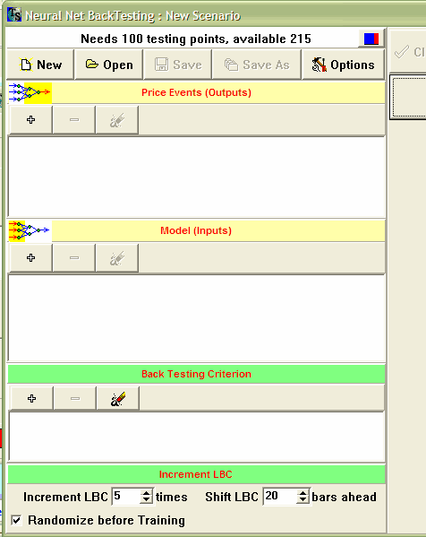
The upper panel "Price Events (Outputs)" serves to define the index/indicator we would like to predict.
There click on "+" button and do this sequence of operations:
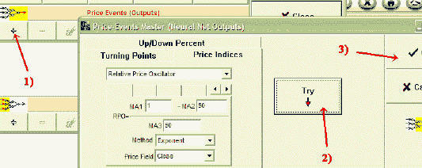
In the example, we will forecast the relative price oscillator for Dow Jones Index, with the period = 50 price bars.
Next panel, "Model (Inputs)", allows you to choose the models to be analyzed:
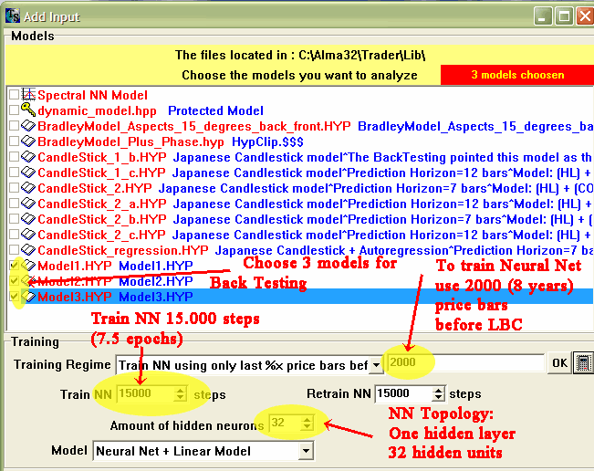
In the example, we have chosen three models.
The Neural Net (NN) will be trained on last 2000 price bars (it covers 8 years data) before the LBC.
Click on the "Calculator" button; the window will show up where you can see the correspondence between the amount of price bars and the time interval covered by these price bars:
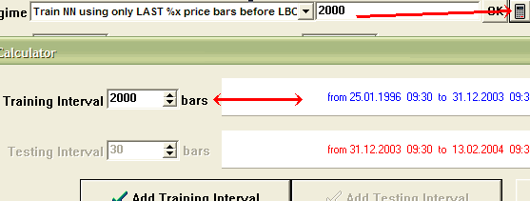
Here you can see that last 2000 price bars before the LBC (which is January 2, 2004) include the price bars from Jan. 25, 1996 to Dec. 31, 2003. The Dec. 31, 2003 is the last price bar before the LBC.
Now let's look at this information panel:
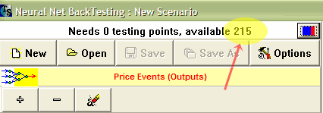

It shows that we have 215 price bars available after the LBC. The last price bar for the downloaded data is Nov 9, 2004.
Therefore, now we have models and the scenario of the Back Testing procedure for these models. To estimate the quality of each model, we need to define the estimation criteria. We can do this in "Back Testing Criteria" window. For the example, the criterion is the correlation between the projection line and relative price oscillator for those 215 price bars after the LBC.
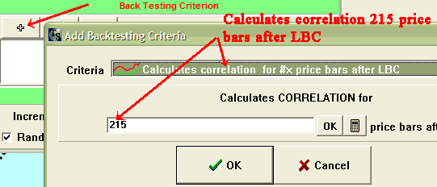

Click again on the "Calculator" button; you will see the correspondence between the amount of price bars and the time interval related to these price bars:
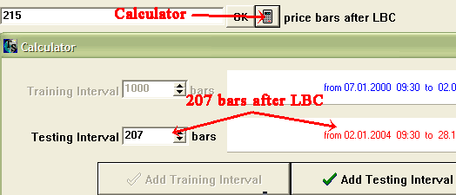
The last panel, "Increment LBC", should be filled out this way:
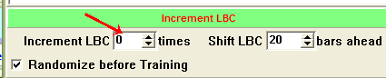
The parameter "Increment LBC" should be set as zero. We will use one LBC only. To produce the more precise Back Testing, we should use several LBC; it will be described in the next example.
Finally, the Back Testing scenario looks like this:
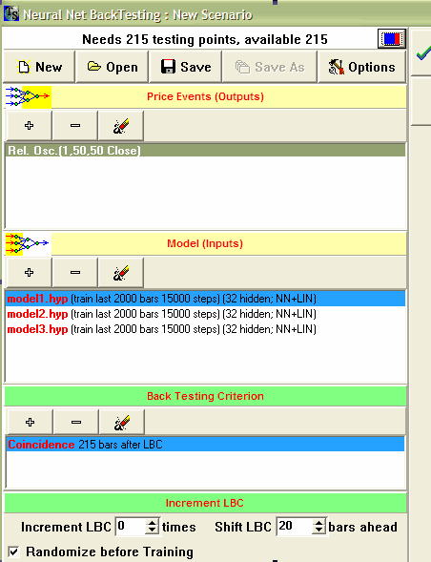
Click on the "Close and Execute" button; the program will start this procedure. Then you will see the window that reflects the results of Back Testing procedure:
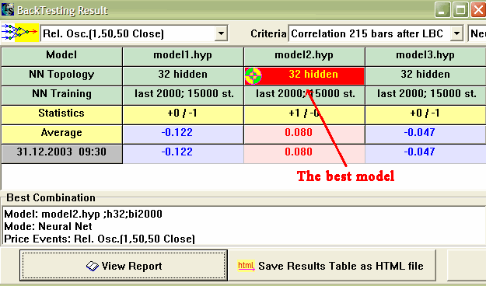
The program provides Back Testing, evaluates the performance of each model and shows the best model in respect to the chosen criteria. Thus, for our example, the best forecasting model for the year 2004 year is Model2.hy file, with the correlation 0.08. It is not the best possible model; it is the best model from the set selected for the Back Testing.
Besides, the program produces the detailed Back Testing report. Here is the example:
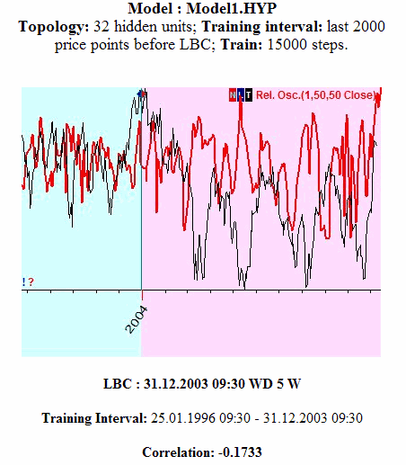
This diagram shows the interval for this example equal to 215:2=107 price bars before the LBC and 215+5 price bars after the LBC. In other words, we can see the price movements inside the chosen testing interval. "215" here is the length of the testing interval. You can set the name of the file for the report, its size and picture quality through the "Back Testing Options" window.

Example N2 - the best parameters the for Spectrum model
Usually, the Back Testing procedure is much more complicated than it is described above. For example, let us consider the parameters that are the best for the model based on fixed cycles (Spectral model).
To find such parameters, we need to vary these things:
- The length of the interval used to calculate the Spectrum (i.e., to extract the playing cycles) and to train the Neural Net model based on these cycles;
- The length of the testing interval;
- The best forecasting interval.
To rely on these results, it would be better to produce such an analysis using different LBCs (the more the better).
Let us show how to do this. Download the Dow Jones index from 1930 to 2004 year.
Set LBC on 1982 year (to have enough points on the testing interval and to have the possibility to shift the LBC ahead):
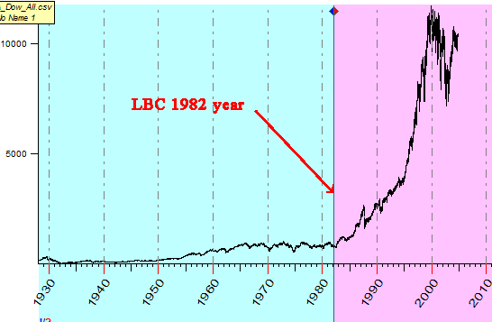
Here is how you should define the model:
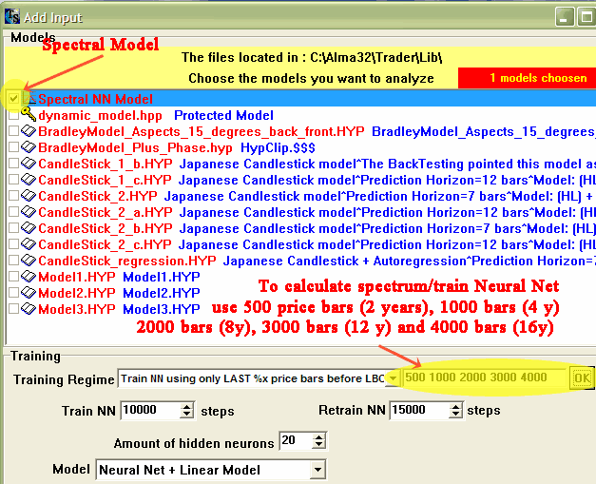
An important note: we use several training intervals here. In other words, the program tries to train the Neural Net (and calculate the Spectrum as well) on several intervals.
Do the same for the testing interval:
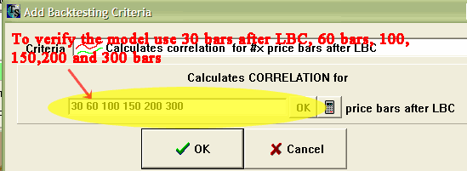
One very important issue to keep in your mind is "Spectrum Options":
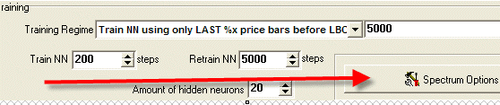
Clicking this button, you will open the window to edit parameters participating in calculation of the Spectrum. These parameters are described in Timing Solution Styles section.
The last thing to do is to set the amount of LBCs to verify the results:
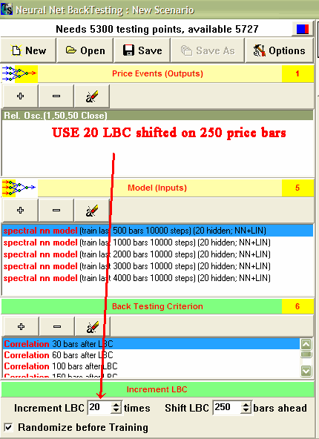
Observe this information panel:
to be sure that the amount of the points on the red region is enough to produce the Back Testing. Otherwise you should shift the LBC clicking on this button: .
Important notice regarding Spectrum model: during the Back Testing procedure the Spectrum and accordingly the most active cycles are calculated after each change of LBC. In other words, for different LBCs the program uses different cycles.
The results of Back Testing look like this:
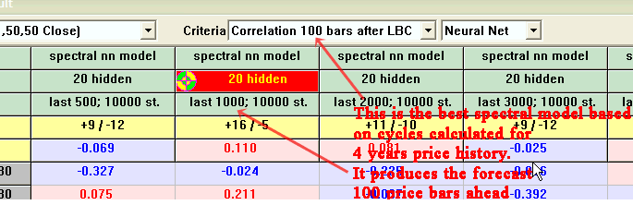
It shows that the best model is based on 1000 price bars and gives the forecast 100 price bars ahead.

Miscellaneous
- Detrended Zigzag Index - the best indicator to reveal turning points
  - Detrended Zigzag
  - Advanced Options

Detrended Zigzag
Generally speaking, zigzag is the line that we draw while connecting together tops and bottoms of the price line. Another name for zigzag is "filtered waves" (this is the theory suggested by Arthur A. Merrill). The biggest problem with zigzag is that we cannot use it for big time intervals due to the existence of the market trend. But - what if we try to eliminate the trend? Thus, we get the detrended zigzag. (By the way, it is a good example of mutual cooperation with the users of Timing Solution. This idea was born in our discussions of the subject.)
You can define the detrended zigzag here creating "Filtered Wave (Zigzag)" index:
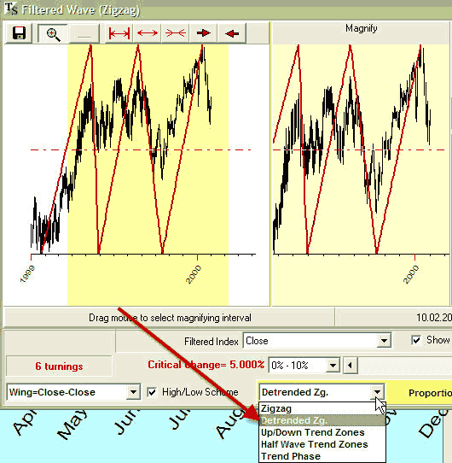

To see the difference between the regular and detrended zigzag, let us draw them both on the same screen (red line is for the detrended zigzag):
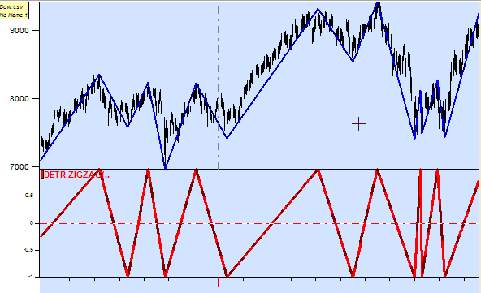
The usage of the detrended zigzag makes possible the analysis of turning points for big time intervals (due to elimination of the trend).
When the detrended zigzag is created, we can use it in all modules of the program. For example, we can calculate Spectrum for it. It will give us the time periods with high probability of turning points:

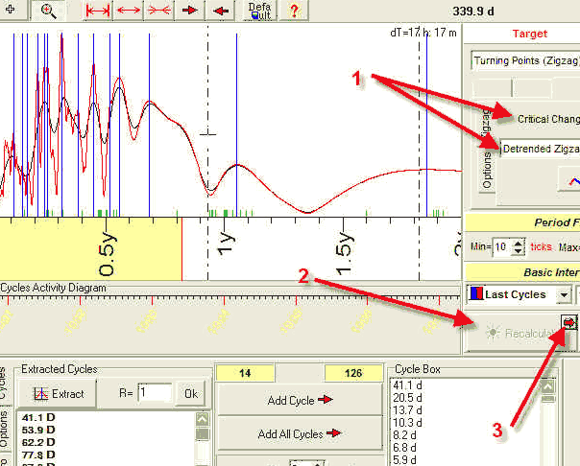
Remember that the program does many operations automatically. You have to define only crucial points of the process simply following the steps shown on the picture above.
Extract the most active cycles. The program puts these cycles into the clipboard automatically.
When it is done, we can create the Neural Net model and predict the future turning points. How do we do that?
First of all, define outputs (i.e., things that we want to predict). In our case, this is the detrended zigzag with critical change 3.225:
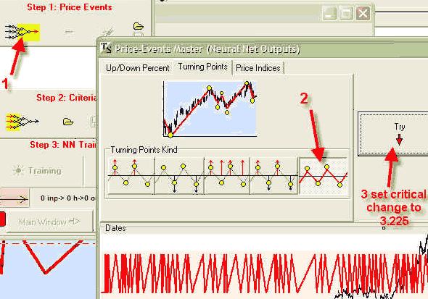
Next step is to define inputs, or factors that we use for the forecast. In our case, we use regular cycles calculated by Spectrum module. These cycles are already found, we get them from the clipboard:
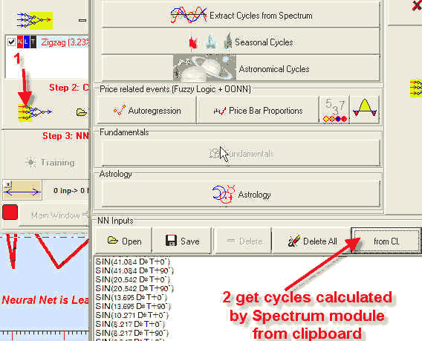
The next step is to train this model.
This simple technique provides surprising results. See the picture below; it shows how well this model is able to predict the turning points, although sometimes we still face the "inversion" effect:
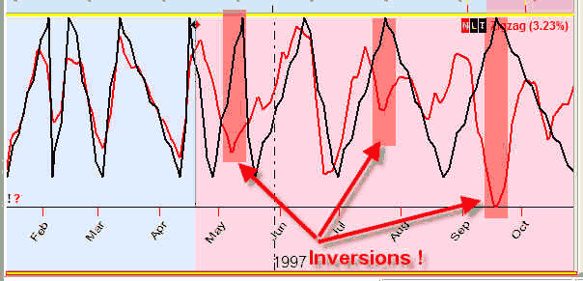
Inversions mean that sometimes the model replaces tops and bottoms. But the most important fact is that this model points out the correct time when the turning point occurs no matter what its nature is (in other words, no matter whether it is a top turning point or a bottom one).
Also, due to its whole appearance as teeth of the saw, the detrended zigzag is able to locate turning points more precisely than with any other existing oscillator.
All the above gives us a very strong reason to use the detrended zigzag for creating timing models.

Advanced Options
There are several parameters to modify this zigzag.
1) Curvature. Probably, the most interesting parameter is curvature.
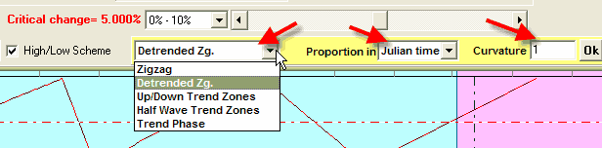
Try to set this parameter as 2 and click on "OK" button. Then set it to 5 and create one more zigzag.
All these zigzags are shown together:
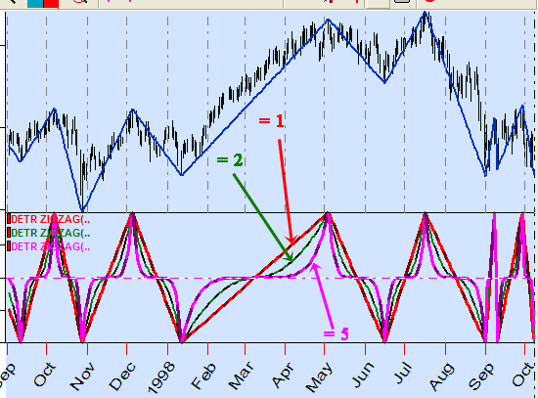
As you see, the higher curvature is, the more we are focused on turning points pointed by this indicator. Now our zigzag looks this way:
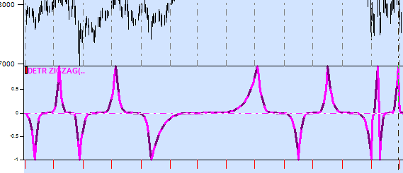
Play with this indicator as a target (output) for Neural Net module. Also it is interesting to use this index for Spectrum module. I applied this experimental technique for FAM models for some stocks and for Spectrum models. Results are really interesting.
2) Proportion In: 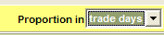 This parameter defines the kind of proportion we use for detrended zigzag. If we use the Julian Day option, the zigzag (with curvature=1) looks as connected straight lines, if we use trade days option, the proportion will be calculated in relative trade days (trade bars).

Some hints to create models for intraday trading
Timing Solution operates with three types of price data. It is very important to distinguish these data because the manner of calculating the projection line by Neural Net module strongly depends on it.
1) Daily data - when we have one price bar per one day. The sample of such data looks like this:
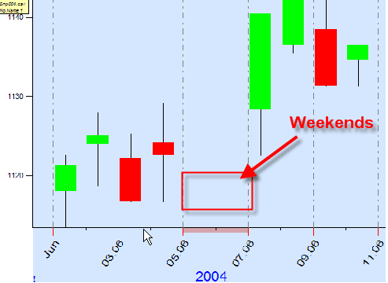

Working with this type of data, we need to exclude weekends and holidays in "Options":
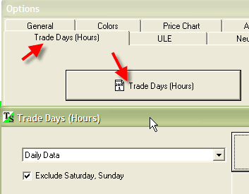

The projection line generated for this data sample is shown here:
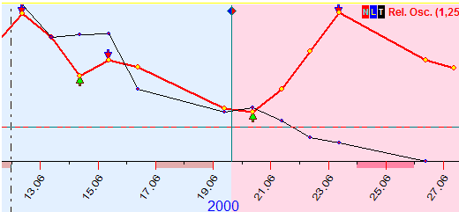
In this case, the program generates a projection line on a daily basis and skips weekends and holidays automatically (see red stripes on the time scale).

2) Daily Intraday data - when we have intraday data stream during the day. For example, if it is measured by 5 min ticks, we will get for just one day many 5 minutes price bars. In other words, this type of data allows observing the intraday dynamics of the price change, and this dynamics is limited by trading hours (i.e., from 9:30 am till 4:00 pm).
This is the typical example of such kind of data:
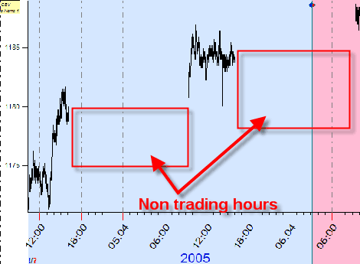
For any day (except weekends and holidays), we have 6:30 hours bunches of price data. In this case, you should set up the time when trading starts and ends during the day:
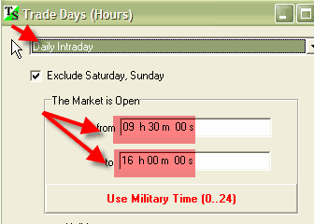
Look how the Neural Net will generate the projection line under these options:
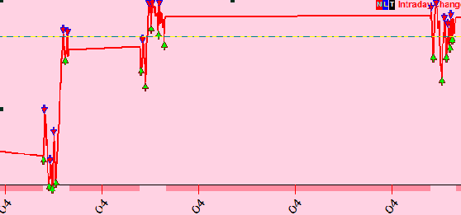
The program will skip non-trading days and non-trading hours (these periods are marked by red stripes under the time scale). If you try to set daily options for this kind of data, you will not get the intraday projection curve. The program must know what kind of data it operates with.
3) Weekly Intraday data - this kind of data corresponds to intraday data within trading hours. The trading begins (as an example) at 9:30 am Monday and stops at 4:00 pm Friday. During this five day period, we have continuing intraday data stream (like for Forex). This is the typical example of weekly intraday data:
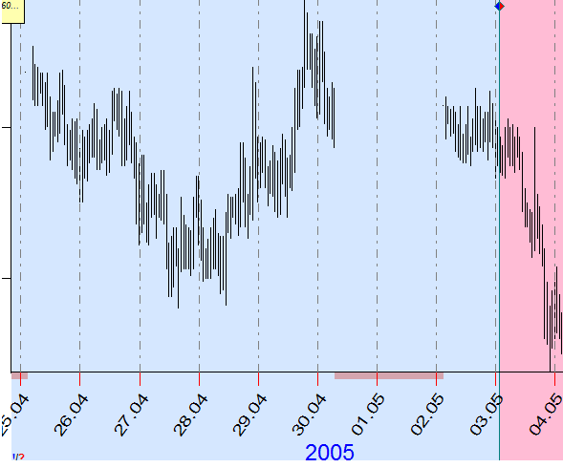
Here we have the data where the trading begins at 3:00 am every Monday and ends Saturday at 7:00 am (local time) every week.
For this particular example, set these options:
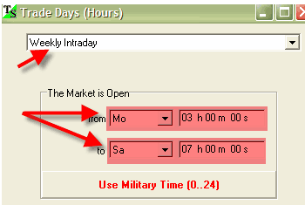
This is the projection line generated by Neural Net under these options:
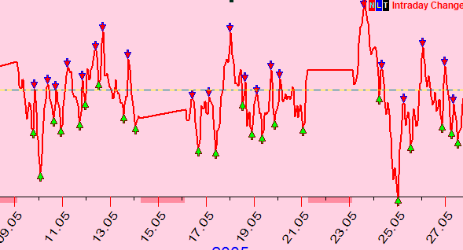
We have series of continuous 5 days data. If you try to use Daily-Intraday for this kind of data, you will not get the projection line for non-trading hours (like on Wednesday from 4:00 pm to 9:00 pm).

Description of the Models in the package
Spectrum Model
This is the model based on fixed cycles. To apply this we recommend using price history data of at least 2 years, though this model gives better results for 10 years data.
The weakness of this model is that it is based on fixed cycles (i.e., these cycles are supposed to be the same all the time). However, in reality, fixed cycles are not fixed - their phase and their period are subjects to change. (Actual fixed cycles might be compared to the orchestra of rather good professionals; as a rule, they provide an excellent performance. But - one of the participants has a little boy and the child care facility does not work one day, so the boy is with his parent and "helps" as much as he can - touching the violin at the wrong moment, changing the tune, etc. It can be compared with a change of period for a fixed cycle. The other person in this orchestra is absent-minded, and pretty often he messes the pages in the folder; thus, performing Bach, he might switch to a piece of Mozart somewhere in the middle. It is an analogy for the change of phase. But, in the whole, the performance is good enough.) The picture shows this situation reflected by the projection line:
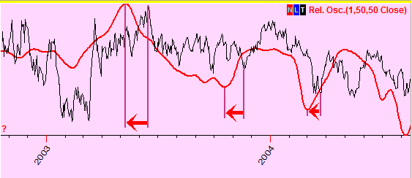
The true picture might be shifted, stretched and squeezed. To deal with these phenomena (i.e., cycles changing their period), we provide the wavelet diagram.
The lifetime of the fixed cycle is defined by the length of the "cycle mode" (John F. Ehlers, MESA and Trading Market Cycles). After that the playing cycles change their period or disappear; the phases of these cycles can make crazy jumps.

Dynamic and Astro Model
We recommend using at least 4 years of price history data for these models.
These models are related to astronomical cycles. The difference between Dynamic and Astro models lies in the methods of describing these cycles.
The worst character weakness of these models is inversions. Look at this example:
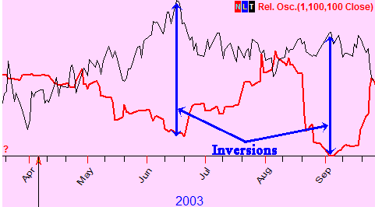
We must state that these models are purely phenomenological. We do not know the reason for their impact on markets, nor do we provide any explanation of such influence. The only thing guaranteed is the correctness of the applied math apparatus. At least, these models may be helpful to find the turning points.

Japanese Candlesticks and Auto regression Models
These models deal with price related events. We recommend using at least 700 price bars history (or 3 years for end of day data) for these models. Both types of models provide the forecast 7 price bars ahead after LBC.
Here you can see the results of the Back Testing procedure for Japanese Candlesticks model: htpp://www.timingsolution.com/TS/BT/Candle5/.

Important note
Working with all these models, you should remember the existence of some X-factor. You can call IT by any names you want, the fact is that any forecast can fail almost any moment - thanks to this X-factor. To understand when, why and how this factor enters our lives might be an unbelievably hard task. The least we can do is to try to catch the moments when it has happened in the past. This is the reason for our attention to Back Testing procedure. Today, it is the only known way to enter this territory.
We will continue the Back Testing procedure for all these models. From time to time, the new information will be released on our website http://www.timingsolution.com/TS/BT/

©Timing Solution 2004-2006
Edition February 23, 2006

