Easy Cycle Module in Timing Solution

Everything goes in cycles. What does this statement mean? Practically, it says that the history repeats itself. Nobody argues that. The question is what can we learn from the history?
In this article, I would like to discuss the new feature of Timing Solution software – Easy Cycle module. This module easily shows the lessons that the history gives to us. I remember that Timing Solution has already much more comprehensive Spectrum module that is able to reveal any cycles. However, this new module is a good helper in understanding the general idea of the cyclic theory.
Before any discussion, let us figure out what the cycle is? Mathematically, the cycle can be presented by a sinus curve. It looks like this:
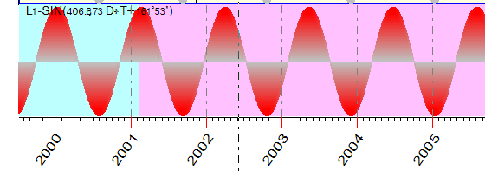
This nice looking curve describes a marvelous amount of processes in our lives. Since Fourier discovered it in 18th century, any scientist spends a lot of time with this nice looking lady. They even gave her a special name – the harmonic function.
In this article, we will try to present the harmonic function’s point of view. There are three most important parameters to describe it:
- Period – shows the length of one full cycle.
- Phase – shows how the maximums of this curve are located.
- Amplitude – shows the height of this curve.

Look at this example. Let us consider the gold prices for the last four years:

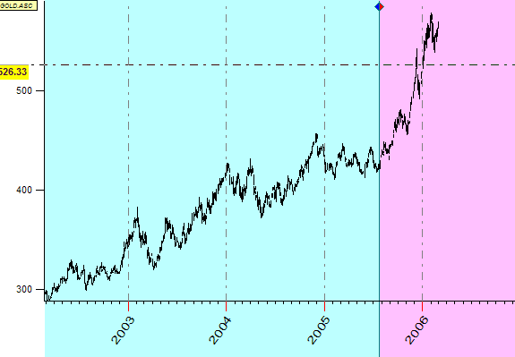

While downloading the gold price, set the forecast horizon on 300 price bars. Thus, we tell the program that we will make a forecast on this time span:

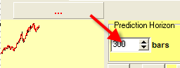

What do we see on this chart? We see several tops (or reversal points that indicate the trend changes), and we would like to use the information regarding these known points to forecast the next one:

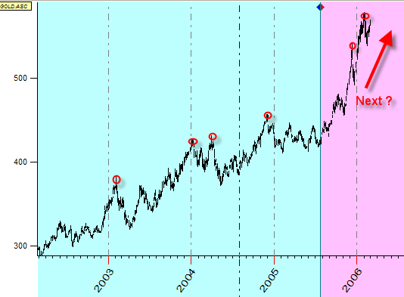

The core idea of the cyclic theory is that there should be some order in location of these reverse points.

This order can be revealed by Timing Solution software. Follow these steps: menu “Tools” -> “Easy Cycle”. You will get this window:
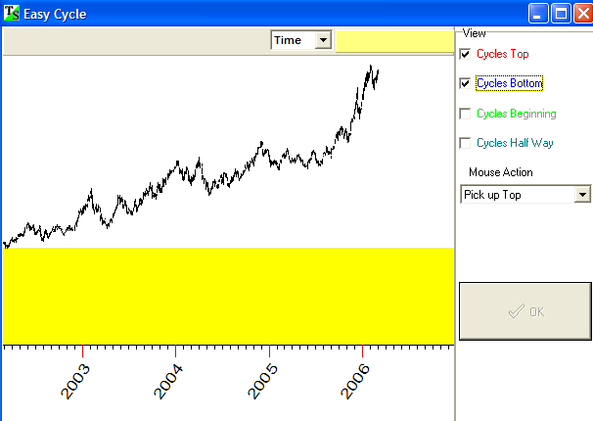

Let us consider two the most important turning top points that took place in 2004:

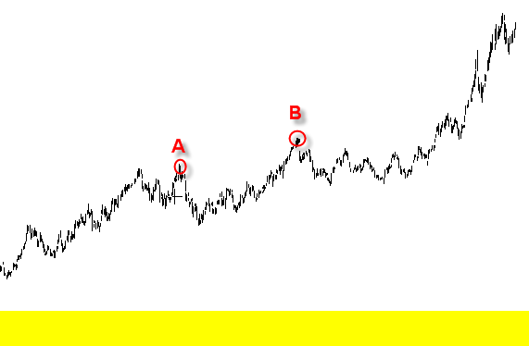
Drag the mouse from the peak A to peak B. You will get this picture:

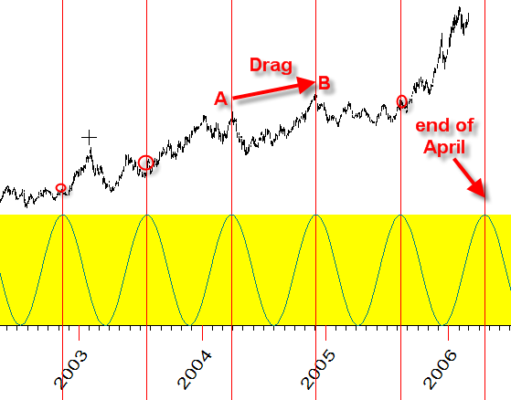

Red vertical lines represent top turning points for the cycle of turning points A and B. The distance between these points is 250 days, so these lines represent 250 days intervals. As you see, these lines hit other local tops giving us some confidence that this cycle has some impact on gold prices.

The yellow bar shows how the sinus wave produced by A and B turning points.

Let’s ask the program to display the bottom turning points produced by this cycle. Check this option “ON”:
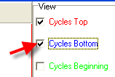

Now the price chart looks like this:
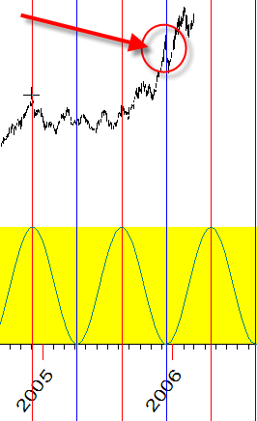

The blue lines should correspond to the bottoms of the cycle (if it would be the ideal cycle). However, look at the circled line: it shows the top turning point for gold instead of the bottom. It happens in reality. This is the “inversion” effect that takes place very often in financial data.

So, we can try different cycles to get the whole picture regarding inner cyclic processes for any financial instrument.

If you work with intraday data, this option may be useful:
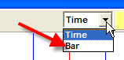

Also, set this option:
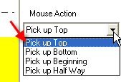
The available choices here allow you to catch bottoms, cycles beginnings and cycles halves. As an idea, this option can be useful if you create the cycle based on bottom turning points.

One very interesting application of this feature can be found in Universal Language of Events (ULE) module. You could create ULE model based on fixed cycles in the previous version. However, the new Easy Cycles module makes this process very comfortable and pleasant. I better show you one example.
I have downloaded the data for inflation index starting from the year 1665!!! See it here (it is a yearly chart):

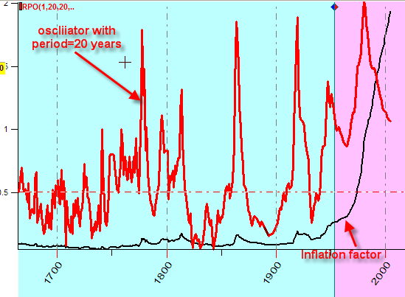

Here the black line represents the inflation factor while the red line is the oscillator for inflation factor with 20-year period. The oscillator is more suitable to reveal the cycles.

Run ULE module and chose “Cycles” tab:
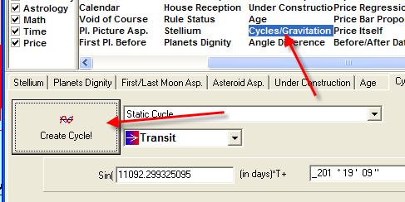

In the previous version, you should define the numeric parameters of the cycles (the period and the phase) manually. Now it is possible to catch these cycles manipulating by mouse only. You simply have no need to know the digits behind these cycles.
Click “Create Cycle” button, and you will get the familiar window (it looks like the 30-year cycle works very well for the last century):

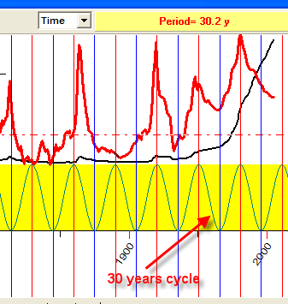

This cycle corresponds to some tops that I see. The program says that it is 30.2 year cycle. I add this cycle to the events list clicking on “+” button:

h

The name of this event is L1.

Then I pick another cycle, 59.5 years, twice longer than the first one:

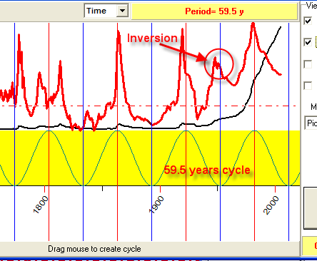

That cycle shows at least one inversion, in 1950th.

Now there are two cycles in Events List, L1 and L2.

Let us create the superposition of these two cycles, i.e. the sum L1 and L2: L1+L2:
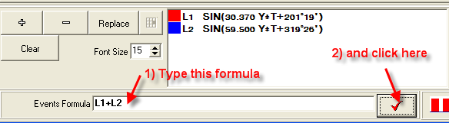

Look at the combination of these cycles (to get it, go to the Main Window and click there the “Calculate” button):
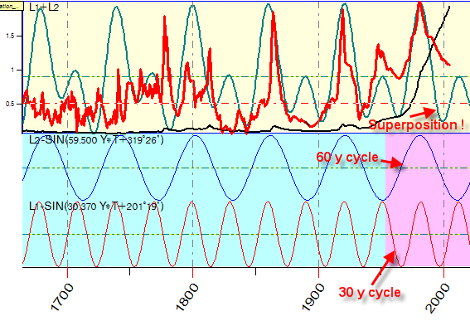
I think the real curve that represents the superposition of 30- and 60-year cycles describes the inflation very well for the last 150 years:
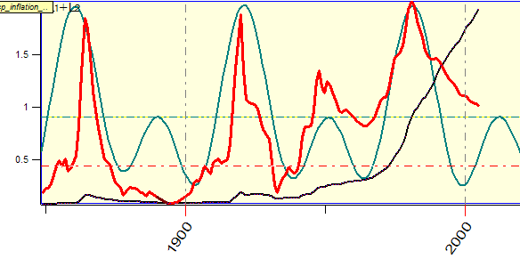

The most appealing feature of this approach is that we totally control the whole process of creating the forecast. You extract the cycles manually. You can play with the weights of these cycles as well, like this:

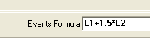

It means that we increase the weight of 60-year cycle on 50%.

You can also add as many cycles as you want.

