USD/CHF Mars Geo Case Study

I have got this note recently: “It would be nice to see your software do Mars Geo on USD/CHF”.
There is no problem. I will show in this article how anybody can perform this type of analysis using Timing Solution software. Highlighted in green are the key words to fast find the appropriate topics in the documentation.

Step #1: Download historical data: USD/CHF 1973-2006. This is the price chart:

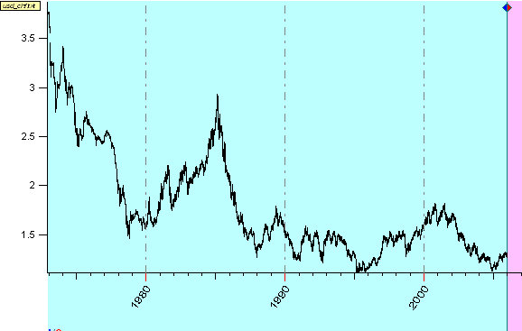

Composite module:
Mars in Geo means that we would like to see whether there is any impact from Mars going through all Zodiac signs in Geocentric coordinate system. It is a cyclic movement. Thus, to get the first impression regarding this cycle, I would recommend starting with the Composite module. Click on “Astronomy” button in the Main window and choose these options for “Mars-Geo”:
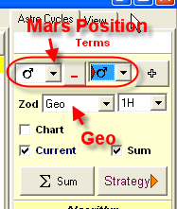

You will see this Composite diagram:

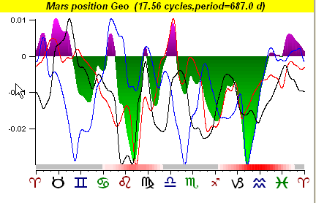

It shows the price changes in respect to Mars position. Is this cycle reliable? Can we use this information while making trading decisions?
The most reliable zones here are Leo and Capricorn - Aquarius. All three lines (red, blue and black) point at the same price movement:

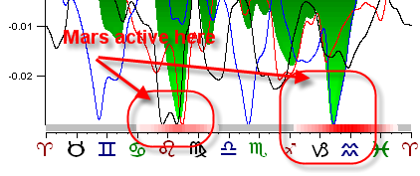

In other words, when Mars is in Leo or Capricorn and Aquarius, it contributes its energy to the strong movements on this market.
These are typical trend lines in respect to Mars position:

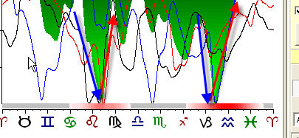

ULE/SuperSearch:
We have got the fist impression regarding this cycle and now would like to see more detailed analysis. In this situation ULE/SuperSearch module is recommended:

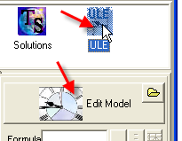

We will explore what happens to USD/CHF when Mars ingresses Leo, Capricorn and Aquarius.
We concentrate first on these three signs because the Composite module shows their importance. We do Efficiency test for each of these three astro events. (I did it for each event; however, the following illustrates the most interesting event. In this case, it is Mars ingress to Aquarius)
Efficiency Test:
Fill this form and click “Efficiency Test” button:

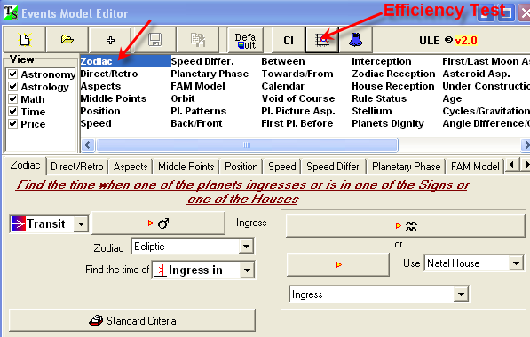

You will get this:

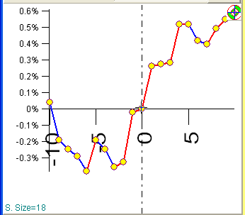

The Efficiency Test shows how the price changes around some specific moment of time (in this case, when Mars ingresses in Aquarius).

You see the price starts going up about 2 days before this event. This upward movement continues for 4 days after the ingress (12 up against 6 up):

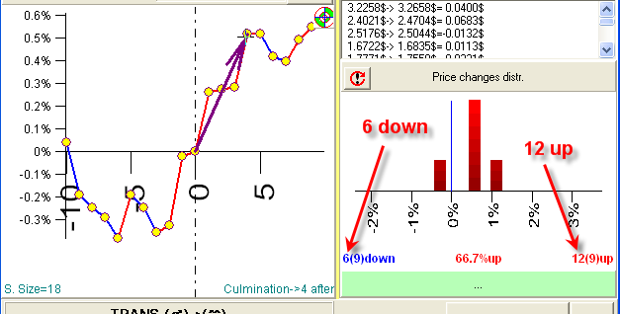

This factor is important, especially taking into account that it occurs on downward general trend for this instrument.

We looked at Mars’s ingresses (single moment events). However, the active zones (found by Composite module) tell us about Mars being in these signs. Let us look at Mars in Leo first (you do the same thing for Mars in Capricorn and Aquarius).
You see here the big drop in price, in the middle of Leo. The program does not do Efficiency test for prolonged events. But - all three diagrams show the bottom right in the middle of Leo:
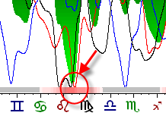

We can look at it in details, degree by degree. Let us start with the middle (i.e., 15 degrees of Leo).
Fill out the form this way:
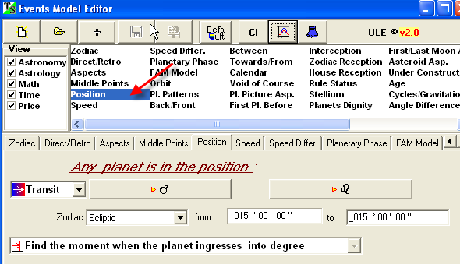

Calculate the Efficiency Test for Mars in 15 degrees of Leo:

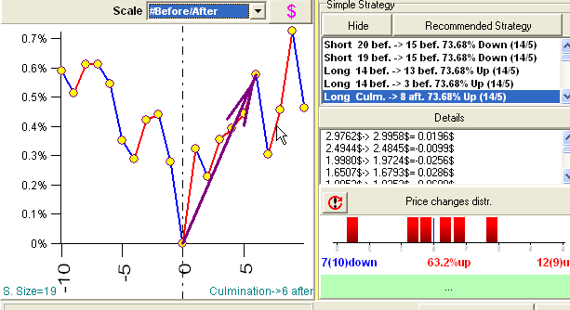

We can say that within a week after the moment when Mars passes 15th degree of Leo the price goes up. However, trading strategy based on this information may be too risky (12 ups against 7 downs).
Also look at he bottom of Efficiency Test window:
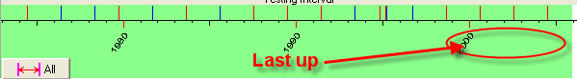

Here the red stripes correspond to the moments when price goes up a week after Mars passes 15th degree of Leo, blue – down. You can see that this rule worked well for the last 4 passes. In other words, this rule works for the last 8 years.

Projection line:
The program is able to create the projection line for Mars cycle (based on the information that we have got doing this research). You can see it immediately in the Main screen:

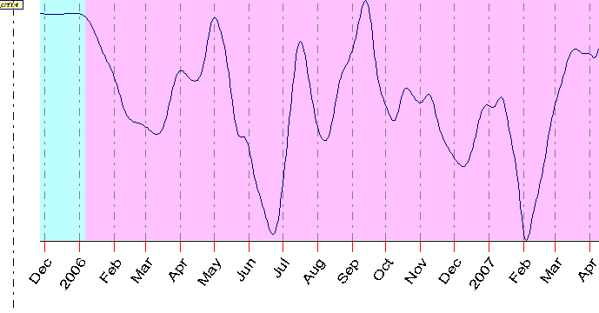

Committee:
The question is: how we can rely on this projection line? I recommend creating Committee of projection lines based on Mars cycle. (Committee is a term used in Neural Net science, it means a variety of projection lines.)
Follow these steps:
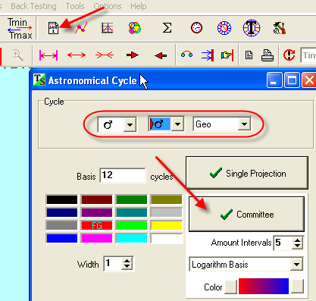

You will get this diagram with 5 projection lines calculated on different time frames (the red diagram based on latest price history, the blue one is based on the whole available history, other lines are based on different intervals within the price data file):

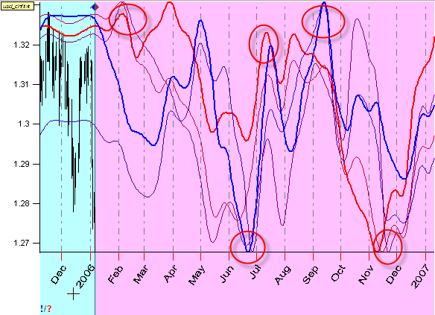

Pay attention to the moments when all these diagrams show the same tendency. They are marked as circles.

Here I made the typical trend lines produced by this cycle:
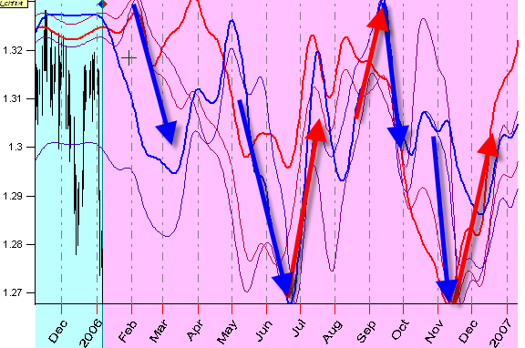

Actually, here you can see the possible ways of playing with this cycle.

Spectrum:
We explored Mars Geo cycle in details. There is one more question regarding this cycle that is not answered yet: is this cycle really important for our data set? There might be some other players, much bigger than that.
To get a whole “cycle structure” of this data, I would calculate a periodogram ( “Spectrum” button):

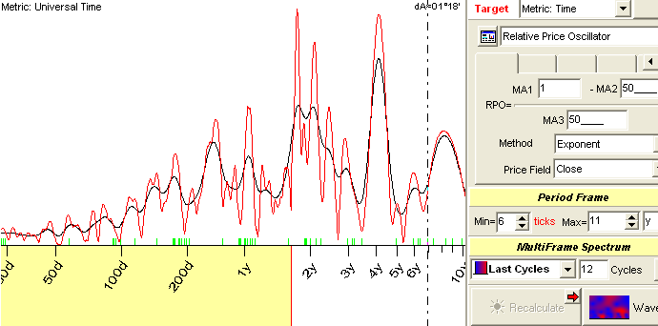

The most prominent “astronomical” cycle here is 762 days cycle:
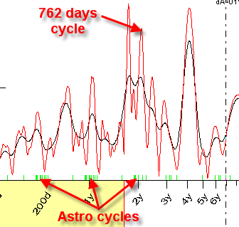

The astro cycles are marked by small lime stripes on the period scale.

This corresponds to the Sun-Mars synodic cycle 779.9 days.

The Sun-Mars composite looks like this:
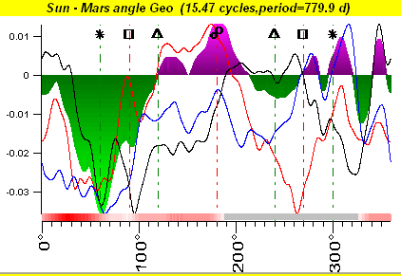

This is the projection line based on this cycle:
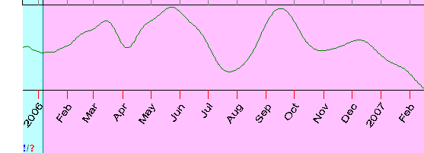

When you are working with synodic cycles that involve the Sun (like the Sun-Mercury, Sun-Venus, Sun-Mars, Sun-Jupiter … cycles), I would recommend to work with planetary phases cycles.

For example, instead of using the Sun-Mercury synodic cycle (period 115.9 days):
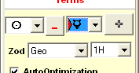

use Mercury phase cycle:
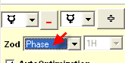

This is especially important for the Sun - Mercury, the Sun - Venus, the Sun - Mars cycles. But this idea needs more research.

All the above is just a draft of the analysis. To get the whole picture, you should analyze all cycles.

