Upgrade May 19, 2006
Annual Cycles
In this upgrade you can easily create the simplest forecast based on annual cycles.
The annual cycle is a very important fundamental factor, and we should take it first into consideration. Now you can create the projection line based on annual cycles by two mouse clicks.
1) Click on this button:
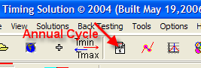
You will get the window where you can define the base interval (it is the interval used to calculate the annual cycle; in this example, we use last 12 years of price history):
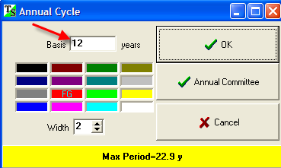
2) Clicking “OK” button, you will activate a set of operations that automatically provides the annual projection line and sends it to the Main window. This is the annual cycle projection line for Dow Jones Industrial index:
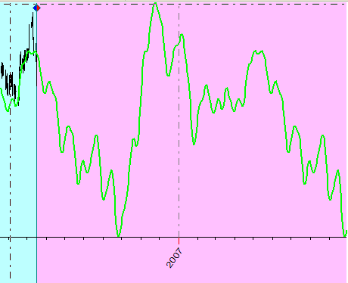
However, one question still exists: how the projection line will be changed if we vary the base interval? As an example, we can calculate the annual cycle for Dow Jones Industrial index using last 2 years and all available 120 years of price history. It gives us different base intervals and different projection lines. The question is: “which annual cycle is better?”
To answer this question, let us calculate the annual cycle using last 2 years, then using 5 years, 10 years … and all 120 years. Plot these projection lines all together and choose the time period where these projection lines point at the same price movement.
You can do it now just clicking this button:
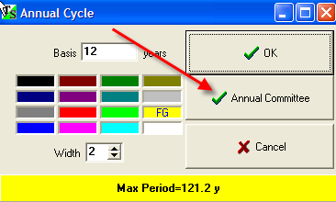
The program itself will recalculate the projection lines for the annual cycle based on different base intervals. You will see them all on the main screen:
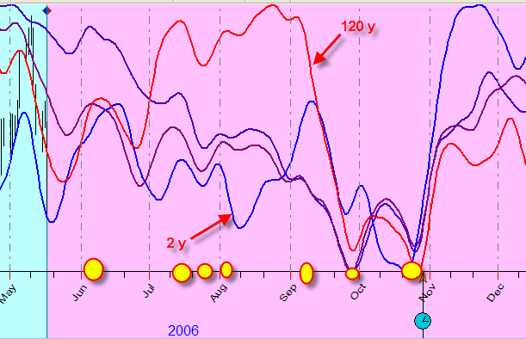
You can see here five projection lines. These projection lines are based on different price history: the blue one is based on 2 years of price history, another extreme is the red line based on 120 years of price history. I marked by yellow pointers the moments when all annual cycles point the same pivot points.
If you do not need some of these lines or all of them, you can delete these lines through the Strategy window:
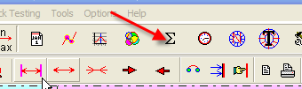

Simple SuperSearch Forecast Models (Neural Net + Super Search)
for advanced users only
Universal Language of Events (ULE) in Timing Solution has a new feature of creating simplest forecast models. It is a step ahead in comparison to regular SuperSearch.
Let me show you this feature. I run Neural Net module and train it using FAM Geo model. Click this button:
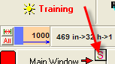

You will get the list of SORTED events that compile this forecast model. The strongest event is the first one, then comes the second best, and so on …
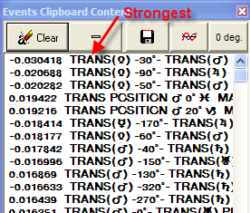

Highlight first 20 events (just push Shift button and hold it) and click this button:
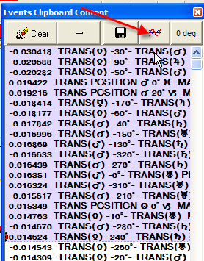

You may hide Neural Net Information panel pushing this button:

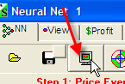

Now watch the SuperSearch window:

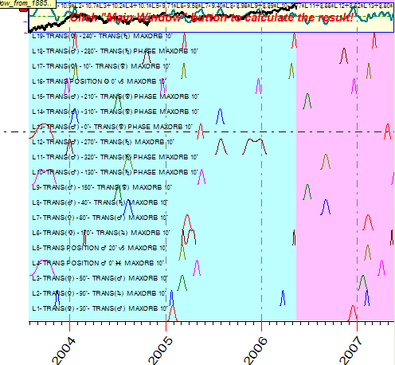

Here you can see how the most influential events work in time. I think you may be interested to see the summary diagram as well. Set this options “Off” to hide insufficient information:

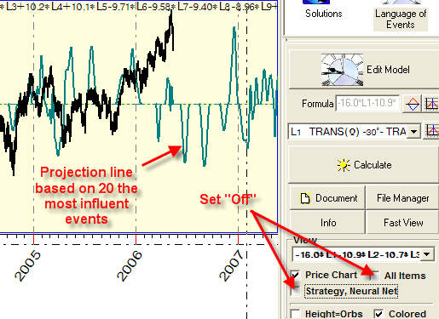

Here you can see the summary projection line based on these events.
Each event has its own weight calculated by the Neural Net module:

Thus, you can create simple SuperSearch models that use the most significant information calculated through a very sophisticated Neural Network module.

