Zigzag

As a source, we use the book by Arthur A. Merrill “Filtered Wave basic theory” published in 1977 year.

This is the window to set the parameters for Zigzag in Timing Solution:

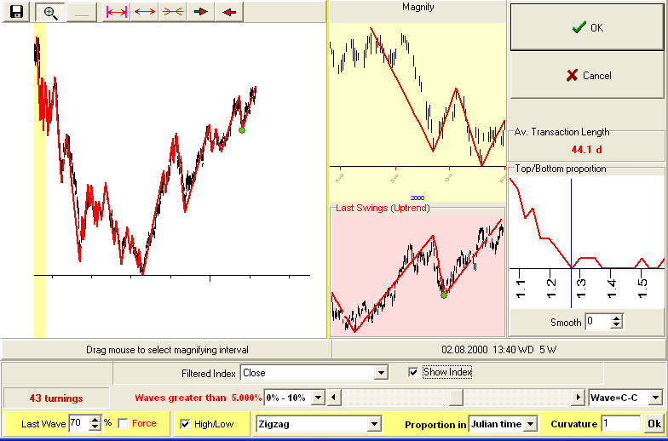

The most important parameter is the minimal height of zigzag swing. Merrill called this parameter FWG (“Filtered Waves Greater than %”).
You can define this parameter here:

Just slide the bar.

Next parameter is how we calculate the swing/wave heights. We can calculate it as a difference between High-Low or Close-Close:

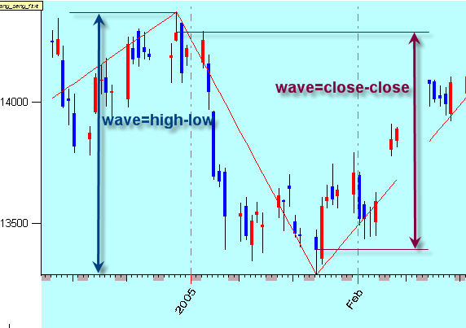

You can define this parameter here:

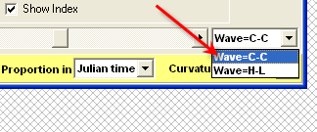

Next parameter: how we specify the reversal points, there are two variants as well:
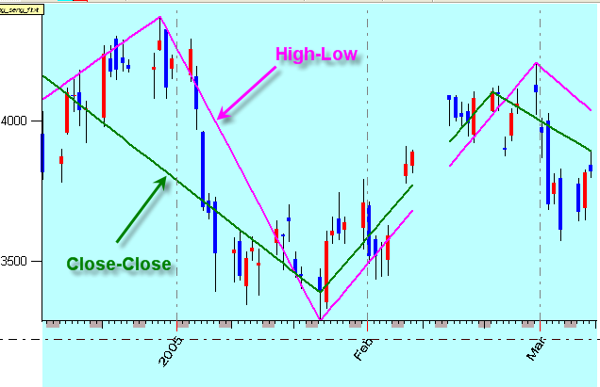

We can specify the reversal point as highest high or as highest close.
This parameter is defined here:
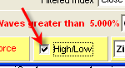

Do not mix these two parameters the swing/wave heights and reversal points. For example, you can define the reversal points as high/low but the “Filtered Waves Greater than %” parameter is calculated as close/close:

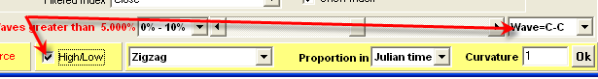

Thus we are doing the double filtering for reversal point: we have to reach highest high and close should be in 5% (as example) higher than close of previous low reversal point.

Very important question is how we handle the last turning point.
For example, the question is: “is A point a low reversal point?”

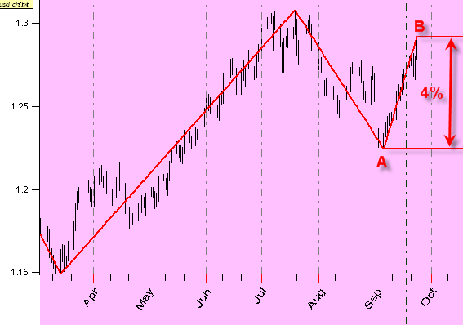

I used here 5% zigzag. Formally we cannot answer this question because the up swing A-B is only 4%, we have not enough confirmation that A is a real low.
We handle the last turning point in a special way: for the last swing, we use a smaller number. These options:

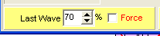

The “last wave” parameter defines the length of last swing. In other words, to confirm the last turning point A, we need 70% of 5% = 3.5% uptrend swing.

The parameter “Force” 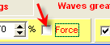 allows to play the more risky games. We can force the last reversal point to the highest high or lowest low disregard the confirmation of opposite movement:
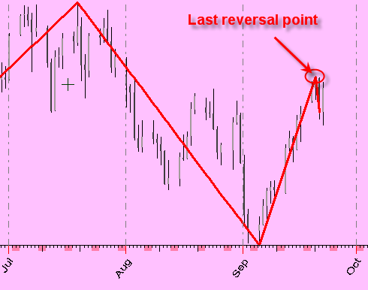

If you plan to use it in Neural Net, Spectrum or Composite modules, I would recommend using the detrended zigzag it is here:

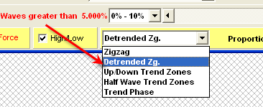

It is more suitable for creating a projection line:
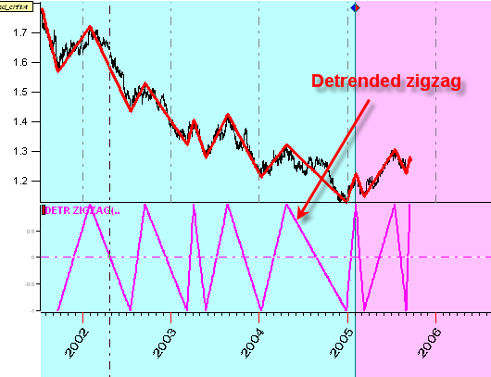

Also, if you work with intraday data, use this option:

